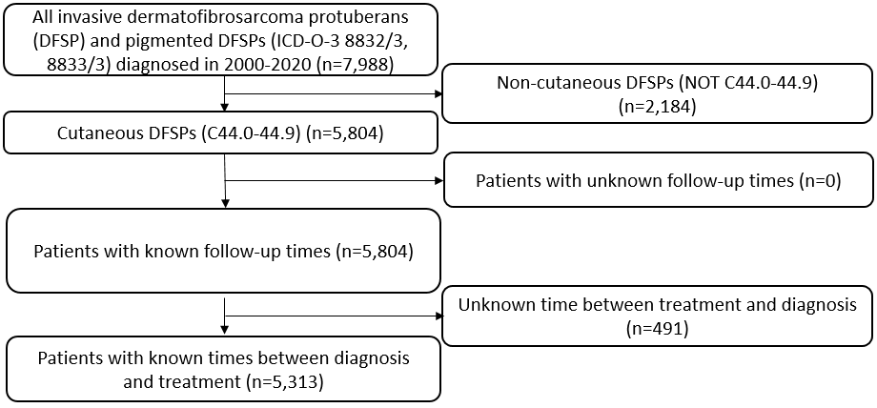

**Supplemental Figure 1** – Inclusion and exclusion criteria for survival analysis for the study. ICD-O-3: International Classification of Diseases for Oncology, 3rd Edition.

**Supplemental Figure 2** – Incidence and 95% confidence intervals of Dermatofibrosarcoma protuberans by race (2000-2020). Dashed horizontal line represents the average incidence of DFSP over the observed time period (4.6 cases per million person-years, 2000-2020).

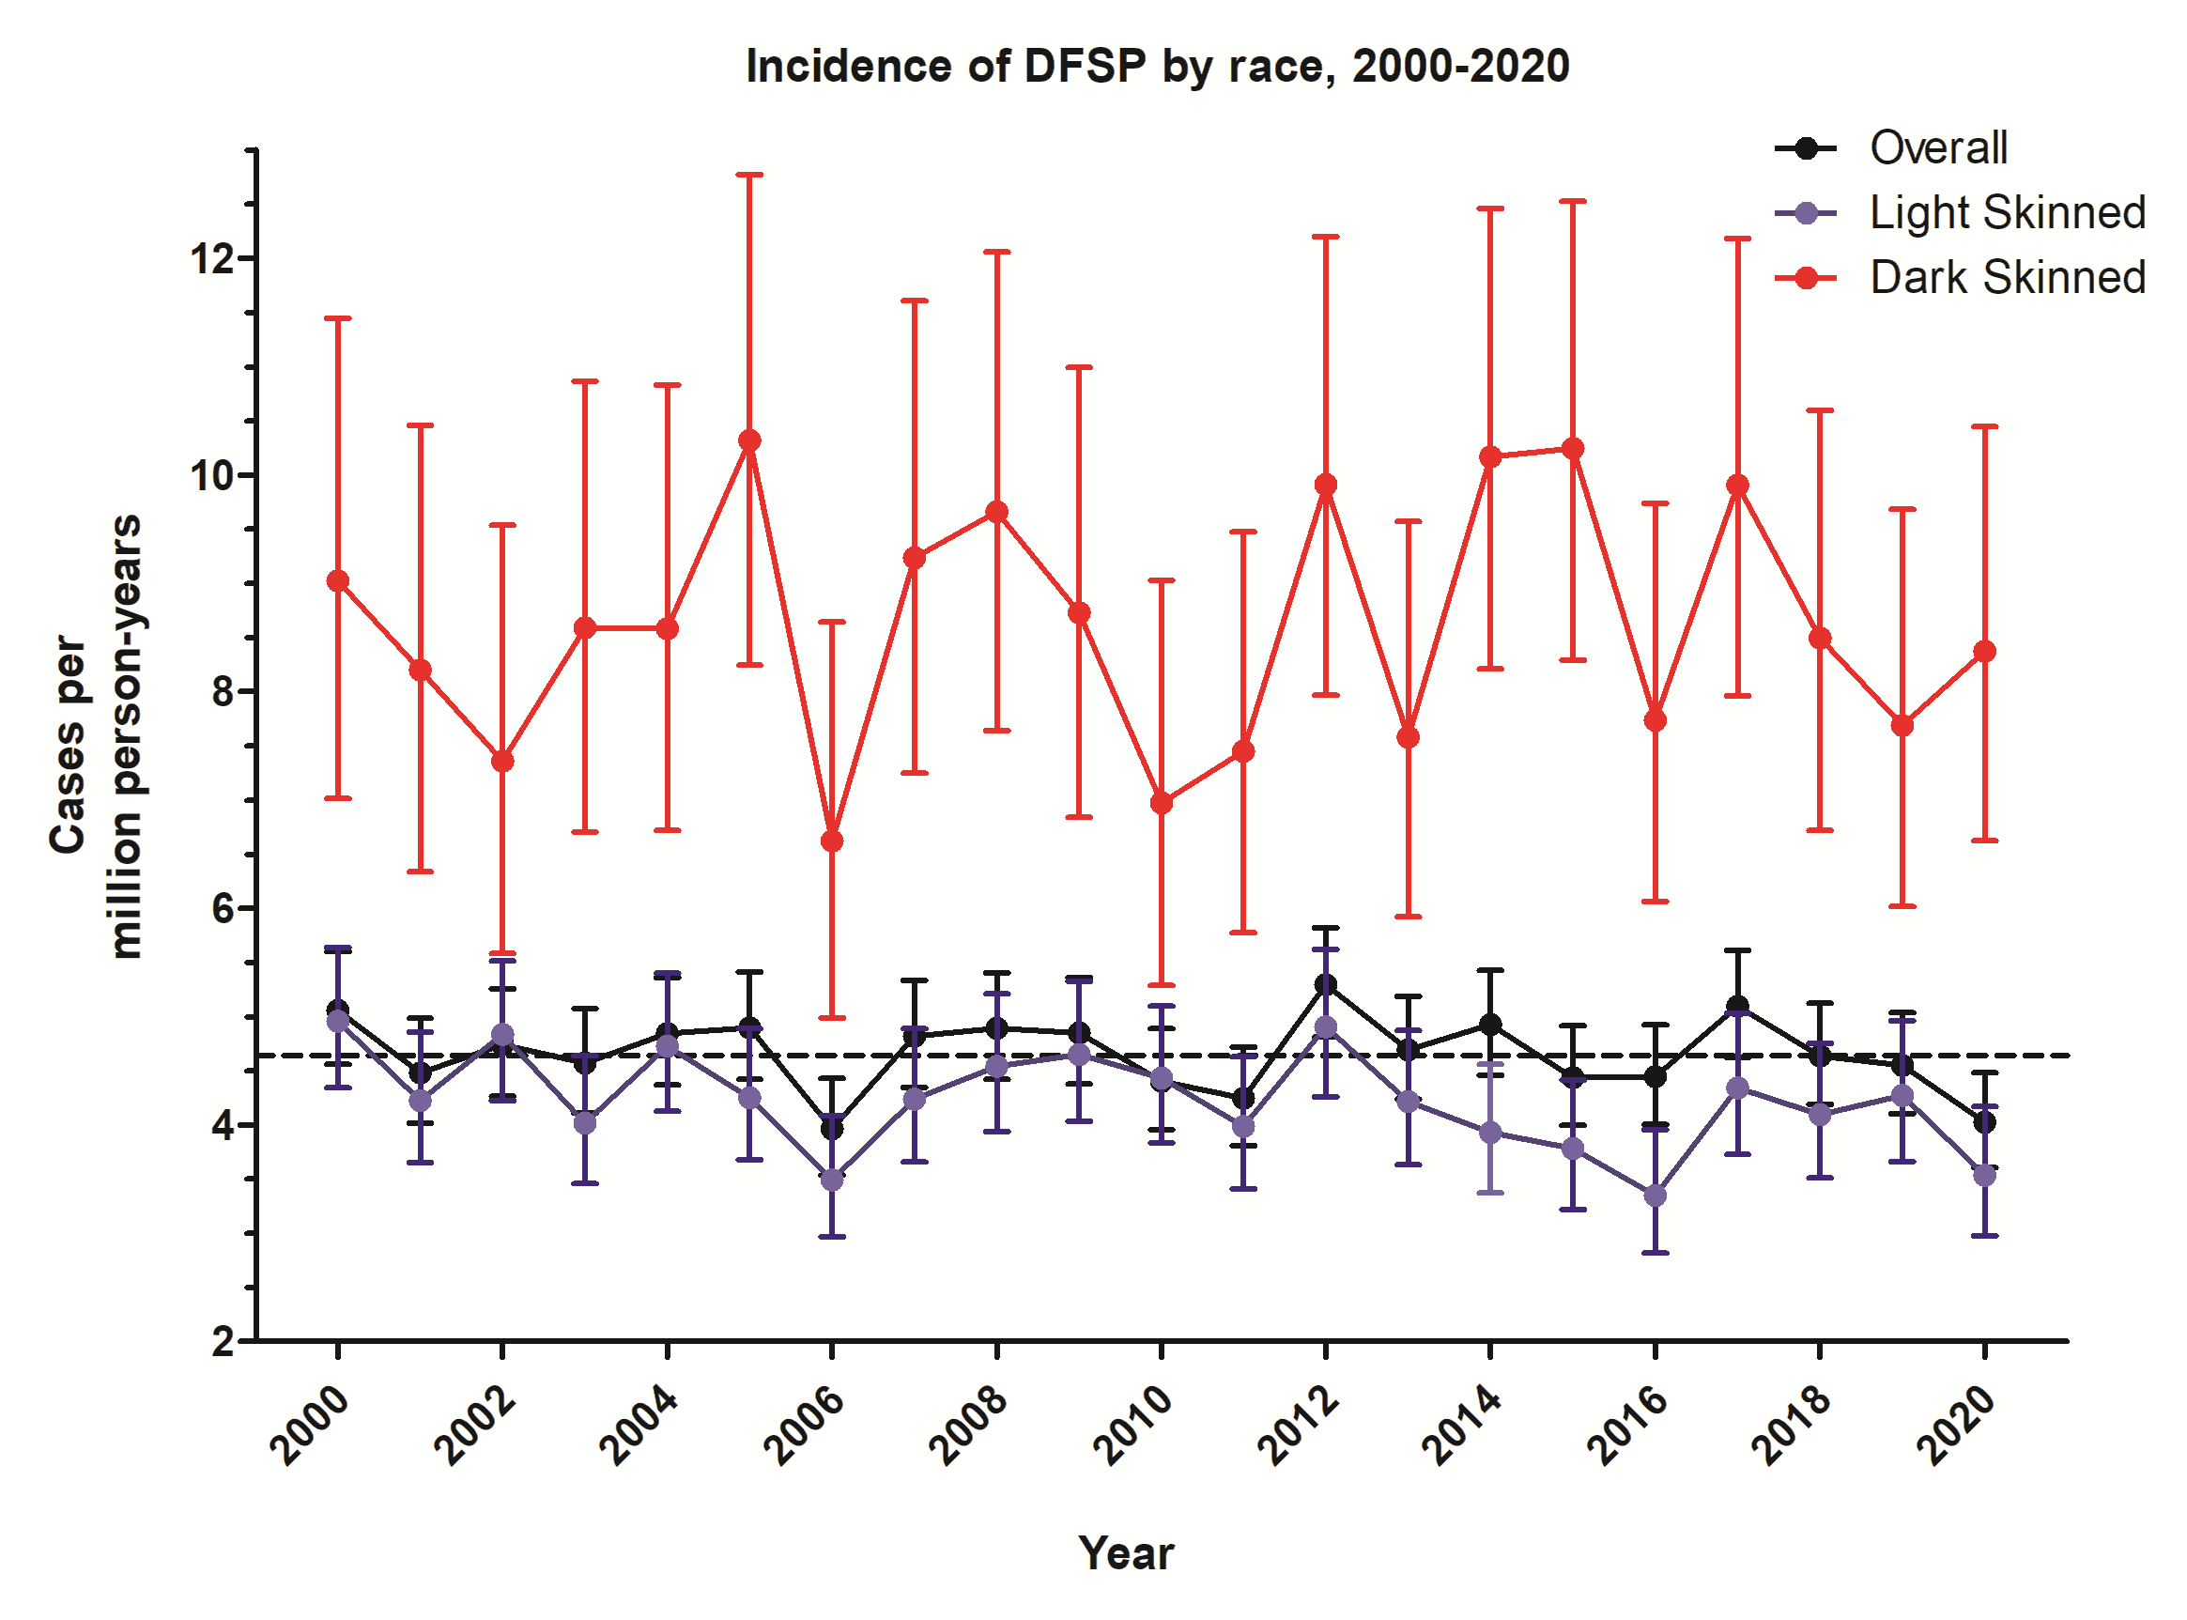

C:\Users\Julie\AppData\Local\Microsoft\Windows\INetCache\Content.Word\Incidence - Age_Race_Skin.tif **Supplemental Figure 3** – Incidence and 95% confidence intervals of DFSP from 2000-2020 by age and race. Dashed horizontal line indicates the average incidence of DFSP observed over this time period (4.6 cases per million person-years)