SUPPLEMENTARY INFORMATION
Title: A diverse hidradenitis suppurativa cohort: a retrospective cross-sectional study of 13,130 patients from a large US healthcare system database from 1995-2022

Kelly Z. Young, MD, PhD^{1#}, Ian Loveless, MS^{1,2,3#}, Wan-Ting K. Su, PhD^{2,3,4#}, Jesse Veenstra, MD, PhD^{1,4,5,6,10#}, Congcong Yin, MD, PhD^{1,5}, Peter Dimitrion, MS^{1,5,7}, Rachel Krevh, MD^{1,5}, Li Zhou, MD, MS^{1,4,5,6,8,9, 10}, Ruicong She, MS², Mingming Pan, MS², Albert M. Levin, PhD^{2,3,4}, Albert Young, MD¹⁰, Eglal Samir, BS¹, Andrea Dai, BS¹, James Ge, BS¹, Richard H. Huggins, MD^{4,6,10}, Cristina de Guzman Strong, PhD^{1,4,5,6,10}, Henry W. Lim, MD^{4,6,10}, David M. Ozog, MD^{4,6,10}, Iltefat Hamzavi, MD¹⁰*, Indra Adrianto, PhD^{1,2,4,5,6}*, Qing-Sheng Mi, MD, PhD^{1,4-10}*

¹Center for Cutaneous Biology and Immunology Research, Department of Dermatology, Henry Ford Health, Detroit, MI, USA.
²Center for Bioinformatics, Department of Public Health Sciences, Henry Ford Health, Detroit, MI, USA.
³Department of Epidemiology and Biostatistics, College of Human Medicine, Michigan State University, East Lansing, MI 48824, USA.
⁴Henry Ford Health + Michigan State University Health Sciences, East Lansing, MI 48824, USA.
⁵Immunology Research Program, Henry Ford Cancer Institute, Henry Ford Health, Detroit, MI, USA.
⁶Department of Medicine, College of Human Medicine, Michigan State University, East Lansing, MI, USA.
⁷Cancer Biology Graduate Program, School of Medicine, Wayne State University, Detroit, MI, USA.
⁸Department of Biochemistry, Microbiology, and Immunology, School of Medicine, Wayne State University, Detroit, MI, USA.
⁹Department of Internal Medicine, Henry Ford Health, Detroit, Michigan, USA.
¹⁰Department of Dermatology, Henry Ford Health, Detroit, MI, USA.
# Equally contributed to this study
*Co-corresponding authors and co-directed this project

Corresponding authors:
Iltefat Hamzavi, MD (ihamzav1@hfhs.org)
Indra Adrianto, PhD (iadrian1@hfhs.org)
Qing-Sheng Mi, MD, PhD (qmi1@hfhs.org)

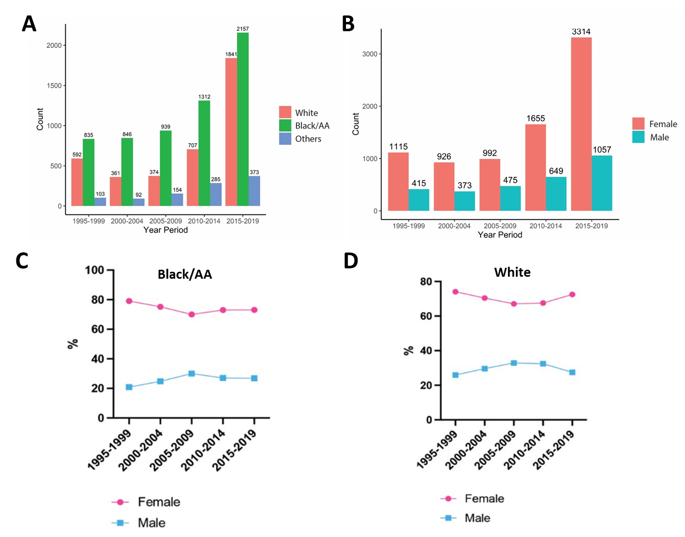
Supplementary Figure S1: (A) Number of patients with HS in 5-year intervals since 1995 stratified by race. (B) The number of female and male patients with HS from our single institution in 5-year intervals since 1995. (C) The proportions of females and males in Black/AA patients. (D) The proportions of females and males in White patients.

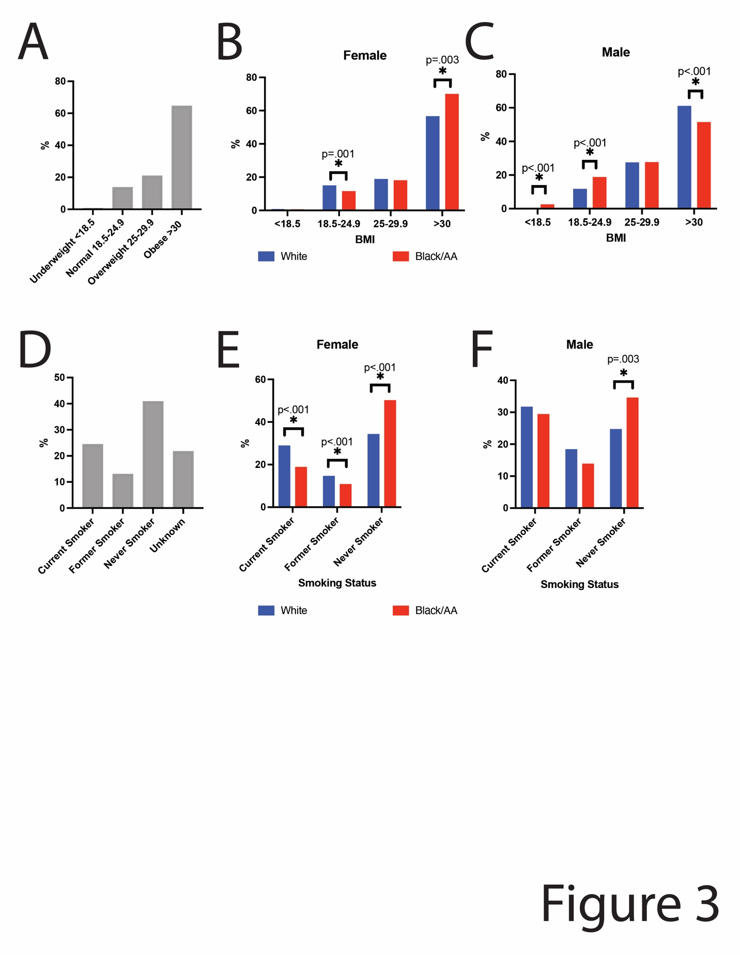
Supplementary Figure S2. Body Mass Index (BMI) and smoking status in a Detroit HS patient population. 20.9% of patients with HS were overweight and 64.6% were obese (A). HS females with normal BMI (18.5-24.9) were more frequently White compared to African American, and females with BMIs in the overweight/obese range (BMI>30) were more frequently Black/AA than White (B). Increased proportions of normal or underweight (BMI<18.5) males were Black/AA compared to White, and increased proportions of obese males were White compared to Black/AA (C). 24.4% of our HS cohort reported that they currently smoke, 13.0% reported they were former smokers, and 40.9% reported that they never smoked (D). Females reporting current or former smoking were more frequently White, and females reporting no prior smoking history were more frequently Black/AA (E). Males reporting no prior smoking history were more frequently Black/AA (F).

Supplementary Table S1: Age at diagnosis of HS by sex and race/ethnicity in 5-Year Periods. A standard deviation (SD) for each mean value is reported.
Period | Mean Female Age  Years (SD) | Mean Male Age  Years (SD) | P value
Black/African American
1995-1999 | 37.1 (13.5) | 41.0 (15.6) | <0.05
2000-2004 | 36.5 (14.5) | 42.4 (15.4) | <0.05
2005-2009 | 36.7 (15.5) | 40.4 (16.7) | <0.05
2010-2014 | 35.4 (15.4) | 40.7 (15.9) | <0.05
2015-2019 | 35.0 (14.8) | 40.4 (15.7) | <0.05
Overall | 35.8 (14.9) | 40.9 (15.9) | <0.05
White
1995-1999 | 38.5 (14.0) | 44.0 (14.0) | <0.05
2000-2004 | 38.3 (14.5) | 43.9 (17.9) | <0.05
2005-2009 | 40.1 (15.9) | 46.9 (16.7) | <0.05
2010-2014 | 37.7 (15.6) | 41.8 (17.1) | <0.05
2015-2019 | 37.8 (15.5) | 42.7 (15.9) | <0.05
Overall | 38.2 (15.2) | 43.3 (16.2) | <0.05
Other
1995-1999 | 35.5 (13.7) | 43.8 (15.2) | <0.05
2000-2004 | 35.5 (14.4) | 42.4 (13.3) | <0.05
2005-2009 | 37.3 (16.5) | 39.3 (16.4) | 0.448
2010-2014 | 35.3 (14.6) | 38.4 (16.7) | 0.117
2015-2019 | 34.0 (13.8) | 34.6 (15.1) | 0.695
Overall | 35.1 (14.4) | 37.9 (15.9) | <0.05

Supplementary Table S2: Comorbidities and Charlson Comorbidity Index (CCI) of patients with HS between 2017 and 2022.

 | Total | Female | Male | White | Black/African American
n | 4,244 | 3,316 | 928 | 1,915 | 2,329
Male (%) | 928 (21.9) |  |  | 448 (23.4) | 480 (20.6)
Myocardial Infarction (%) | 47 (1.1) | 28 (0.8) | 19 (2.0) | 30 (1.6) | 17 (0.7)
Congestive Heart Failure (%) | 90 (2.1) | 56 (1.7) | 34 (3.7) | 38 (2.0) | 52 (2.2)
Peripheral Vascular Disease (%) | 64 (1.5) | 40 (1.2) | 24 (2.6) | 38 (2.0) | 26 (1.1)
Cerebrovascular Disease (%) | 48 (1.1) | 34 (1.0) | 14 (1.5) | 21 (1.1) | 27 (1.2)
Dementia (%) | 8 (0.2) | 4 (0.1) | 4 (0.4) | 5 (0.3) | 3 (0.1)
Chronic Pulmonary Disease (%) | 355 (8.4) | 285 (8.6) | 70 (7.5) | 142 (7.4) | 213 (9.1)
Rheumatic Disease (%) | 50 (1.2) | 45 (1.4) | 5 (0.5) | 18 (0.9) | 32 (1.4)
Peptic Ulcer Disease (%) | 14 (0.3) | 12 (0.4) | 2 (0.2) | 5 (0.3) | 9 (0.4)
Mild Liver Disease (%) | 18 (0.4) | 10 (0.3) | 8 (0.9) | 10 (0.5) | 8 (0.3)
Diabetes with Chronic Complication (%) | 173 (4.1) | 120 (3.6) | 53 (5.7) | 68 (3.6) | 105 (4.5)
Diabetes without Chronic Complication (%) | 454 (10.7) | 343 (10.3) | 111 (12.0) | 203 (10.6) | 251 (10.8)
Hemiplegia or Paraplegia (%) | 11 (0.3) | 6 (0.2) | 5 (0.5) | 6 (0.3) | 5 (0.2)
Renal Disease (%) | 138 (3.3) | 76 (2.3) | 62 (6.7) | 42 (2.2) | 96 (4.1)
Any Malignancy (%) | 71 (1.7) | 56 (1.7) | 15 (1.6) | 38 (2.0) | 33 (1.4)
Moderate or Severe Liver Disease (%) | 6 (0.1) | 4 (0.1) | 2 (0.2) | 3 (0.2) | 3 (0.1)
Metastatic Solid Tumor (%) | 18 (0.4) | 11 (0.3) | 7 (0.8) | 11 (0.6) | 7 (0.3)
CCI Score ≥ 4 (%) | 153 (3.6) | 95 (2.9) | 58 (6.2) | 59 (3.1) | 94 (4.0)
CCI Score (mean (SD)) | 0.45 (1.18) | 0.40 (1.09) | 0.60 (1.46) | 0.43 (1.20) | 0.46 (1.17)

