Vulcanization, interfacial interaction, and dynamic mechanical properties of *in-situ* organic amino modified kaolinite/SBR nanocomposites based on latex compounding method

Yongjie Yang a, Hao Zhang a, Kenan Zhang a, Lihui Liu a, Leibo Ji b, Qinfu Liu a[1]*,

aSchool of Geoscience and Surveying Engineering, China University of Mining and Technology, Beijing, 100083, China

b Zaozhuang Sanxing Advanced Materials Co., Ltd., Zaozhuang, China

* Corresponding author

Email: [lqf@cumtb.edu.cn](mailto:lqf@cumtb.edu.cn)

**Abstract:** With the help of soluble amino modifiers, thevulcanization delay of kaolinite/SBR composites is investigated to shorten the optimum curing time of the filled rubber system based on the latex compounding method (LCM). Compared to the traditional dry blending method, the LCM had better kaolinite dispersion in the rubber matrix. The two different amino modifiers, i.e., quaternary ammonium salt ((CH3)3-N-CH2-) and amino silane (H2N–(CH2)2–NH–(CH2)2–NH–(CH2)3–) were selected in the *in-situ* modification through two different routes: physical adsorption and chemical bonding. The Moving Die Rheometer revealed that the curing process with the amino group could accelerate the crosslinking reaction, and the kaolinite grafted KH892 nanocomposite showed the best vulcanization performance. An improvement in the curing rate and mechanical properties of kaolinite/SBR composite is ascribed to the outstanding distribution and chemical bonding of nanokaolinite lamellae in the vulcanizate. Furthermore, SEM, HR-TEM, and DMA results demonstrated that both the dispersion of kaolinite in the vulcanizate and the wet skid resistance of the kaolinite/SBR hybrid materials are superior to the composite made by the dry blending method.

**Keywords:** kaolinite, in-situ modification, amino group, vulcanization delay, latex compounding method

1. **Introduction**

Carbon black (Yeoh, 1990) and silica (Wang et al., 2013) are the reinforcement fillers traditionally employed in the rubber industry. However, their synthesis process demands a significant amount of energy and causes specific environmental problems (Wu et al., 2016). As the most abundant naturally occurring mineral, kaolinite is being widely used in polymers as the substitutes of carbon and silica, which can significantly save the cost and efficiently reduce the pollution (Liu et al., 2008; Zhang et al., 2015b). Moreover, the main differences between nano-tubular (Kamalieva et al., 2018; Mohanty et al., 2017) and spherical fillers like silica and carbon black is the high aspect ratio, which can generate good thermal and gas resistance. Therefore, the kaolinite served as a potential replacement for carbon black and silica in the gas barrier and thermal resistance rubber industry. A conventional dry blending method is commonly used to add kaolinite powder directly into the rubber while mixing. Nevertheless, this method is more or less plagued by the issues of dispersion and dust (Zhang et al., 2015b). The general performance of kaolinite/SBR composite is significantly affected by the dispersion state and aggregate size of kaolinite in the rubber matrix. A uniformly dispersion state at the nanoscale leads to excellent performance (Stephen et al., 2006; Zhang et al., 2015a). However, the clustering of filler in the composites usually generates stress concentration points, causing inferior macroscopic characteristics, such as the dynamic and static mechanical performances (Hamed, 2000).

Latex compounding method (LCM) was employed to improve the dispersion of the fillers in the rubber matrix (Karger-Kocsis, 2005; Varghese, 2004a; Wu et al., 2005; Zhang et al., 2011; Zhang et al., 2014a). It has been applied to obtain montmorillonite/rubber composite (Zha et al., 2014), silica/rubber composite (Gui et al., 2016), and nanotube/rubber composite (Peng et al., 2010). Other materials such as graphene (Xing et al., 2014) or starch (Wu et al., 2006) were also loaded in the rubber composite to acquire high-performance vulcanizates through this method.

Many pristine clay/rubber vulcanizates obtained by LCM exhibit several disadvantages. For example, the modulus of the composite at large deformation (e.g., modulus at 300%) displays a small value (Wu et al., 2005). It suggests that the crosslink density remains at a relatively low degree, resulting in a weak interaction between rubber and filler, which reduces potential industrial applications. Furthermore, few drawbacks such as high polarity, poor compatibility (Gui et al., 2016), and vulcanization delay (Du et al., 2008; Monti et al., 2011) were noted in the nonpolar rubber owing to the active Al-OH groups on the surface of kaolinite. To surmount these disadvantages, a variety of organic modifiers have been investigated to improve the interfacial interaction (Johansson, 1999; Zhang et al., 2012). On the other hand, previous investigations were mainly focused on the properties of gas barrier (Zhang et al., 2010; Zhang et al., 2015b) and thermal stability (Zhang et al., 2014a; Zhang et al., 2014c; Zhang et al., 2014d) of the silane-modified kaolinite/rubber composites, reduced vulcanization, along with viscoelasticity performances.

More recently research on organic modifier on kaolinite has been used in many promising applications, such as intercalation-assisted exfoliation and energy conversion in nanofluidic channels. Jia et al. (2019) prepared methoxy-grafted kaolinite *via* acid treatment and heating method, which dramatically shortened the preparation time from 7d to less than 1h. Zhou et al. (2019) prepared 2D nanochannels with prominent surface charge-governed ion transport behaviors. The reconstructed 2D nanomaterial was modified on few-layered kaolinite nanosheets by using Si-69.

In this study, amino modifiers were used to carry out *in-situ* organic modification directly on kaolinite in the water phase before compounding with styrene-butadiene rubber (SBR) matrix, and then the curing and dynamic mechanical characteristics of the composite were examined. The type and structure of organic amino modifiers have dramatic effects on the reinforcement of the kaolinite/SBR composites. Besides, it is well documented that the existence of the amino group is in favor of the vulcanization of clay/rubber composites (Ismail, 1995). For example, the oil-soluble (3-aminopropyl) trimethoxysilane (KH550) is the most commonly used amino organic modifier for the modification of kaolinite (Chen et al., 2016). However, it is not acceptable for the LCM, since it is incompatible with kaolinite in the aqueous system. Therefore, the soluble quaternary ammonium salt, CTAC, and super softener KH892 were selected as the modifiers. The modifiers can neutralize the Lewis/Brønsted acid (Chrysikopoulos and Syngouna, 2012; Flessner et al., 2001; Van Oss, 1993) on the surface of the kaolinite, improve the vulcanization delay problem, yield a composite with better mechanical and viscoelasticity behaviours. Additionally, the pre-dispersion masterbatches with modified kaolinite as additives can be prepared for other polymers to make environmentally friendly materials.

1. **Experimental**
   1. **Materials**

SBR latex 1502 and ESBR 1502 were manufactured by Qilu Petrochemical Co., Ltd., and the properties were shown in **Table 1**. Kaolinite was provided by Zaozhuang Sanxing Advanced Materials Co., Ltd., the chemical constitution is SiO2 49.92%, Al2O3 31.29%, TiO2 1.79%, Fe2O3 1.15%, P2O5 0.16%, K2O 0.13%, CaO 0.09%, MgO 0.09%, and MnO less than 0.01%. The 3-[2-(2-aminoethyl-amino)ethylamino]propyl-trimethoxy-silane (KH892) was obtained from Hangzhou Jessica Chemical Co., Ltd., and cetyltrimethylammonium chloride (CTAC) was available from Sinopharm Chemical Reagent Co., Ltd. All other materials were also commercially available in China.

* 1. **Preparation of the suspension of exfoliated kaolinite**

Kaolinite (solid content: 20%) was dispersed in water with a specific amount of sodium polyacrylate to obtain a slurry. The above kaolinite slurry was vigorously stirred at 2000 rpm for 1 h, and the pH was adjusted to 10 by using a sodium hydroxide solution. Using the siphon method, extraction to another container was then followed after settling for 8 h, and the solid content of the suspension was measured immediately. At the end of this process, the water-soluble organic modifier diluent (CTAC or KH892) was slowly dropped into the exfoliated kaolinite slurry, and the resultant is referred to as, g-CTAC or g-KH892, correspondingly. Then, the suspension was stirred for 1 h. The mass ratio of the modifier to kaolinite was 5 (e.g., 5 g of KH892 for every 100 g of kaolinite particles). Finally, the *in-situ* organic modified kaolinite suspension was prepared. For comparison purposes, unmodified kaolinite slurry and oven-dried nanoparticle were also prepared. The particle size distribution of kaolinite was tested using a laser particle size analyzer (Mastersizer 2000, Malvern, USA), and the test condition was using ultrasound for 1 min in the cycle injection mode (Zhang et al., 2014b). The particle sizes related to the cumulative size distribution percentage were D10 = 0.349 μm, D50 = 1.260 μm, and D90 = 3.172 μm.

* 1. **Preparation of kaolinite/SBR masterbatches**

SBR latex was added into the kaolinite slurry and stirred at 600 rpm for 1 h. The mass ratio of kaolinite to SBR was 1:2 (e.g., 50 g of kaolinite particles for every 100 g of SBR). Then, the mixed slurry was flocculated by employing 0.5 wt% H2SO4 solution with a peristaltic pump at a flow rate of 10 ml/min until no more sediments were formed. Eventually, the compounds were washed with distilled water several times until the pH reached 7, and then dried in an oven at 60 ℃ for 24 h to obtain the kaolinite/SBR compounds. **Fig. 1** presents the schematic diagram demonstrating the modification and the latex co-coagulating processes.

* 1. **Preparation of kaolinite/SBR composites**

**Table 2** lists the recipe used for kaolinite/SBR compounds. The masterbatch was masticated through a laboratory two-roll open mill (Wuxi No.1 Rubber & Plastics Mechanical Co., Ltd. China). Then, the ingredients of vulcanization and other additives were added to the masterbatch one by one. The whole process was controlled in 15 min. For comparison purposes, the dry composites were also prepared. Notably, the unmodified oven-dried kaolinite powder was added directly with ESBR on the open mill, and the procedure followed for the processing was the same as above.

The composite was obtained using a 350 mm × 350 mm 25TQLB electrothermal press vulcanizer (Wuxi No.1 Rubber & Plastics Mechanical Co., Ltd. China). The determine the mechanical properties, the test specimens with a thickness of 2 mm were prepared in a vulcanizate mold at 150 ℃ to obtain kaolinite/SBR composites.

* 1. **Characterizations**

XRD patterns were recorded using an X-ray diffractometer (Rigaku D/max-2000, Japan) with Cu Kα radiation operated at 40 kV and 150 mA.

The curing characteristics of kaolinite/SBR compound were measured by an M2000 moving die rheometer (Gotech Testing Machines Inc, China). The time of optimal cure (t90) and scorching (t10) of the composites were examined at 150℃.

The kaolinite dispersion state in the SBR matrix was studied with a scanning electron microscope (SEM; Hitachi SU8020, Japan) at an accelerator voltage of 20kV. The brittle fractured surfaces were sputtered with a thin layer of platinum in an SPI sputter coater.

The morphologies of kaolinite dispersion were also recorded by a high-resolution transmission electron microscopy (HR-TEM; JEM2100, Japan), with an accelerating voltage of 200 kV. A microtome cut the ultrathin sections at -100℃ and the slices were put on copper grids.

FTIR spectra of kaolinite samples were recorded on a Nicolet 6700 (Thermofisher，USA) at a resolution of 4 cm-1 in the range of 4000-400cm-1 in KBr pellet form (2mg sample in 300mg KBr).

The static mechanical performance of the vulcanizates was examined through an A1-7000GD electrical tensile tester (Gotech Testing Machines Inc, China) at a crosshead speed of 500mm/min. The tensile and tear test method was based on the standard of ASTM D412 (Method A) and ASTM D624, respectively. Shore A Durometer hardness was tested based on the standard of ASTM D2240.

The dynamic thermomechanical performance of the composites was analyzed by a DMA50 (01 Db-Metravib, France). First, the dynamic rheological properties were measured in the strain sweep mode at 10Hz. The strain amplitude was changed from 0.1% to 100% with the test temperature of 60℃. Second, tension mode at 10Hz was selected to measure the viscoelastic performance. With a heat rate of 2℃/min, the test temperature was changed from -80℃ to 80℃ at the value of 0.25% of dynamic strain.

1. **Results and discussion**
   1. **TEM and XRD analysis of kaolinite**

The pristine kaolinite clearly showed the euhedral, typical pseudo-hexagonal morphology, consisting of multilamellar arrangements as shown in Fig. 2.

Most peaks in the XRD pattern (Fig. 3) can be assigned to kaolinite except one weak peak, indicated with solid black circle, which is assigned to quartz. The raw kaolinite showed a characteristic (001) reflection with 0.72 nm basal spacing.

* 1. **Spectroscopic analysis of Kaolinite**

FTIR spectra of the obtained kaolinite samples are shown in **Fig. 4**. The characteristic bands at 3691 cm-1, 3650 cm-1, and 3622 cm-1 could be noted, which are ascribed to the inner-surface and inner -OH stretching vibrations of pristine kaolinite. The other bands at 1115 cm-1, 1029 cm-1, 1004 cm-1,and 746 cm-1 are due to the stretching vibration of Si-O (Castellano et al., 2010; Madejova, 2003; Zhang et al., 2015a).

After treatment with quaternary ammonium salts, the CTAC modified kaolinite shows peaks at 2918 cm-1 and 2845 cm-1, which are assigned to the stretching vibration of -CH2 and the peak at 1458 cm-1 is due to the deformation vibration of -CH2 (Zhang et al., 2016). These three bands observed are similar to those noted in the g-KH892 sample but were weaker. The bands at 2960 cm-1 and 1375 cm-1 are related to the -CH3 group. Furthermore, the band at 722 cm-1 is assigned to the -CH2 group (out of plain swing) indicates that the existence of a long-chain alkyl group. However, no band shift was observed, implying that the adsorption of CTAC on the kaolinite surface is mainly dominated by physical adsorption due to electrostatic attraction.

The spectrum of KH892 modified kaolinite clearly shows the presence of -NH2 group, which is reflected by the two rather small peaks at 3303 cm-1 and 1638 cm-1. Three weak vibration bands noted at 3070 cm-1, 1540 cm-1, and 1262 cm-1 are assigned to the vibration of the N-H group. Also, the broad band at 1094 cm-1 with a broad shoulder at 1203 cm-1 is attributed to the vibration of siloxane (SiO)n groups (Zhang et al., 2015b). The new band appearing at 963 cm-1 overlaps with the bending vibration of Si-O of kaolinite is due to the stretching of Si-OH. Another new band noticed at 698 cm-1 is attributed to the CH2 rocking vibration of Si-CH2R (Bois et al., 2003). These results demonstrate that KH892 has been successfully immobilized on the surface of kaolinite lamellae through chemical covalent bonds, which is favorable to form polymerized networks in the filled rubber system.

The FTIR results demonstrate that the absorption intensities of the groups represented by chemical bonding are stronger than physical adsorption, which means that the interfacial interaction between the KH892 and the kaolinite surface is much stronger than physical adsorption between CTAC and kaolinite particles (Johansson, 1999).

* 1. **Vulcanization characteristics of kaolinite/SBR compounds**

Curing is a fundamental process for rubber products, and the modulus increases rapidly during vulcanization. **Fig. 5** and **Table 3** show the curing features of kaolinite/SBR compounds. It is evident that for the two unmodified kaolinite/SBR compounds, the occurrence of vulcanization is delayed. The dried compounds have the slowest vulcanization rate since large aggregation can prevent heat from flowing inwards. It could be noted that the T90 of the wet compounds is slightly longer than the dry compounds. This phenomenon is probably due to the increased number of Lewis sites (Flessner et al., 2001) on the surface with a better dispersion compared to the dry compounds. Also, due to the increased Lewis sites on the surface, the T90 of the wet compounds is slightly longer than the dried sample (Hertz, 1984).

g-KH892 exhibited the highest maximum torque and the lowest minimum torque, indicating the formation of the most robust filler network. The maximum torque of the g-KH892 compounds reached quickly and remained constant, which results in the shortest T90 and the highest MH-ML compared to g-CTAC compounds. After curing, the chemical crosslinking point between kaolinite and macromolecule is formed, and an excellent dispersion of grafted kaolinite in the unvulcanized compound could be noted in the composites. **Fig. 5** shows that the amino organic modifiers, CTAC, and KH892 could accelerate the occurrence of the curing process, confirming that the amino could vulcanize kaolinite (Ismail, 1995).

T90 and T10 of the amino-modified kaolinite/SBR hybrid are shorter than those of the unmodified composites, indicating that amino-modified kaolinite acts as an efficient ingredient of accelerant for the SBR composite, which is consistent with earlier reports (Kim et al., 2007; Varghese et al., 2003; Varghese, 2004b). The ammonium groups in the modified kaolinite could participate in the process of the curing reaction of Zn complex and sulphur and contribute to the completion of crosslinking further (Dirksen, 2001; Nieuwenhuizen, 1998; Reyneke-Barnard, 2000). The crosslink density of kaolinite/SBR composite is a valuable factor for investigating their characteristics.

The volume V*S* of the rubber component in the swollen composite sample can be calculated from equation (1):

$V_{s}=\frac{{(W-FW_{0})}/{ρ_{r}}}{{(W-FW_{0})}/{ρ_{s}}+{A_{0}}/{ρ_{s}}}$ (1)

Where V*s* is the molar volum of the solvent toluene (106.35cm3/mol), F is the mass fraction of the insoluble component in the composite, and A*0* is the mass of solvent absorbed by the composite sample. Besides, ρ*r* is the density of the SBR (0.933g/cm3), and ρ*s* is the solvent density (toluene, 0.867g/cm3). In this study, the kaolinite loading is 50 phr, as a result F=33.33%.

The molecular weight between crosslinking (M*c*) was valued from the equilibrium swelling date by employing the Flory-Rehner equation:

Mc  (2)

Where φp is the volume fraction of the polymer in the swollen state. The value of φp was calculated by the following equation:

$φ_{p}={[1+\frac{ρ_{p}w_{2}}{ρ_{s}w_{1}}-\frac{ρ_{p}}{ρ_{s}}]}^{-1}$ (3)

Where W1 is the initial weight of the in the composite, W2 is the weight of swollen composite. After calculating, the Flory–Huggins interaction parameter χ used was 0.446 for SBR-toluene systems. The crosslink density (V*c*) was calculated by the following equation:

$V_{c}=1/{M_{c}}$ (4)

The crosslinking density is calculated for the kaolinite/rubber composites, as shown in **Table 4**. The crosslink density of the composites treated by animo modifiers is increased compare to untreated kaolinite/rubber composites. Therefore, the composites without amino groups showed a lower crosslink density than the treated ones due to the lack of cure accelerator, which can easily adsorpted onto the kaolinite surfaces.

Cure rate index (CRI), which is a measure of the rate of the cure reaction (Aprem et al, 2003), **Table 3** reveals that g-KH892 composites possesses the highest CRI. Therefore, the higher the content of the related ammonium groups, the greater the possibility of the formation of ammonium-Zn-sulphur complex in the composites. Correspondingly, the curing rate and the value of MH-ML are anticipated to be faster and larger, respectively. In comparison, an *in-situ* modification with a multi-amino group could reduce the time of vulcanization as well as cost.

* 1. **Micromorphology of the kaolinite/SBR composites**

To examine the dispersion and particle size of kaolinite in the rubber matrix, the brittle fracture surfaces were analyzed through SEM and TEM. In SEM images the black portion denotes the rubber matrix, and the bright parts indicate the presence of dispersed kaolinite nanoparticles, as shown in **Fig. 6(a-d)**. While in TEM images, the black of gray lamellas denotes the kaolinite particles, and the light color portion indicates the rubber matrix, as shown in **Fig. 6(a’-d’)**.

**Fig. 6a,a’** shows the presence of a large amount of kaolinite lamelle with a thickness of about 50-300 nm and dispersed in large clusters, indicating that the composites obtained by the traditional dry blending method show a large filler network structure. Relatively it becomes difficult for the large agglomerates to participate in the crosslinking reaction with rubber molecules. However, for the composites obtained by LCM, the distribution of kaolinite lamella is improved, and the cluster size becomes smaller in the matrix without any reagglomeration (**Fig. 6b,b’**). Compared with the traditional dry blending method, with LCM, it is easier to obtain a more homogeneous kaolinite dispersion. In **Fig. 6c,c’**, the dispersion of g-CTAC kaolinite in the matrix is better than the unmodified wet sample, as well as the smaller size of the cluster. It indicates that the modifier CTAC can improve the dispersion and reducing agglomeration. For g-KH892 kaolinite/SBR nanocomposites, an *in-situ* modification with amino silane could improve the kaolinite distribution significantly, and most of the laminates with a thickness of 5-30 nm are the most homogeneously dispersed in the matrix (**Fig. 6d,d’**).

As shown in **Fig. 6d**, the finer silane-grafted particles were embedded in the composites (**Fig. 6d**). In the case of dried and wet composites, the interaction between unmodified kaolinite lamella and vulcanizates was inconspicuous, since the laminar kaolinite emerges clean with rubber adhesion scarcely (Wang et al., 2013). It shows that KH892 grafted on the surface of lamella enhances the affinity between kaolinite and macromolecule, which promotes the distribution of kaolinite further. Moreover, as compared with the physical adsorption of CTAC modified kaolinite (**Fig. 4c**), g-KH892 (**Fig. 6d**) grafted the kaolinite surface with the strongest interfacial interaction has a rough surface and form rod-like particles with the rubber chains attached to the kaolinite lamellae. The bound rubber macromolecules of g-KH892 on the kaolinite surface found to have more freedom of movement.

* 1. **Effect of organic modifiers on the performance of kaolinite/SBR composites**

CTAC, as a cationic surfactant, is extensively used in montmorillonite (Atkin et al., 2003; Fu et al., 2016). There is little doubt that CTAC have tremendous application potential in montmorillonite both as organic modification and formation of inserted layer structure. The cationic surfacant (CTAC) dissloved into Cl- and CTAC+ in the dispersion system, and then CTAC+ could be inserted into the interlayer space through ion exchange. However, the use of CTAC modification for kaolinite following different mechanism because of absense of exchangeable interlayer ions. When the kaolinite is exfoliated in the alkaline slurry, the end face and surface (tetrahedron layer and octahedron layer) will be negatively charged (Gupta et al., 2011). After the dissolution of CTAC in the kaolinite slurry, according to the FTIR results aformentioned, the positively charged NH4+ at the end of the alkyl chain can be absorbed onto the negatively charged surface of the exfoliated kaolinite. A weak connection exists between the layered kaolinite and rubber matrix after coagulation. Then the amino group will acclerate the curing process when the kaolinite/SBR composite initiated by heat, and as a consequence the composite is stiffened. The CTAC modified kaolinite will act as physical crosslinks, preventing chain slippage when the composite subjected to exteral stress.

Kaolinite possesses abundant active Al-OH groups in the (001) plane, which are very helpful to achieve the modification of kaolinite. Polymer chains or small molecules can be easily grafted onto the (001) plane *via* chemical reactions. The silanes generally form -Si-OH groups after hydrolysis, which will occasionally linking the Al-OH of the kaolinite surface. KH892 is frequently used as a silicone softener in the chemical industry (Bois et al., 2003; Piper-Feldkamp et al., 2013). In this study, after hydrolysis of silanol, the chemical bonding due to the interfacial interaction between KH892 and kaolinite could be stronger. Theoligomerization of KH892 in the kaolinite suspension is another factor that should be considered. It hydrolyzes to silanol oligomers and forms chemical bonding on the surface of kaolinite. Consequently, it might result in the grafted quantity being much higher than the content of active hydroxyl groups on the surface of kaolinite. However, the -NH and -OC2H5 of KH892 can chemically bonded with SBR macromolecules through participating in a complex curing reaction. Two types of combined structures were obtained after the reaction between KH892 and kaolinite. **Fig. 7a** exhibits KH892 oligomers linking two singular kaolinite lamellae to form an attached kaolinite stack. **Fig. 7b** presents a silane oligomer that forms chemical bonds on the surface of kaolinite. When the composite is subjected to stress, the elastic grafted oligomers will soften the abrupt deformation between kaolinite and rubber matrix. Consequently, the KH892 modified kaolinite will reinforce the rubber through the increased compatibility between the two phases.

* 1. **Static mechanical performances of the kaolinite/SBR composites**

The mechanical properties strongly depend on the morphology and structure of the filler. The kaolinite structure is one of the high aspect ratio particles with in the matrix. (Hussain, Farzana, et al., 2006). The kaolinite structure in the composite is either (a) exfoliated layer sheets of nanometer level thickness with less aggregates or (b) stacked kaolinite layer sheets were separated from one another by intercalating agents (e.g. DMSO, KAc). **Table 5** exhibits the results of static mechanical performances of kaolinite/SBR composites. It could be noted that the main static mechanical performances of wet vulcanizates are slightly higher, while the tension set and elongation at break are lower than those of dry vulcanizates. The mechanical properties of the g-CTAC composite were slightly improved compared to the wet composite as there were weak interactions caused by the physical adsorption of static electricity. The tensile strength and modulus at 300% are 11.12 and 2.47 MPa, respectively, which are about 108% and 115% higher than those of wet composites. Unlike g-CTAC nanocomposite, the chemically grafted g-KH892 composites demonstrated significantly increased mechanical properties. The tensile strength and modulus at 300% of the g-KH892 composites were dramatically enhanced to 15.54 and 5.60 MPa, respectively. They were 153% and 260% higher than those obtained from wet composites.

Due to the laminar morphology and high aspect ratio of kaolinite, it could stop crack propagation across the layer and increase the toughness of the composite, result in the high tear resistance of the hybrid composites. Besides, the abundant interfacial adhension is desirable because the strong interface would soften the abrupt changes of stress between the two phases. In the case of tear resistance and shore A hardness, the g-KH892 composites are superior to the other three. It indicates that KH892 is more effective than CTAC in improving the crosslinking between kaolinite particles and rubber chains, which is consistent with the observed results from FTIR. However, due to an increase in the crosslink density, the elongation at break decreases for the g-KH892 composites.

The interfacial bonding strength is the dominant factor of the reinforcement in the filler system under the same structure and particle size of kaolinite fillers. Therefore, the static mechanical properties confirmed that the *in-situ* organic modification of KH892 exhibits outstanding performance.

* 1. **Dynamic** **rheological properties of the kaolinite/SBR composites**

The storage modulus is a prominent parameter influencing the properties of rubber. The variations in the shear modulus (G`) of the kaolinite/SBR composites concerning strain amplitude were examined to investigate the aggregated structure of kaolinite, as presented in **Fig. 8a**. It shows the same trend of a decrease in G` with an increase in the strain amplitude for these four composites. It indicates that the destruction of the filler network when the composite was subjected to external sinusoidal alternating forces.

Unmodified kaolinite particles are generally regarded as “inert” filler which results from their incompatibility in the rubber matrix, where only a hydrodynamic effect exists, as predicted by the Van der Poel’s theory (Van der Poel, 1958), indicating the weak linkages between rubber and kaolinite particles. Therefore, large aggregates are separated in the first-place under small deformation, which leads to a rapid drop-off in the storage modulus in the case of dry composites, as illustrated in **Fig. 8a**. However, the difference between wet and dry composites is due to the degree of dispersion. Payne effect can be considered as the filler-filler interactions which occur at small strain. The main characteristic is indeed a substantial decrease in the storage modulus of a particle-reinforced elastomer with an increase in the amplitude of mechanical oscillations. The lower Payne effect accounts for the weak network for kaolinite loaded hybrid system, simultaneously, it implies that a peculiar and homogeneous network structure was formed. The results demonstrate that the better the dispersion, the lower Payne effect. As for the organically modified g-KH892 and g-CTAC composites, the amount of graft is an essential factor influencing the storage modulus. The value of G` of the two modified SBR-kaolinite composites is KH892 > CTAC.

Compared with **Fig. 8a**, the value of tanδ of all the composites is reversed in **Fig. 8b**. Tanδ relies on the elasticity of the kaolinite loaded rubber composites. It is widely accepted that the higher the elasticity, the lower the tanδ (Das et al., 2008). Low tanδ indicates that the material has superior interfacial interaction. Therefore, the interfacial interaction between these two vulcanizates has been investigated. Typically, the plate-like surface interaction is the primary site in contrast with the edge interaction, since the surface area is much larger than the edge area. Moreover, based on the above results of FTIR spectra, CTAC molecules are attached to the surface of kaolinite through electrostatic adsorption, and the alkyl chains interact only with rubber molecules even after curing. Consequently, the interfacial strength of g-CTAC composites is not strong enough as compared to g-KH892 composites, leading to the interface slipping in the tensile process and high hysteresis loss through dynamic deformation. However, the three Si-OH groups of KH892 hydrolysate are more likely to attach with the chains of rubber molecules by participating in the intricate vulcanization process. Therefore, the surface of exfoliated kaolinite serves as the crosslinking reaction site, which increases the modulus of the heterogeneous composites further and prominently decreases the interfacial hysteresis.

Compared to unmodified wet and dry composites, these two organic modified composites have a lower Payne effect. It implies the formation of a peculiar and homogeneous network structure.

**3.8 Viscoelastic properties of the kaolinite/SBR composites**

The effect of temperature on the loss factor (tanδ) distribution is presented in **Fig. 9**. As it could be seen that the kaolinite/SBR composites undergo three-phase transition stages: solid phase (-80 ℃ ~ -60 ℃), glass phase (-60 ℃ ~ -20 ℃), and rubber phase (-20 ℃~ 80 ℃). In the solid phase, the molecular chains freeze and hence become not able to move, which leads to a small change in the values of tanδ. While in the glass phase, the molecule begins to regain elasticity with an increase in temperature, and the existence of nanoscopic kaolinite causes blocking the molecular segment. As a result, tanδ increases sharply. It is apparent that the value of tanδ at Tg of the SBR-kaolinite composites follows the order: dry> wet > g-CTAC> g-KH892. However, with an increase in the crosslink density, the Tg slightly moves towards the high-temperature region, which is ascribed to the decline in the flexibility of the molecular chain, further supporting an increase in the interfacial interaction of the organic modifier.

When the temperature exceeds Tg, the molecule completely restored to elasticity, signifying the turning of the composites into the rubber phase. The layered kaolinite slowly oriented due to stretching, leading to a gradual decrease in the values of tanδ. The tanδ at 0 ℃ is generally considered as the wet-skid resistance of the nanocomposite, which reflects the high-frequency feature of the dynamic strain. The hysteresis loss of the tread rubber, characterized by tanδ at 60 ℃ is an important parameter related to the rolling resistance of tires. High-performance rubber composites should have both a high tanδ at 0 ℃ and a low tanδ at 60 ℃. As shown in **Fig. 9** and **Table 6**, the LCM is favorable to improve the hysteresis loss compared to the dry composites, and the *in-situ* organic modified kaolinite could enhance the tanδ at 0 ℃ further. However, it is the opposite of tanδ at 60 ℃. The g-KH892 composites have the highest tanδ at 0 ℃ and 60 ℃, indicating that the g-KH892 composites have the best wet-skid resistance but the worst rolling resistance. These results demonstrate that increasing the interfacial interaction could enhance wet traction but are not beneficial for the rolling and cold resistance of the kaolinite/SBR composites.

1. **Conclusion**

In this investigation, a method of *in-situ* modification of kaolinite based on LCM has been proposed. It is an environmentally friendly and easy to operate fabrication technique. In this, two different organic amino modifiers were successfully grafted on the surface of kaolinite, which was confirmed through infrared spectra. The presence of the amino group could neutralize Lewis acid sites of the kaolinite surface, which effectively accelerates the vulcanization, resulting in a decrease in the T10 and T90 of the vulcanizates. These two modifiers can significantly enhance the dispersion state of kaolinite during the preparation process of kaolinite/SBR masterbatches. The KH892 grafted kaolinite forms a covalent interfacial interaction which exhibits the highest mechanical performance. The chemical grafted surface of the lamella can bond to the macromolecular chains of rubber in two dimensions, and the thickness of the kaolinite lamella reaches dozens of nanometers, giving the g-KH892 composites a better tensile performance. The KH892 silane with three Si−OH groups can solidify with more than one hydroxyl group on the surface of kaolinite, which provides the feasibility to construct chemical bonds between kaolinite lamellae and benefit the dispersion of kaolinite further. Based on the outcome, it is believed that this method is assumed to be useful for other clay minerals.

**Acknowledgments**

The authors gratefully acknowledge the financial support of Science and Technology Major Projects of Shanxi Province of China (Project Number: 20181101003). Authors also thank the technical support of Zaozhuang Sanxing Advanced Materials Co., Ltd and Xuzhou College of Industrial Technology.

**References**

Aprem A S, Jose S, Thomas S, et al. 2003. Influence of hygrothermally degraded polyester-urethane on physical and mechanical properties of chloroprene rubber. European polymer journal 39, 69-76.

Atkin, R., Craig, V.S.J., Wanless, E.J., Biggs, S., 2003. Mechanism of cationic surfactant adsorption at the solid–aqueous interface. Adv Colloid Interfac 103, 219-304.

Bois, L., Bonhommé, A., Ribes, A., Pais, B., Raffin, G., Tessier, F., 2003. Functionalized silica for heavy metal ions adsorption. Colloids and Surfaces A: Physicochemical and Engineering Aspects 221, 221-230.

Castellano, M., Turturro, A., Riani, P., Montanari, T., Finocchio, E., Ramis, G.B., G., 2010. Bulk and surface properties of commercial kaolins. Applied Clay Science 48, 446-454.

Chen, S., Lu, X., Wang, T., Zhang, Z., 2016. Preparation and characterization of urea-formaldehyde resin/reactive kaolinite composites. Particuology 24, 203-209.

Chrysikopoulos, C.V., Syngouna, V.I., 2012. Attachment of bacteriophages MS2 and PhiX174 onto kaolinite and montmorillonite: extended-DLVO interactions. Colloids Surf B Biointerfaces 92, 74-83.

Das, A., Costa, F.R., Wagenknecht, U., Heinrich, G., 2008. Nanocomposites based on chloroprene rubber: Effect of chemical nature and organic modification of nanoclay on the vulcanizate properties. European Polymer Journal 44, 3456-3465.

Dirksen A, N.P.J., Hoogenraad M, et al, 2001. New mechanism for the reaction of amines with zinc dithiocarbamates. Journal of applied polymer science 79, 1074-1083.

Du, M., Guo, B., Lei, Y., Liu, M., Jia, D., 2008. Carboxylated butadiene–styrene rubber/halloysite nanotube nanocomposites: Interfacial interaction and performance. Polymer 49, 4871-4876.

Flessner, U., Jones, D., Roziere, J., Zajac, J., Storaro, L., Lenarda, M., Pavan, M., Jiménez-López, A., Rodrıguez-Castellón, E., Trombetta, M., 2001. A study of the surface acidity of acid-treated montmorillonite clay catalysts. Journal of Molecular Catalysis A: Chemical 168, 247-256.

Fu, M., Zhang, Z., Wu, L., Zhuang, G., Zhang, S., Yuan, J., Liao, L., 2016. Investigation on the co-modification process of montmorillonite by anionic and cationic surfactants. Applied Clay Science 132-133, 694-701.

Gui, Y., Zheng, J.C., Ye, X., Han, D.L., Xi, M.M., Zhang, L.Q., 2016. Preparation and performance of silica/SBR masterbatches with high silica loading by latex compounding method. Composites Part B-Engineering 85, 130-139.

Gupta V, Hampton M A, Stokes J R, et al., 2011. Particle interactions in kaolinite suspensions and corresponding aggregate structures. Journal of Colloid and Interface Science 359, 95-103.

Hamed, G.R., 2000. Reinforcement of rubber. Rubber chemistry and technology 73, 524-533.

Hertz, D.L., 1984. Theory and Practice of vulcanization. Elastomerics 116, 17-21.

Hussain F, Hojjati M, Okamoto M, et al. 2006 Polymer-matrix nanocomposites, processing, manufacturing, and application: an overview. Journal of composite materials, 40, 1511-1575.

Ismail H, F.P.K., Sutherland I, et al, 1995. Effects of multifunctional additive on mechanical properties of silica filled natural rubber compound. European polymer journal 31, 1109-1117.

Jia X, Cheng H, Zhou Y, et al., 2019. Time-efficient preparation and mechanism of methoxy-grafted kaolinite via acid treatment and heating. Applied Clay Science 174, 170-177.

Johansson U, H.A., Forsling W, et al. , 1999. Adsorption of silane coupling agents onto kaolinite surfaces. Clay Minerals 34, 239-246.

Kamalieva R F, Ishmukhametov I R, Batasheva S N, et al., 2018. Uptake of halloysite clay nanotubes by human cells: Colourimetric viability tests and microscopy study. Nano-Structures & Nano-Objects 15, 54-60.

Kim, M.-S., Kim, G.-H., Chowdhury, S.R., 2007. Polybutadiene rubber/organoclay nanocomposites: Effect of organoclay with various modifier concentrations on the vulcanization behavior and mechanical properties. Polymer Engineering & Science 47, 308-313.

Liu, Q., Zhang, Y., Xu, H., 2008. Properties of vulcanized rubber nanocomposites filled with nanokaolin and precipitated silica. Applied Clay Science 42, 232-237.

Madejova, J., 2003. FTIR techniques in clay mineral studies. Vib Spectrosc 31, 1-10.

Mohanty F, K Swain S. 2017. Carbon Nanotube Embedded Polymer Composite: Properties and Applications. Current Organic Synthesis 14, 249-262.

Monti, M., Puglia, D., Natali, M., Torre, L., Kenny, J.M., 2011. Effect of carbon nanofibers on the cure kinetics of unsaturated polyester resin: Thermal and chemorheological modelling. Composites Science and Technology 71, 1507-1516.

Nieuwenhuizen P J, E.A.W., Hofstraat J W, et al, 1998. The first theoretical and experimental proof of polythiocarbamatozinc (II) complexes, catalysts for sulfur vulcanization. Chemistry–A European Journal 4, 1816-1821.

Peng, Z., Feng, C., Luo, Y., Li, Y., Kong, L.X., 2010. Self-assembled natural rubber/multi-walled carbon nanotube composites using latex compounding techniques. Carbon 48, 4497-4503.

Piper-Feldkamp, A.R., Wegner, M., Brzezinski, P., Reed, S.M., 2013. Mixtures of supported and hybrid lipid membranes on heterogeneously modified silica nanoparticles. J Phys Chem B 117, 2113-2122.

Reyneke‐Barnard, C.P., Gradwell, M. H. S., & McGill, W. J. , 2000. N′‐Pentamethylenethiuram disulfide‐and N, N′‐pentamethylenethiuram hexasulfide‐accelerated sulfur vulcanization. II. Relative stability of N, N′‐pentamethylenethiuram disulfide and tetramethylthiuram disulfide with respect to amine formation. Journal of applied polymer science 77, 2732-2739.

Stephen R, Ranganathaiah C, Varghese S, et al. , 2006. Gas transport through nano and micro composites of natural rubber (NR) and their blends with carboxylated styrene butadiene rubber (XSBR) latex membranes. Journal of Polymer 47, 858-870.

Thomas, Sabu, et al., eds. 2012 Polymer Composites, Macro-and Microcomposites M. John Wiley & Sons, Vol. 1.

Van der Poel, C., 1958. On the rheology of concentrated dispersions. Rheol Acta 1, 198-205.

Van Oss, C.J., 1993. Acid—base interfacial interactions in aqueous media. Colloids and Surfaces A: Physicochemical and Engineering Aspects 78, 1-49.

Varghese S, Karger-Kocsis J., 2005 Layered silicate/rubber nanocomposites via latex and solution intercalations. Polymer Composites. Springer, Boston, MA, 77-90.

Varghese S, G.K.G., Apostolov A A, et al, 2004a. Morphology and mechanical properties of layered silicate reinforced natural and polyurethane rubber blends produced by latex compounding. Journal of applied polymer science 92, 543-551.

Varghese, S., Karger-Kocsis, J., Gatos, K.G., 2003. Melt compounded epoxidized natural rubber/layered silicate nanocomposites: structure-properties relationships. Polymer 44, 3977-3983.

Varghese S, K.K.J., 2004b. Melt‐compounded natural rubber nanocomposites with pristine and organophilic layered silicates of natural and synthetic origin. Journal of Applied Polymer Science 91, 813-819.

Wang, R.G., Yao, H., Lei, W.W., Zhou, X.X., Zhang, L.Q., Hua, K.C., Kulig, J., 2013. Morphology, interfacial interaction, and properties of a novel bioelastomer reinforced by silica and carbon black. Journal of applied polymer science 129, 1546-1554.

Wu, X., Wu, Y., Zhang, S., Liu, H., Fu, L., Hao, J., 2016. Assessment of vehicle emission programs in China during 1998-2013: Achievement, challenges and implications. Environ Pollut 214, 556-567.

Wu, Y.-P., Qi, Q., Liang, G.-H., Zhang, L.-Q., 2006. A strategy to prepare high performance starch/rubber composites: In situ modification during latex compounding process. Carbohyd Polym 65, 109-113.

Wu, Y.-P., Wang, Y.-Q., Zhang, H.-F., Wang, Y.-Z., Yu, D.-S., Zhang, L.-Q., Yang, J., 2005. Rubber–pristine clay nanocomposites prepared by co-coagulating rubber latex and clay aqueous suspension. Composites Science and Technology 65, 1195-1202.

Xing, W., Tang, M., Wu, J., Huang, G., Li, H., Lei, Z., Fu, X., Li, H., 2014. Multifunctional properties of graphene/rubber nanocomposites fabricated by a modified latex compounding method. Composites Science and Technology 99, 67-74.

Yeoh, O.H., 1990. Characterization of elastic properties of carbon-black-filled rubber vulcanizates. Rubber chemistry and technology 63, 792-805.

Zha, C., Wang, W.C., Lu, Y.L., Zhang, L.Q., 2014. Constructing Covalent Interface in Rubber/Clay Nanocomposite by Combining Structural Modification and Inter lamellar Silylation of Montmorillonite. Acs Applied Materials & Interfaces 6, 18769-18779.

Zhang, L.Q., Wu, Y.P., Wang, Y.Q., Lu, Y.L., Tian, M., 2011. Design, preparation, performance, industrialization and application of advanced clay-rubber nanocomposites. American Chemical Society 241,1155.

Zhang, Q., Liu, Q.F., Zhang, Y.D., Cheng, H.F., Lu, Y.P., 2012. Silane-grafted silica-covered kaolinite as filler of styrene butadiene rubber. Applied Clay Science 65-66, 134-138.

Zhang, Y., Liu, Q., Xiang, J., Frost, R.L., 2014a. Thermal stability and decomposition kinetics of styrene-butadiene rubber nanocomposites filled with different particle sized kaolinites. Applied Clay Science 95, 159-166.

Zhang, Y., Liu, Q., Xiang, J., Frost, R.L., 2015a. Influence of kaolinite particle size on cross-link density, microstructure and mechanical properties of latex blending styrene butadiene rubber composites. Polym Sci Ser a+ 57, 350-358.

Zhang, Y., Liu, Q., Zhang, Q., Lu, Y., 2010. Gas barrier properties of natural rubber/kaolin composites prepared by melt blending. Applied Clay Science 50, 255-259.

Zhang, Y., Liu, Q., Zhang, S., Zhang, Y., Cheng, H., 2015b. Gas barrier properties and mechanism of kaolin/styrene–butadiene rubber nanocomposites. Applied Clay Science 111, 37-43.

Zhang, Y., Liu, Q., Zhang, S., Zhang, Y., Zhang, Y., Liang, P., 2016. Characterization of kaolinite/styrene butadiene rubber composite: Mechanical properties and thermal stability. Applied Clay Science 124-125, 167-174.

Zhang, Y.D., Liu, Q.F., Xiang, J.J., Zhang, S.L., Frost, R.L., 2014b. Influence of the structural characteristic of pyrolysis products on thermal stability of styrene-butadiene rubber composites reinforced by different particle sized kaolinites. J Therm Anal Calorim 117, 1201-1210.

Zhang, Y.D., Liu, Q.F., Xiang, J.J., Zhang, S.L., Frost, R.L., 2014c. Influence of the structural characteristic of pyrolysis products on thermal stability of styrene-butadiene rubber composites reinforced by different particle sized kaolinites. J Thermal Analysis and Calorimetry 117, 1201-1210.

Zhang, Y.D., Zhang, Q., Liu, Q.F., Cheng, H.F., Frost, R.L., 2014d. Thermal stability of styrene butadiene rubber (SBR) composites filled with kaolinite/silica hybrid filler. J Thermal Analysis and Calorimetry 115, 1013-1020.

Zhou Y, LaChance A M, Smith A T, et al., 2019. Strategic Design of Clay‐Based Multifunctional Materials: From Natural Minerals to Nanostructured Membranes. Advanced Functional Materials 29, 1807611.

**Lists of Figures and Tables**

**Fig.1.** Schematic diagram of the blending process of kaolinite with SBR latex. In the CTAC modification route, the little red dot of the end of the molecule represents ((CH3)3-N-) +.

**Fig 2.** TEM micrographs of the pristine kaolinite.

**Fig 3.** X-ray powder diffraction pattern of pristine Kaolinite.

**Fig 4.** Infrared spectra of kaolinite samples: (a) pristine kaolinite, (b) CTAC modified kaolinite, (c) KH892 modified kaolinite.

**Fig 5.** Vulcanization characteristics of kaolinite/SBR compounds.

**Fig 6(a-d).** SEM observations of kaolinite/SBR nanocomposites. (a) dry, (b) wet, (c) g-CTAC, (d) g-KH892; (a’-d’) TEM observations of kaolinite/SBR nanocomposites. (a’) dry, (b’) wet, (c’) g-CTAC, (d’) g-KH892.

**Fig 7.** Schematic diagram of the modified kaolinite by KH892.

**Fig 8.** Strain amplitude dependence of (a) shear modulus, and (b) tanδ of kaolinite/SBR composites.

**Fig 9.** Temperature dependence of loss factor (tan δ) of kaolinite composites.

**Table 1** Properties of SBR1502 latex and ESBR1502

**Table 2** Recipe of kaolinite/SBR compound, phra

**Table 3** Vulcanization characteristics of kaolinite/SBR compounds.

**Table 4** Crosslink density of the kaolinite/SBR composites.

**Table 5** Static mechanical properties of kaolinite/SBR composites.

**Table 6** Loss factor (tan δ) results of kaolinite/SBR composites.

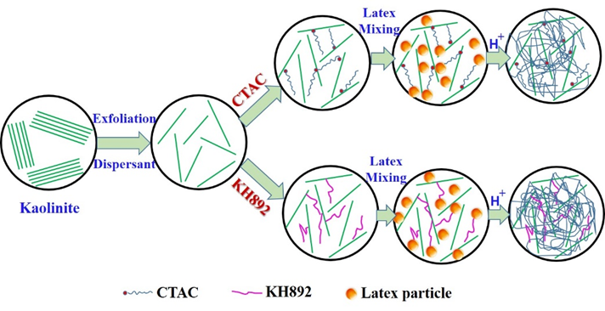

**Fig 1.** Schematic diagram of the blending process of kaolinite with SBR latex. In the CTAC modification route, the little red dot of the end of the molecule represents ((CH3)3-N-) +.

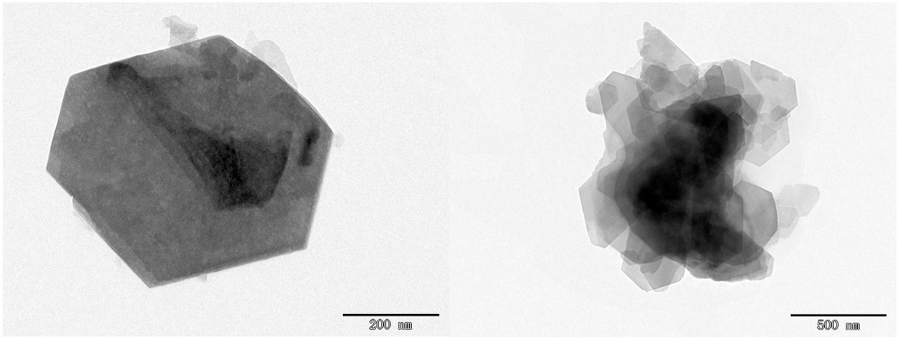

**Fig 2. TEM micrographs of the pristine kaolinite.**

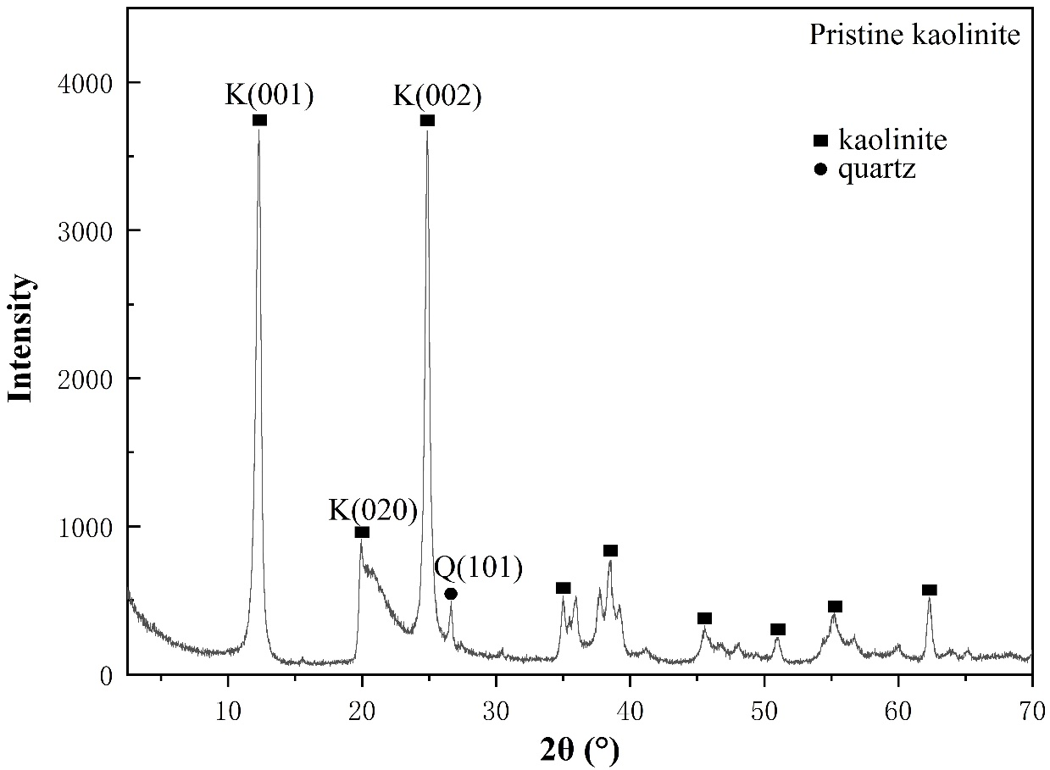

**Fig 3. X-ray powder diffraction pattern of pristine Kaolinite.**

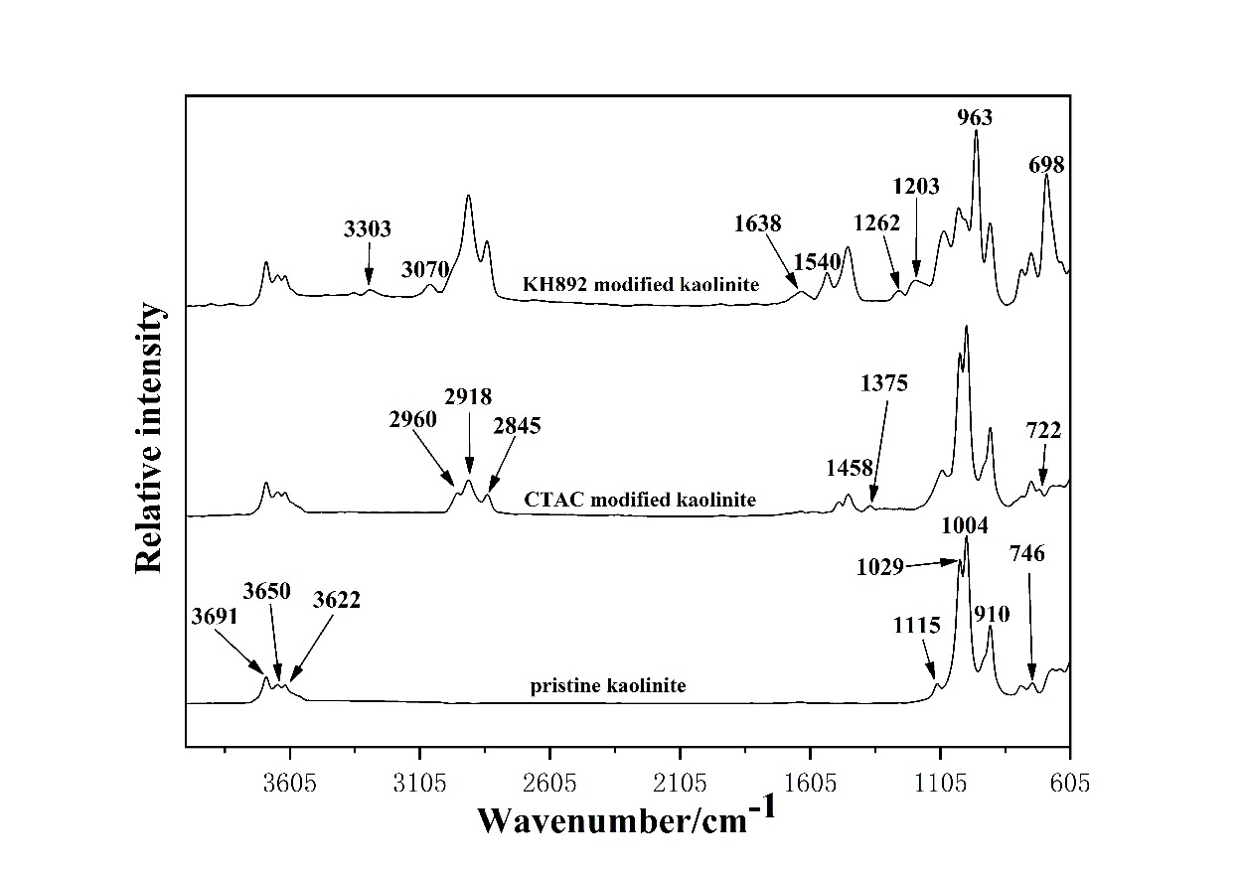

**Fig 4.** Infrared spectra of kaolinite samples.

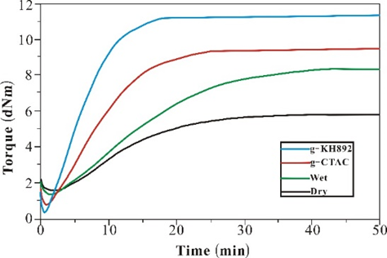

**Fig 5.** Vulcanization characteristics of kaolinite/SBR compounds.

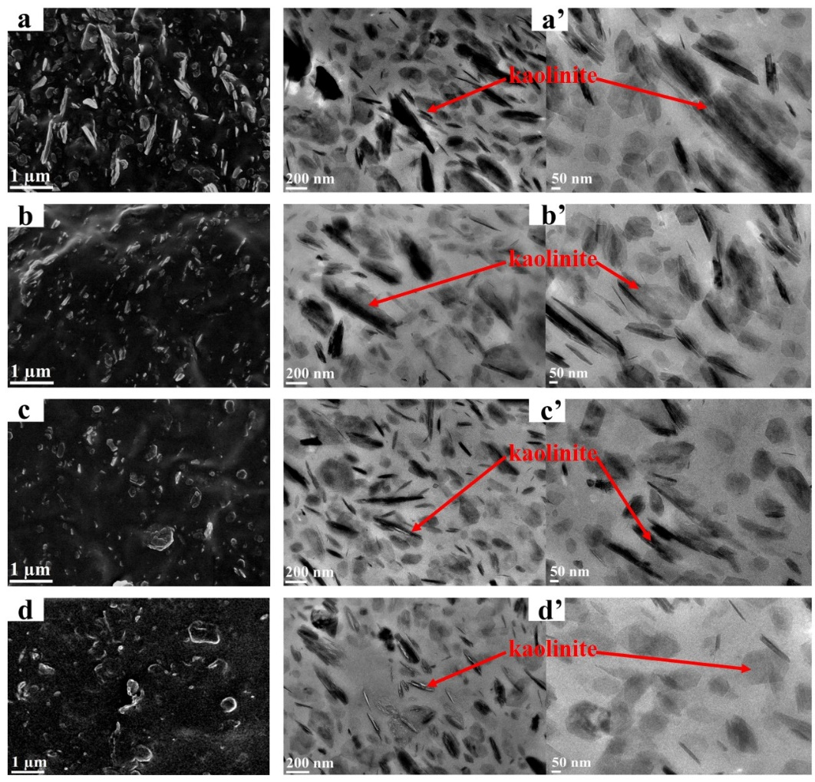

**Fig 6(a-d).** SEM observations of kaolinite/SBR nanocomposites. (a) dry, (b) wet, (c) g-CTAC, (d) g-KH892; (a’-d’) TEM observations of kaolinite/SBR nanocomposites. (a’) dry, (b’) wet, (c’) g-CTAC, (d’) g-KH892.

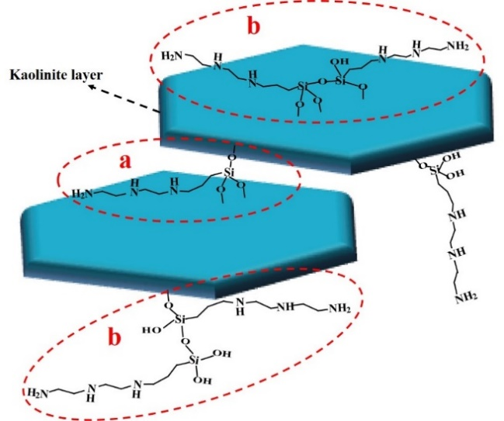

**Fig 7.** Schematic diagram of the modified kaolinite by KH892.

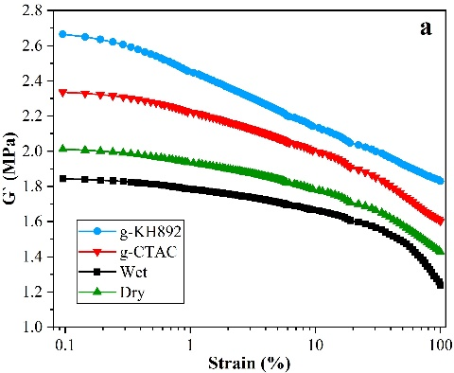 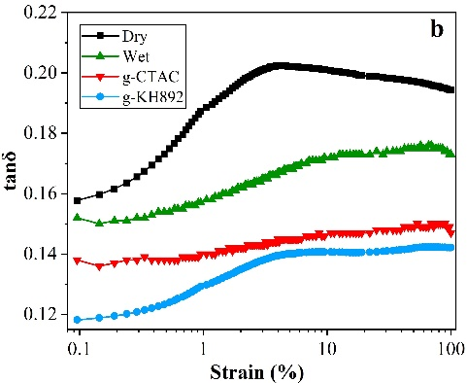

**Fig 8.** Strain amplitude dependence of (a) shear modulus, and (b) tanδ of kaolinite/SBR composites.

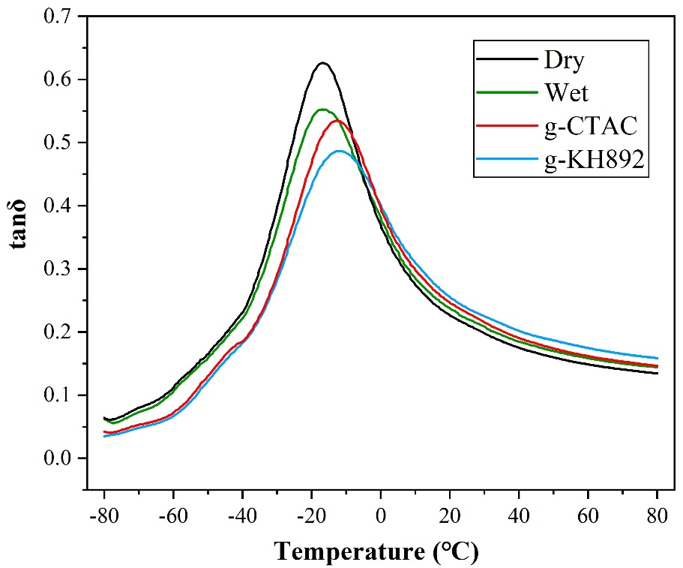

**Fig 9.** Temperature dependence of loss factor (tan δ) of kaolinite composites.

**Table 1** Properties of SBR1502 latex and ESBR1502

|  |  |  |
| --- | --- | --- |
| **Property** | **SBR latex 1502** | **ESBR 1502** |
| **Total solid content (%wt)** | 23.35 |  |
| **Dry rubber content (%wt)** | 22.7 |  |
| **Mechnaical stability (5min%)** | ≤1.0 |  |
| **Particle size (nm)**  **pH**  **Mooney viscosity (ML1+4, 100℃)** | 60~90  9~10 | 52 |
| **Volatile matter (%wt)**  **Specific gravity (g/cm3)** |  | <0.75  0.933 |
| **Ash content (%wt)**  **styrene content (%wt)** |  | <0.5  23.5 |

**Table 2** Recipe of kaolinite/SBR compound, phra

|  |  |  |  |  |
| --- | --- | --- | --- | --- |
| **Ingredients** | **Wet** | **Dry** | **g-CTAC** | **g-KH892** |
| **Masterbatch** | 150b |  | 150b | 150b |
| **CTAC** |  |  | 5 |  |
| **KH892** |  |  |  | 5 |
| **ESBR1502** |  | 100 |  |  |
| **Kaolinite powder** |  | 50 |  |  |
| **Zinc oxide** | 3 | 3 | 3 | 3 |
| **Stearic acid** | 1 | 1 | 1 | 1 |
| **Anti-oxidant 4010NAc** | 1 | 1 | 1 | 1 |
| **Accelerator TBBS** | 1 | 1 | 1 | 1 |
| **Sulfur** | 1.75 | 1.75 | 1.75 | 1.75 |

a Parts per hundred of rubber.

b 150 phr of the masterbatch =100 phr of SBR +50 phr of kaolinite.

c N-isopropyl-N’-phenyl-1,4-phenylenediamine.

**Table 3** Vulcanization characteristics of kaolinite/SBR compounds

|  |  |  |  |  |  |  |
| --- | --- | --- | --- | --- | --- | --- |
| **Samples** | **T10**  **(min)** | **T90**  **(min)** | **Minimum torque, ML (dNm)** | **Maximum torque, MH (dNm)** | **MH-ML, (dNm)** | **CRIa, (min-1)** |
| **Dry** | 1.81 | 30.32 | 1.62 | 5.84 | 4.22 | 3.51 |
| **Wet** | 1.45 | 36.52 | 1.28 | 8.13 | 6.85 | 2.85 |
| **g-CTAC** | 1.12 | 21.72 | 0.71 | 9.43 | 8.72 | 4.85 |
| **g-KH892** | 0.76 | 13.65 | 0.33 | 11.2 | 0.87 | 7.76 |

a Cure Rate Index [=100/(T90-T10)]

**Table 4 Crosslink density of the kaolinite/SBR composites.**

|  |  |  |  |  |
| --- | --- | --- | --- | --- |
| **Samples** | **Dry** | **Wet** | **g-CTAC** | **g-KH892** |
| **Crosslink demsity Vc×10-3 (mol/g)** | 1.865 | 1.949 | 1.968 | 2.072 |

**Table 5** Static mechanical properties of kaolinite/SBR composites.

|  |  |  |  |  |  |  |  |
| --- | --- | --- | --- | --- | --- | --- | --- |
| **Samples** | **Tensile strength (MPa)** | **Elongation at break (%)** | **Modulus at 100% (MPa)** | **Modulus at 300% (MPa)** | **Tension set**  **(%)** | **Tear resistance (kN/m)** | **Shore A hardness (°)** |
| **Dry** | 7.96±0.5 | 737.79±20 | 1.19±0.1 | 1.96±0.1 | 4.22±0.5 | 25.89±1 | 56±1 |
| **Wet** | 10.26±0.3 | 704.62±20 | 1.22±0.1 | 2.15±0.1 | 6.85±0.5 | 29.02±1 | 55±1 |
| **g-CTAC** | 11.12±0.3 | 682.67±20 | 1.35±0.1 | 2.47±0.1 | 8.72±0.5 | 33.54±1 | 56±1 |
| **g-KH892** | 15.54±0.3 | 638.4±20 | 1.60±0.1 | 5.60±0.1 | 10.87±0.3 | 37.91±1 | 58±1 |

**Table 6** Loss factor (tan δ) results of kaolinite/SBR composites.

|  |  |  |  |
| --- | --- | --- | --- |
| **Samples** | **Tg (℃)** | **tanδ at 0℃** | **tanδ at 60℃** |
| **Dry** | -16.7 | 0.369 | 0.149 |
| **Wet** | -16.8 | 0.383 | 0.160 |
| **g-CTAC** | -12.3 | 0.399 | 0.165 |
| **g-KH892** | -11.5 | 0.405 | 0.176 |

1.