Supplemental Materials

Data Source
TriNetX (Cambridge, MA) is an international health research network that provides access to electronic health records (EHRs) from healthcare organizations (HCOs) predominantly in the United States. TriNetX operates on a cloud-based platform, delivering real-time, deidentified clinical data that complies with Health Insurance Portability and Accountability Act (HIPAA) regulations. This platform typically serves large academic health centers, aggregating data from their numerous affiliates. TriNetX data can be identified by ICD-10, ICD-10 PCS, CPT, LOINC, and RxNorm codes. Beyond structured EHR data such as patient demographics, diagnoses, treatments, medications, and procedures, TriNetX employs natural language processing to extract relevant details from clinical narratives. The data undergoes a conversion process to align with standardized clinical terminologies and is organized into a proprietary format, which includes a rigorous quality control procedure to eliminate substandard records. TriNetX's data handling has received a waiver from the Western Institutional Review Board due to the federated nature of the network, which only aggregates and reports deidentified data, ensuring that neither patients nor healthcare organizations are identifiable.

Patient Identification and Outcomes

Identification
Adults aged 18 and older diagnosed with hidradenitis suppurativa (L73.2) from September 11, 2015, when adalimumab received FDA approval, until May 10, 2023. Patients with Crohn’s disease, ulcerative colitis, rheumatoid arthritis, psoriasis, or ankylosing spondylitis—conditions for which TNF inhibitors are also approved—were excluded. Confounding variables that were controlled for included demographic factors (age, race, and sex,) and comorbidities such as hypertension (I10), nicotine dependence (F17), chronic lower respiratory diseases (J40-J4A), dyslipidemia (E78), diabetes mellitus (E08-E13), chronic kidney disease (N18), atherosclerosis (I25.1), alcohol use disorders (F10), cerebral infarction (I63), BMI>30, and liver fibrosis/cirrhosis (K74).

De-Novo HF Outcome
New onset HF was defined as any first-time documented HF episode within 1 year following adalimumab initiation for HS patients with no documented HF before the corresponding index event. HF was defined using an approach from Xu et al (2022) with ICD-10 codes that have shown 92.4 positive predictive value. This included heart failure (I50), hypertensive heart disease with HF (I11.0), hypertensive heart and CKD with HF and Stage 1-4 CKD or unspecified chronic kidney disease (I13.0), Hypertensive Heart and CKD with HF and Stage 5 CKD or end stage renal disease (I13.2), ischemic cardiomyopathy (I25.5), dilated cardiomyopathy (I42.0), other restrictive cardiomyopathy (I42.5), cardiomyopathy due to drug and external agent (I42.7), other cardiomyopathies (I42.8), and cardiomyopathy in diseases classified elsewhere (I43).

HF Exacerbation Outcome
HF exacerbation was defined as a composite of recorded acute on chronic systolic (I50.23) or diastolic CHF (I50.33), acute chronic combined systolic and diastolic HF (I50.43), acute on chronic RHF (I50.813), acute RHF (I50.811), acute combined systolic and diastolic HF (I50.41), acute systolic HF (I50.21), acute diastolic HF (I50.31), or use of intravenous loop diuretic use such as furosemide (4603), torsemide (38413) or bumetanide (1808).

Statistical Analysis
Patient characteristics were summarized and compared using measures such as means, standard deviations, and proportions. To analyze categorical variables, the Pearson chi-square test was employed, while continuous variables were assessed using an independent-samples t test. To mitigate confounding factors, 1:1 propensity score matching (PSM) using the greedy nearest-neighbor algorithm with a caliper of 0.1 pooled standard deviations. Matching quality was deemed satisfactory if the standardized mean differences (SMD) were below 0.1. If post-matching SMD values exceeded 0.1, a p-value greater than 0.05 was used to determine if differences in confounding variables between the cohorts were statistically insignificant.

Supplemental Tables

 | Before Propensity Matching |  |  | After Propensity Matching
Characteristic Name | Adalimumab (N=4645) | No Adalimumab (N=117209) | Standardized Mean Difference | Adalimumab (N=4644) | No Adalimumab (N=4644) | Standardized Mean Difference
Age at Index; years | 35.2±12.7 | 35.8±14.3 | 0.042 | 35.2±12.7 | 35.3±13 | 0.004
BMI ≥ 30 kg/m² | 1957 (42.1%) | 47703 (40.7%) | 0.029 | 1956 (42.1%) | 1952 (42.0%) | 0.002
Female | 3234 (69.6%) | 87664 (74.8%) | 0.116 | 3233 (69.6%) | 3221 (69.4%) | 0.005
White | 1999 (43.0%) | 53427 (45.6%) | 0.051 | 1999 (43.0%) | 1982 (42.6%) | 0.007
Black | 1692 (36.4%) | 37290 (31.9%) | 0.097 | 1691 (36.4%) | 1752 (37.7%) | 0.027
Hispanic | 451 (9.71%) | 11346 (9.68%) | 0.001 | 451 (9.71%) | 444 (9.56%) | 0.005
Essential hypertension | 1063  (22.8%) | 24228  (20.6%) | 0.054 | 1063 (22.9%) | 1045 (22.5%) | 0.009
Nicotine dependence | 1016  (21.9%) | 21058 (17.9%) | 0.099 | 1015  (21.9%) | 982 (21.1%) | 0.017
Chronic lower respiratory diseases | 886 (19.1%) | 22283  (19.0%) | 0.002 | 886 (19.1%) | 847 (18.3%) | 0.021
Diabetes mellitus | 734 (15.8%) | 14456 (12.3%) | 0.100 | 733 (15.8%) | 701  (15.1%) | 0.012
Dyslipidemia | 681  (14.6%) | 19269  (16.4%) | 0.050 | 681  (14.6%) | 616 (13.2%) | 0.040
Chronic kidney disease (CKD) | 231 (4.9%) | 3666 (3.1%) | 0.094 | 230  (5.0%) | 186 (4.0%) | 0.046
Cerebral infarction | 103  (2.2%) | 1701  (1.45%) | 0.057 | 230 (2.22%) | 186 (1.93%) | 0.026
Atherosclerotic heart disease of native coronary artery | 99 (2.1%) | 2473 (2.1%) | 0.002 | 99 (2.1%) | 56 (1.2%) | 0.07
Alcohol related disorders | 83  (1.8%) | 1731 (1.5%) | 0.025 | 83  (1.8%) | 71 (1.5%) | 0.020
Fibrosis and cirrhosis of liver | 48 (1.03%) | 844 (0.72%) | 0.034 | 47 (1.01%) | 28 (0.60%) | 0.046
Supplemental Table 1. Baseline characteristics for risk of first-time incident heart failure in HS patients.

 | Before Propensity Matching |  |  | After Propensity Matching
Characteristic Name | Adalimumab (N=155) | No Adalimumab (N=4244) | Standardized Mean Difference | Adalimumab (N=153) | No Adalimumab (N=153) | Standardized Mean Difference
Age at Index | 45.2±14.1 | 52.8±14.9 | 0.524 | 45.4±14.1 | 45.6±14.5 | 0.011
BMI ≥ 30 kg/m² | 110 (78.7%) | 2579 (60.7%) | 0.216 | 108 (70.6%) | 111  (72.5%) | 0.024
Female | 98 (63.2%) | 2558 (60.3%) | 0.061 | 97 (63.4%) | 102 (66.7%) | 0.069
Black | 72 (46.4%) | 1613 (38.0%) | 0.172 | 70 (45.7%) | 83 (54.2%) | 0.171
White | 57 (36.7%) | 1901 (44.8%) | 0.164 | 57 (37.3%) | 46 (30.1%) | 0.153
Hispanic or Latino | 15  (9.6%) | 249 (5.9%) | 0.143 | 15  (9.8%) | 13  (8.5%) | 0.045
Essential Hypertension | 108 (69.7%) | 3212 (75.7%) | 0.135 | 108 (70.6%) | 105 (68.6%) | 0.043
Diabetes mellitus | 98 (63.2%) | 2414 (56.9%) | 0.129 | 96 (62.7%) | 91 (59.5%) | 0.07
Dyslipidemia | 79 (52.11%) | 2625 (63.22%) | 0.221 | 79 (51.6%) | 82 (53.6%) | 0.039
Nicotine dependence | 76 (49.0%) | 1757 (41.4%) | 0.154 | 75  (49.0%) | 81  (52.9%) | 0.078
Chronic lower respiratory diseases | 68 (43.8%) | 2067  (48.7%) | 0.098 | 68  (44.4%) | 76 (49.7%) | 0.104
Chronic kidney disease (CKD) | 63 (40.6%) | 1458 (34.4%) | 0.130 | 61 (39.9%) | 62 (40.5%) | 0.013
Atherosclerotic heart disease of native coronary artery | 49 (31.6%) | 1655 (39.0%) | 0.155 | 49 (32.0%) | 52 (34.0%) | 0.042
Cerebral infarction | 17 (11.0%) | 601 (14.2%) | 0.100 | 17 (11.1%) | 13  (8.5%) | 0.088
Fibrosis and cirrhosis of liver | 10* | 180 (4.2%) | 0.098 | 10* | 10* | <0.001
Alcohol related disorders | 10* | 225 (5.3%) | 0.049 | 10* | 10* | <0.001
*Cell Counts ≤10 were obfuscated to protect patient privacy

Supplemental Table 2. Baseline characteristics for risk of heart failure exacerbation in HS patients with pre-existing HF.

Additional Figures

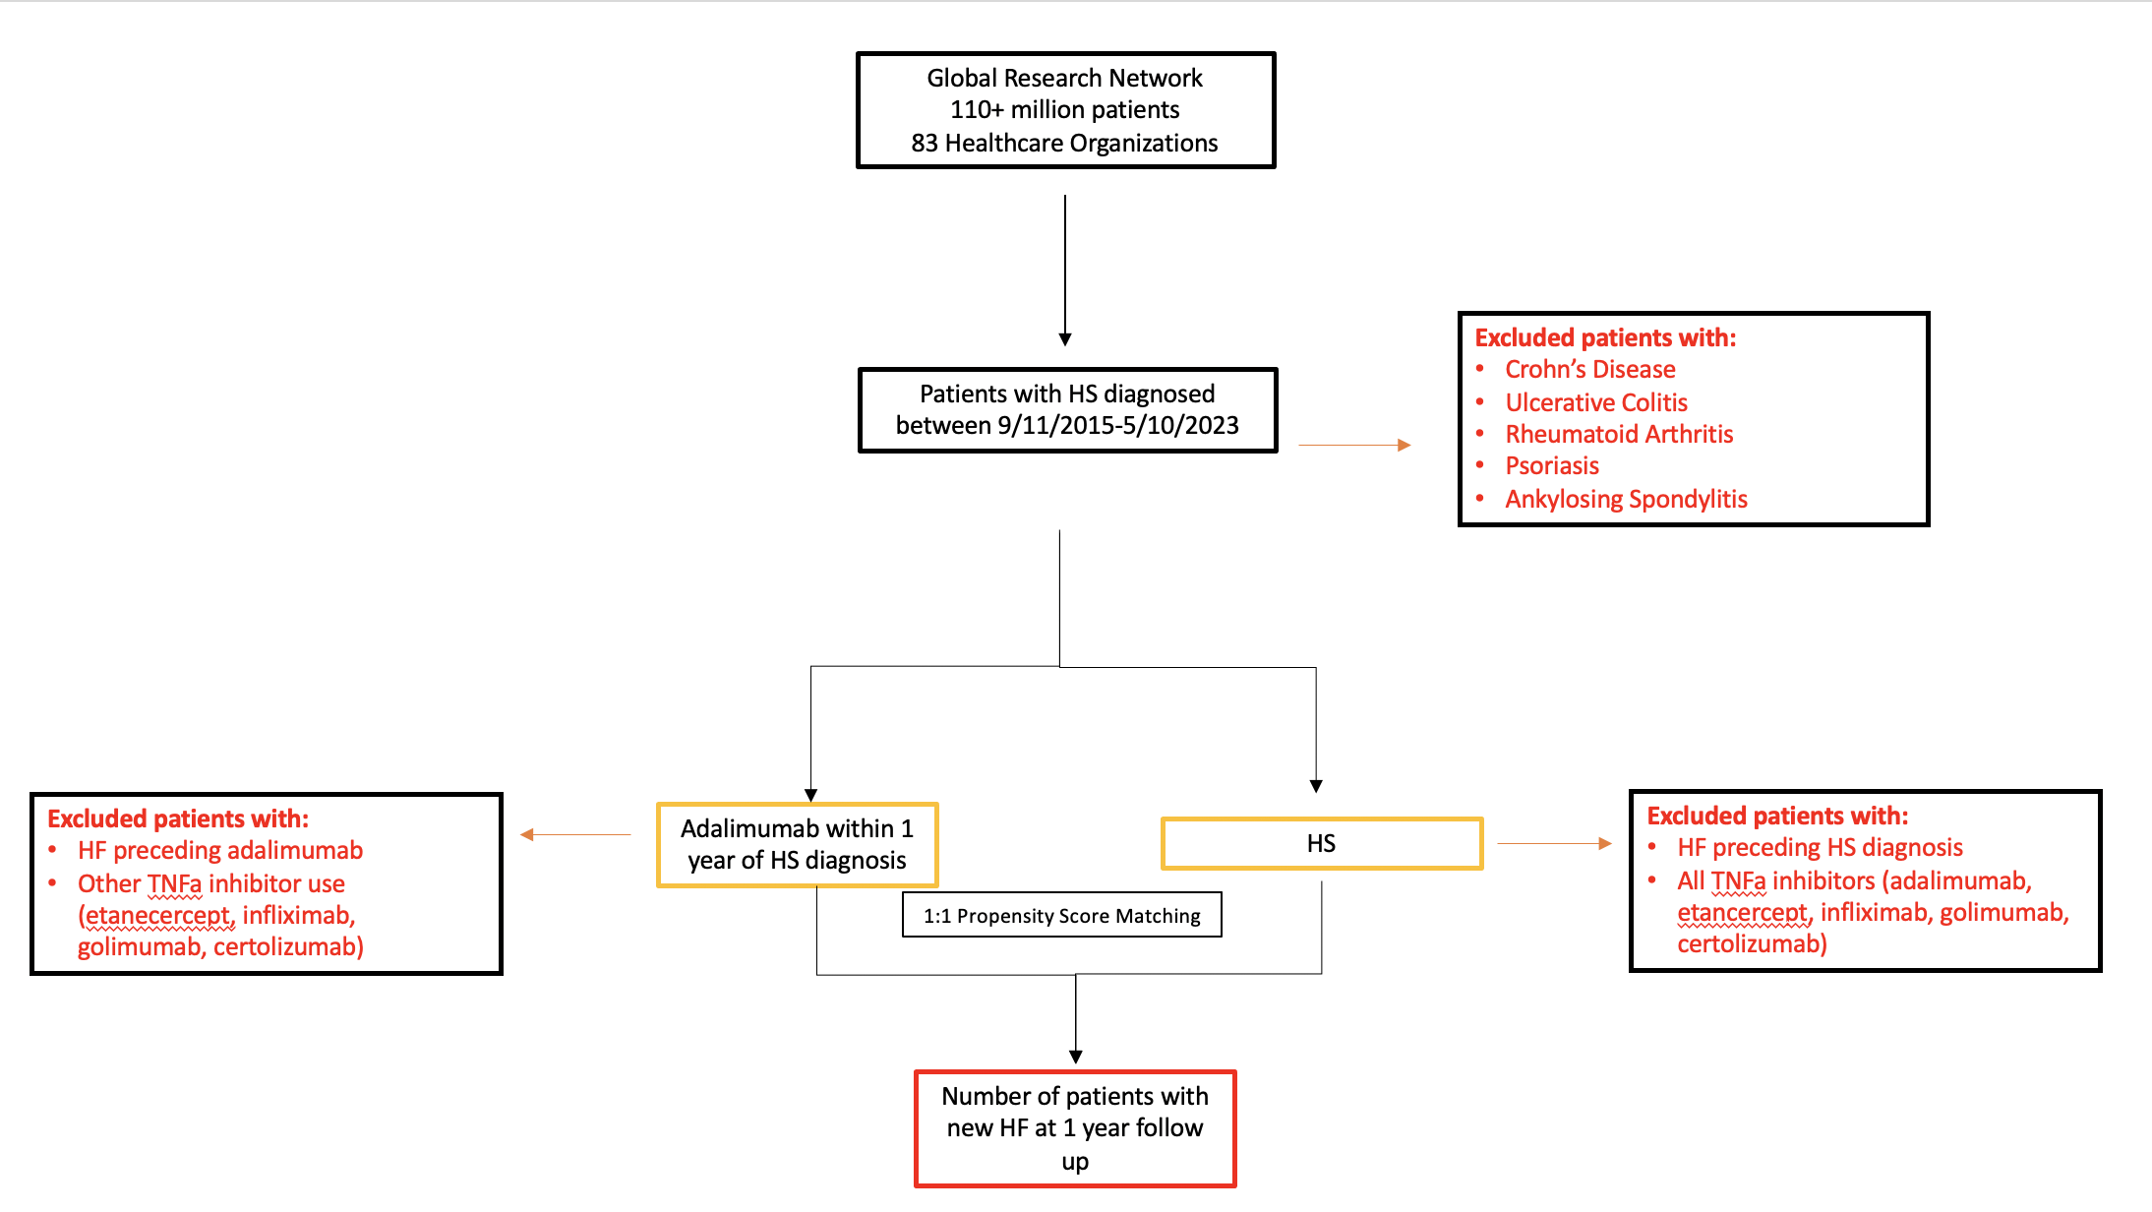
Additional Figure 1 – Analysis of new onset HF in HS patients with and without adalimumab exposure.

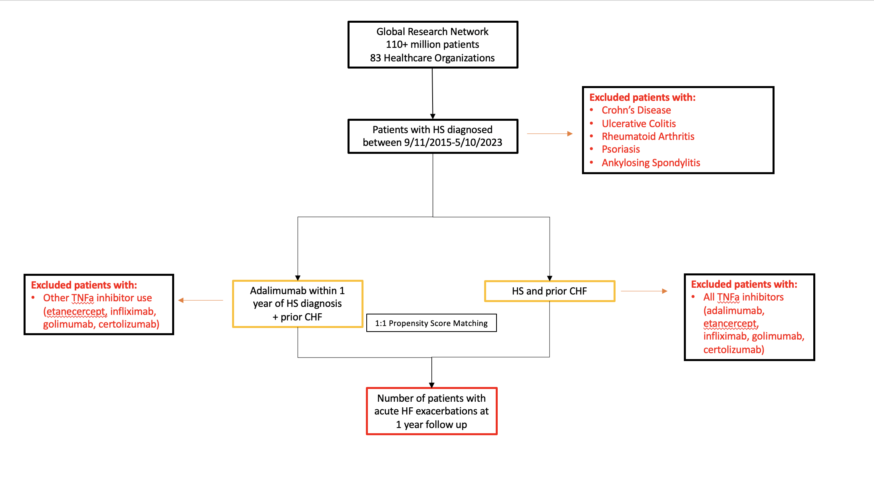
Additional Figure 2 – Analysis of HF exacerbation in HS patients with and without adalimumab exposure.

