Automating Knowledge: A Case Study of Library Automation in of College Libraries of Dadra and Nagar Haveli
Ruchi Rajesh Sinha*
Head, Librarian of SSR College of Arts, Commerce and Science,
Silvassa. UT of D.N.H. & DD, India (Affiliated to Savitribai Phule, Pune University)
E-email- ruchi.sinha0406@gmail.com
Abstract
This study examines the implementation and impact of library automation in college libraries in the Union Territory of Dadra and Nagar Haveli, with a focus on Silvassa. The research investigates the opportunities and challenges of library automation, assesses its effectiveness in enhancing library services and user experiences, and provides recommendations for optimization. The study finds that library automation has improved cataloguing, classification, circulation, and searching efficiency, but challenges persist in areas such as infrastructure, training, and user awareness. The research contributes to the understanding of the current state of academic college libraries in Dadra and Nagar Haveli, providing valuable insights for library managers, policymakers, and researchers. The study focuses on housekeeping operations, advantages, limitations, and user and librarian satisfaction levels using the programme. This research looks at the software NewGenLib, KOHA, VIRDDHI, and LIBRARIAN. The research was conducted utilising a survey method with a questionnaire as the research tool. Despite significant obstacles, the majority of respondents were satisfied with the automation of library operations and considered it to be beneficial. This research contributes significantly to the situation of academic college libraries in Dadra and Nagar Haveli.
Keywords: Library Automation, College Libraries, Dadra and Nagar Haveli, Silvassa, Library Services, User Experience.
Introduction
Human beings require education in order to survive. Human beings can accomplish their desired development through education. From elementary school to college and university, education is available. Educational institutions are the conduits via which knowledge is disseminated. The universe of knowledge is immense. Knowledge is attempted to be imparted through a variety of disciplines. These faculties were established by various colleges, academic activities are evolving, new subjects are continually being researched, and the University Grants Commission is establishing similar faculties at the national level. As a result, knowledge and education are always changing. Technologies and information and communications technologies have advanced to the point where they now play a vital part in our daily lives. It has also provided a new platform for academic college libraries; ICT applications assist in providing current information and informative services to users in a timely manner, such as database search, bibliographic service, reference service, referral service, CD-Rom and online database services. The proliferation of information and communication technology infrastructure has propelled libraries to the pinnacle of automation services. ICT also stimulates and creates an environment in which library workers may collaborate and provide improved library services. Professional librarians have risen to the challenge of transitioning from traditional to digital libraries. "The method or system of operating or regulating a process by highly automatic means, such as electronic equipment, reducing human intervention to a minimum," according to the library automation definition. Various libraries Automation Software such as Koha. Evergreen, NewGenlib, Librarians, Library Solutions, Slim, Soul, OpenBiblio, Libsys, and others have filled the market. The programme can be used by libraries based on their needs and requirements. We can assist and provide a digital environment to our users with the help of library automation.
Objective of the Study
- Students working in the college library must supply library materials that are aligned with the curriculum for overall development work, as well as providing information about newly published works to both professors and students.
- Providing necessary supplemental facilities and equipment for the educational process.
- To compile material on subjects other than those in the syllabus.
- Integrate library service with continuing education, public education and literaracy campaigns.
- To encourage staff and students to become more reading oriented by utilizing the library.
- To study the impact of application of information technology on library services.
- To study the software used in these libraries.
- To study staff pattern working for information technology in their libraries.
- To find out state of information technology used in college libraries.
- To study user education for information technology.
- To study information needs of the users of a library.
Literature Review
The study of the literature is an important aspect of the research. It is extremely significant in scientific methodology. The fundamental goal of this literature evaluation is to keep the researcher from repeating his research on the same topic. The researcher has agreed on the key and basic information of the chosen study issue through a literature review, which includes an examination of the literature to provide the researcher with a theoretical basis and research methodology.
Doifode, R. R. (2020). Academic libraries have been reformed from a position where print services can be acquired through ICT media such as CDROMs and the Internet. Virtual classrooms have replaced libraries. The library will soon be put to the test using its statistical method. Cloud-based knowledge linked to a vast sea of Internet-based service now covers today's libraries. Research and development, as well as obtaining answers from journals and articles, are all part of the process. The SPSS information processing tools and the Database Questionnaire were used to collect data. This study will aid in increasing growth and 116 updating programmes to meet consumer demands. Regular information changes are part of the new technology paradigm, and its electronic media has now become a forum for the same reason that the World Wide Web has changed people's information-seeking behavior dramatically. 96.5 percent of respondents said they spend a couple hours a day in the library. Our library has its own internet portal, according to 54.5 percent of respondents. The College Library does not have a web-based library automation kit, according to 100% of users.
Sen, P., Das, S.K. (2019). A library is a place where dependable and accurate information for specific fields can be discovered. A library is regarded as a prime source of information in graduate and graduate college. As a result, given the developing knowledge environment for improved access to the information library, several ICT tools such as e-resource, e-case, Web – OPAC, and others have been accepted to exchange information for testing and assessing the facility. This survey will identify and improve many of the facility's benefits and shortcomings. SWOT analysis of personnel composition can also aid in the management of university facilities. These new services will be critical in the future for students' development. S.R. Ranganathan advocated it in the initial staff formula in 1958.
Manjunatha, N., & Babu, K. S. (2018). The findings of the study found that the majority of people use the Internet as a source of information and that e-mail is used to share information. The pupils did self-training to learn how to look for data on the internet. Writing articles requires the usage of web data search. The library's biggest problem was that it didn't have any current materials. The lack of data cannot be cited as the main reason for less library used.
Suleiman, H., Abdulkadir, A., & Isah, R. (2017). The paper discovered several issues in gathering data from various sources. The findings were measured and analyzed for user-applied research, and they were based on a quantitative technique. The study's major goal was to learn more about librarians' knowledge of sources, resource usage, and issues. Users were aware of the importance of learning through e-sources and e-journals, among other things. The librarian's biggest challenge was a lack of network connectivity, and the facility's main disadvantage was the increased use of sources.
Suresha (2016). Users' satisfaction with library facilities and services was investigated. The results of the survey revealed that a large proportion of people were pleased with the library's facilities and services. He also discovered that books are the most commonly used by consumers, with library circulation systems being the most popular service. Users also submitted suggestions to improve the library's accessibility and dependability.
Thompson, S (2015). Libraries have been particularly active in investigating the use of spaces, both in terms of their buildings and their contents. Traditional methods for monitoring the use of library construction, such as gate counts, provide little information about what visitors do while inside the library; nevertheless, new tools for studying the usage of space are becoming more widely used. Smart phones are especially promising since they make it possible to directly monitor and track user actions in library locations. We noticed that observation paired with mobile technology enables the library to analyses user research activities and space utilization patterns from anywhere in the library. Findings were tracked using an iPad and two popular mobile applications, Cloud On and Counter. The results were compared to more traditional data gathered by the reservation system.
Saxena, S. (2014). By examining gaps in the management of digital libraries, the study justified its goals in terms of acquisition, organization, incorporation, preservation, and access to digital content/resources/services in special libraries. There is also a disconnect between the IT infrastructure requirements for DLs and their upkeep. Differences in the evolving behavior of users of digital restrictions/services overprint, access, and search methods, including 80 methods and systems used for keeping their information current for different ideas, cutting library visits, IT skills, no reliance on libraries/staff, convenient use, have all been used to justify the impact of DLs on users of special libraries in the Delhi area. Rather than a set, library construction was more user-centered than before.
Sadu, (2013). The demand for greater production standards in the ICT setting is increasing by the day, putting current library efforts in jeopardy. According to the author, there are a slew of issues confronting academic libraries as a result of this new environment, in which ICT and the electronics revolution are key factors. It also considers the impact of the new world on library professionals, and it hopes to bring together the canter's expertise and young talent to discuss the need to shrink university libraries. As a result, it discusses 75 the range of expertise solutions required for library practitioners to address the present changes brought on by the creative climate.
Research Methodology
The importance of research methodologies in the research process cannot be overstated. They cover the various stages of an action plan for implementing a research issue in a study, such as how the matter is formulated. For example, the way the problem is phrased. These processes include identifying concepts, selecting a data collection topic, analysing and interpreting, and making inferences and generalisations. A practical and realistic method for the investigator to target and address the problem under investigation would be part of a pre-planned and well-described approach. Research is a vital and useful instrument for propelling mankind forward. The technical shift occurred as a result of the field of cluelessness' personality-seeking; the discovery of new facts, which can lead to new and better ways in society. The survey method was used as a tool for data collection for this study after understanding the available literature and the approaches employed in previous investigations. A well-designed questionnaire was personally distributed to library staff and users of various categories, including undergrads, post grads, and faculty members. A total of 200 replies were collected from eight colleges. Further, staff view of eight libraries also considered.
Methodology: This study employed a survey research design to investigate the importance of library automation in college libraries of Dadra and Nagar Haveli. The survey method was chosen as it allowed for the collection of data from a large sample size, providing a representative view of the library staff and users.
Research Design: The study adopted a descriptive research design, aiming to describe the current state of library automation in college libraries of Dadra and Nagar Haveli. The design also allowed for the identification of challenges and areas for improvement.
Data Collection Instrument: A well-designed questionnaire was developed to collect data from library staff and users. The questionnaire consisted of both open-ended and closed-ended questions, allowing for the collection of both qualitative and quantitative data.
Sampling Method: The study employed a non-probability sampling method, specifically a convenience sampling method. The questionnaire was personally distributed to library staff and users of various categories, including undergraduates, postgraduates, and faculty members, from eight colleges in Dadra and Nagar Haveli.
Sample Size: A total of 200 responses were collected from the eight colleges. Additionally, the views of library staff from eight libraries were also considered.
Data Analysis: The collected data was analyzed using descriptive statistics, including frequencies, percentages, and means. The data was also analyzed using thematic analysis to identify patterns and themes.
Limitations: This study had some limitations, including:
- The use of a non-probability sampling method, which may limit the generalizability of the findings.
- The reliance on self-reported data, which may be subject to biases.
- The limited sample size, which may not be representative of the entire population.
Position of libraries from different Colleges in Silvassa UT of Dadra and Nagar Haveli
Dr. A.P.J. Abdul Kalam Government College
Dr. A.P.J. Abdul Kalam Government College is a bachelor's degree college in Silvassa. The college offers an innovative learning atmosphere, as well as chances for creativity and individual growth. Gujarat University has been associated with the college since July 2011. Currently, the college offers bachelor's degrees in the arts, commerce, and science streams. The college currently has 1700 students and 48 faculty and staff members. The college was in charge of the Uchcha Shiksha Samiti (USS) society, which is run by the DNH government. The college was also recognized by the University Grants Commission (UGC). The Learning Resource Centre (Library) at College is a vibrant and well-stocked library. The Learning Resource Centre (Library) in Silvassa and around the country provides a vibrant learning environment. On a Word press platform, the librarian produces a world-class website. The open source library automation programme NewGenLib (Source No.1). Patrons can also access a variety of open materials at the library. An old exam paper in electronic format can be found on the library's website. In this library, there are two staff members. The LRC Library offers a wide range of services. Books lending service, Book Bank service, Newspaper service, Reference service, Literature printing service, Current Awareness service, Reprographic service (currently only for staff), Periodical service, Email service, Literature search service, Carrier Counseling, Old Question Papers are just some of the services available (available in digital and print).
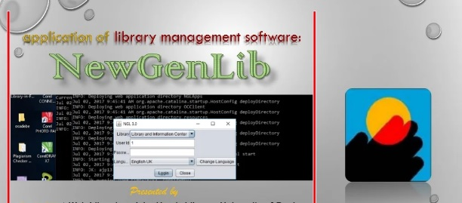
Image No.1: Library Software of NewGenLib
Smt.Devkiba Mohansinhji Chauhan College of Commerce and Science
Smt. Devkiba Mohansinhji Chauhan College of Commerce & Science was founded in year 2014-2015 with Mumbai University. Smt. Devkiba Mohansinhji Chauhan College of Commerce and Science believe that Knowledge is Power. The college provides an excellent learning atmosphere. The colleges are located in Sanjibhai Delkar Marg, Silvassa. Devkiba College builds a well-organized library with seating capacity of 150 users. The library is a temple of knowledge including over growing collection of around general 3500 books and 450 reference books. The library subscribes 7 international and 4 national journals, average 70 books issue to the patrons daily. Library divided the collection in science, commerce, management and competitive exam books. It always encourages innovative research and also circulates the innovative knowledge to 550 students, 26 faculties and 14 administrative staff. The library center of the attraction in this college, it followed Ranganathan principles. Library offer a various types of services to the end user such as circulation, CAS, SDI, indexing, newspaper clippings, etc.
Smt.Devkiba Mohansinhji Chauhan College of Law
Smt. Devkiba Mohansinhji Chauhan College established under the nonprofit Lions Club of Silvassa Charitable Trust. The College has accepted by Indian bar council and affiliated with Mumbai University. At present the college provides a L.L.B. bachelor of legislative law three years’ courses. Bachelor of Legislative Laws is an undergraduate Law Course. The college also provides a B.L.S. LL.B. five-year full time integrated law course. The law library is well arranged and spread in a big area. Library comfort design and Wi-Fi added additional value in the campus. The library subscribes 12 legal and 15 non legal print journals. It also provide a online 40 services such as Westlaw India, supreme court cases law, Manupatra.com, CLR (www.clrindia.com), etc. the library offer a different types of electronic databases like ProQuest Central, JSTOR, EBSCO, Science Direct, IEL Online, Springer, ASME. The library allows legal professionals a wide variety of resources and programs as well as encourages research, legal research, and profound information.
SSR College of Education
SSR College of education Silvassa had started in the 2007 under the SSR memorial trust. The college is associated with the University of Savitribai Phule Pune and endorse by national council of teacher education, Bhopal. At present, the college offers a B.Ed. course with English and Marathi medium. The college had 100 student’s intake 43 capacity. College is situated in green campus; the greenery generates a learning environment. Every time college tries its best to create teachers who shall fulfill demands of 21st century society both at local and global level. The SSR B.Ed. Library provides the books and other study material essential for staff and students in this educationally backward area throughout the academic area. It issues text books, reference books and other study material to the user of the SSR campus. It has a rich collection of books around 6367 including Reference Books, Encyclopedias, Dictionaries, Handbooks, and School Text books, Book Bank Books, Educational Books, and General Books. Library provides right information through Library resources like that Books, Dictionaries, Journals/Magazines, Encyclopedias, Newspapers and E-Resources. Library is fully automated with LIBRARIAN software developed by CR2 Technologies Ltd, Ahmadabad for various Library operations like that Barcode technology, Circulation, Acquisition , OPAC, Serial control and various report generation.
SSR College of Pharmacy
The SSR College of Pharmacy was founded in 2007 and is one of the premier colleges in the field of pharmacy education. Silvassa College was founded under the SSR memorial trust. The college is situated on a green campus and offers students a complete learning environment. The Directorate Technical Education, Maharashtra, Mumbai, and the administration of Dadra and Nagar Havel recognised it. From 2019 to 2022, the college's B. Pharma programme is accredited by NBA. It is recognised by Maharashtra's DTE and the DNH administration. The college is affiliated with the University of Savitribai Phule in Pune and is registered with the All India Council of Technical Education and the Pharmacy Council of India. It provides bachelor’s and master's degree programmes in pharmaceuticals (B. Pharm, M. Pharm). Pharmacology and Pharmaceutical Quality Assurance the College’s laboratories, auditorium, canteen, conference hall, and transportation facilities are all well-equipped. The SSRCP has a well-equipped, excellent, big, well-furnished, and well-ventilated library with 100-seat reading hall. Library resources such as books, dictionaries, encyclopaedias, journals/magazines, newspapers, and other E-Resources offer users with accurate information. The SSR College of Pharmacy Library has about 9011 books and subscribes to 24 National and DELNET Journals with a total of 5000+ articles, as well as numerous other e-databases. CR2 Technologies Ltd, Ahmadabad created Librarian software version 5.4.1 Rev.G (Source No.2) for various library activities such as barcode technology, acquisition, serial control, OPAC, and many library related report production. Swayam, Mooc.org, and Courses are just a few of the online learning platforms linked on the library portal. In addition, a competitive exam and valuable connections are provided. The library has a number of useful online tools and e resources for pharmacists. Free online calculators, Google translator, city distance tool, Google alert, Google scholar, MLA bibliography/citation machine tool, and resume maker are among the resources available. These are the educational internet resources. The library also subscribes to Delnet and the national digital library database, as well as purchasing an e-book from kopykitab. The library has books, journals, and electronic documents. The library gives old exam papers from the midterm and end of the semester, as well as well-organized exam papers. The library also provides a book bank service to newly registered students, issuing 10 to 15 volumes to each student before the start of the academic year. The library is open from 8:30 a.m. to 5:00 p.m. every day. The e-library has its own room with 09 desktops and a LAN connection with a speed of 30 MBPS. Students can obtain all vital information regarding learning materials through the librarian's own library website, www.ssrcplibrary.webs.com.
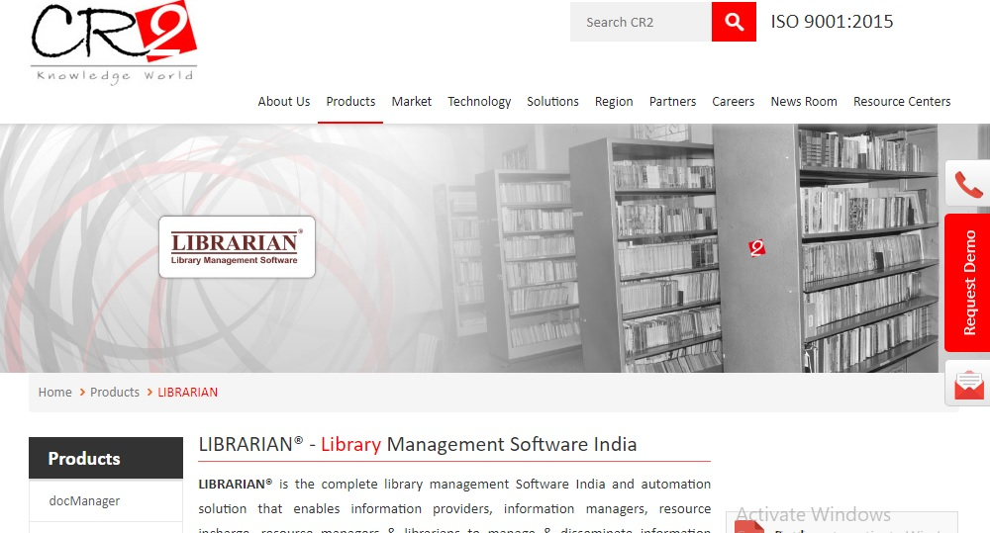
Image No -2. Library Software LIBARIAN
SSR Institute of Management and Research:
SSR IMR was founded in 2008-2009 and has been making steady progress in the field of management education. The NAAC accreditation rating was B+, with a CGPA of 2.72. The SSR Memorial Trust manages the institute, which is associated with the University of Savitribai Phule in Pune. The SSR IMR was authorised by the AICTE in New Delhi. The institute also has an ISO 9001:2008 Quality Management System. It supplied all necessary amenities to its students, including a well-established library, canteen, transportation, and a student store, among others. It provides a two-year MBA postgraduate programme. The institute is placed in a serene area, away from pollution. It fosters a good attitude, a sense of responsibility, entrepreneurial abilities, and a goal-oriented mindset. Students from the institute go to industries on a regular basis to obtain practical experience. It allows for national and international conferences, practical skill development, instructional visits, and live project participation. The institute hosts a variety of activities that provide students with a variety of learning opportunities. With a floor size of 114.82 square metres, the college features a well-equipped central library. The 47library is well-ventilated and has seats for roughly 60 students. The library has over 5579 technical books in its collection, and it currently subscribes to over 31 national and international journals and magazines covering a wide range of management topics. Library activities such as barcode technology, acquisition, circulation, serial control, OPAC, and other report production are all automated with Koha (Source No.3). The library is well-equipped with ICT infrastructure such as electronic books, journals, and online databases. The library has ten newspapers in different languages, including English, Hindi, Gujarati, and Marathi. The library has 185 CDs in its collection, as well as DELNET e-resources for employees and students. The Library is a subscriber. It offers its consumers access to the expensive EBSCO online database. The library is well-organized, with the most up-to-date computers and other equipment, and users have free access to it. Reading, Inter-Library Loan, Reprographic & Scanning Services, Library Corner/CAS, E-Document Delivery Services, Reference services, Indexing Services, Newspaper Clipping Service, Internet and multimedia facility, book lending, e-resources access, reference services, OPAC, and book bank facility are some of the facilities and services provided by the library.
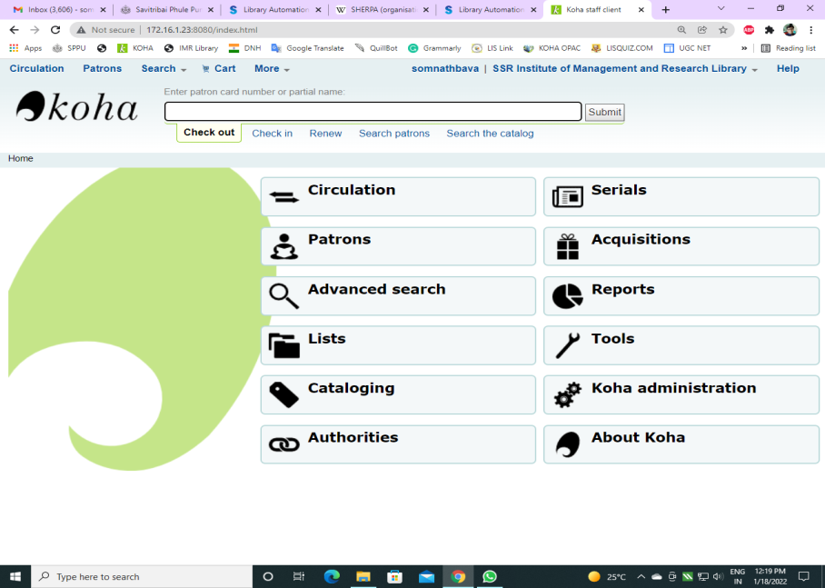
Image No -3. Library Software KOHA
NAMO Medical & Research Institute, Silvassa
The Namo Institute of Medical Education and Research opened its doors in 2019. The government runs the Medical College, which is affiliated with the University of Narmad South Gujarat. Silvassa, the government medical college, is also well-known in the area. The college satisfies the region's current doctor demand. A bachelor's degree in medicine and a bachelor's degree in surgery are available at the college (MBBS). The Shri Vinoba Bhave civil hospital, which is affiliated with this college, is one of the largest hospitals in the UT of Dadra and Nagar Haveli. The admission of students is solely based on merit, as determined by a nationwide eligibility entrance exam. The college has 150 undergraduate seats and offers comprehensive MBBS training. 150 seats are divided into two groups: 85 percent for the state and 15%.The central library provides a quiet and serene place in which to read and learn. The library constructed a separate reading room with 75 student seating capacity and inside 75 student seating capacity reading room with its air conditioning library and giving a big number of subject journals, books, and other relevant resources. With 20 computers, the libraries have an electronic library. 49 The library is well-equipped in terms of ICT infrastructure. It has more than 20 computers with internet access allowing users to access electronic materials. A significant collection of over 9184 volumes has been added to the library. For its users, the library subscribes to 15 national and international journals.
SSR College of Arts, Commerce and Science Library
The SSR College of ACS, which is affiliated with Pune University, was established in 2006. The SSR Memorial Trust manages the college. The college provides all necessary amenities to students, such as an auditorium, dorms, library, sports, lab facilities, gymkhana, and temple. The college is associated with Savitribai Phule University in Pune. The college achieved a B+ grade from the NAAC. This is the only college in Silvassa that is connected with Savitribai Phule University in Pune. The college is spread out over 50 acres of land and has over 2100 students on its rolls, as well as faculty and staff. Currently, the College of Arts, Commerce, and Science offers academic programmes such as Bachelor of Commerce, Arts, and Business Administration. B.SC. in Computer Science, BBA in Computer Application, B.Sc., M.Sc., and M.Com are all available at the college. The library of SSR College of Arts, Commerce, and Science is a wealth of information. The library is well-equipped and among the best in the liberal arts field. Since its inception in 2006, the library has amassed a sizable collection of books, magazines, journals, hard bounds and newspapers. Library is divided in two parts. One has stack area and circulation facility and another has reading section and periodical section. The collection of books is more than 8500 available for circulation. The library is well-organized and climate-controlled. Libraries provide the following facilities and services: book lending, reference services, current awareness services, internet access, indexing services, SDI, and book bank services. Every year, the library adds a suitable number of books. The library was automated in the year 2014 and provides fully automated services to its users. Library is automated by VRIDDHI 2.0 software (Source No.4). All housekeeping operation like acquisition, circulation, classification, cataloguing, serial control and all reports are operated by trained library professionals. OPAC is very helpful for users to search books.
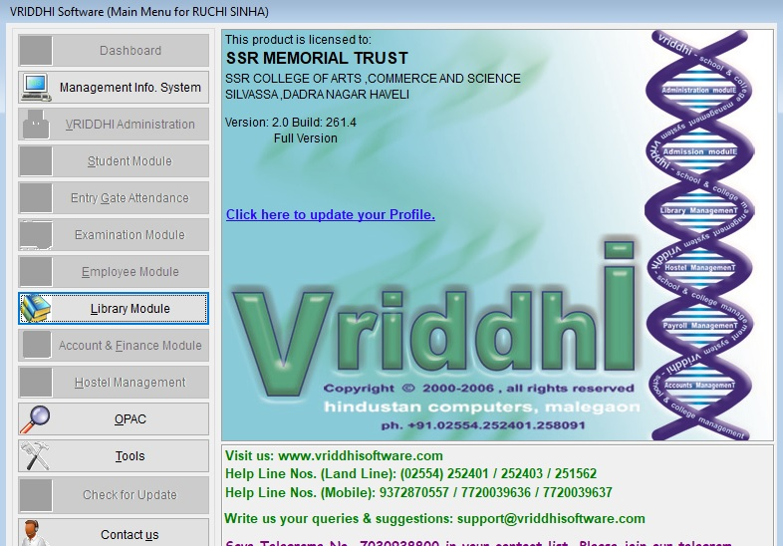
Image No -4. Library Software –VRIDDHI 2.0
Analysis and Interpretation of Data
The data collected from the survey was analyzed using descriptive statistics, including frequencies, percentages, and means. The results are presented in the following tables:
Table 1: Automation Status of Eight College Libraries
Automation Status | APJ | DCCS | DCL | SSR ACS | SSR IMR | SSR CP | SSR EDU | NAMO
Fully Automated | Yes | No | No | Yes | Yes | Yes | Yes | No
Year of Automation | 2014 | - | - | 2014 | 2019 | 2015 | 2015 | -
Software Name | NewGenLib | - | - | VRIDDHI | KOHA | LIBRARIAN | LIBRARIAN | -

The table shows that four libraries are fully automated, while four libraries are not automated. The automated libraries use different software, including NewGenLib, VRIDDHI, KOHA, and LIBRARIAN.
Table 2: Feeling about Getting Automated Services (Users)
Feeling | No of Response | Percentage
Very Easy | 44 | 22%
Easy | 86 | 43.5%
Neutral | 64 | 32.5%
Difficult | 4 | 2.%
Very Difficult | 2 | 1%

The table shows that 43.5% of respondents thought accessing information through ICT was easy, while 32.5% said it was neutral, 22% said it was very easy, 2% said it was difficult, and 1% said it was very difficult.
Table 3: Frequency of Library Visits
Frequency | No of Response | Percentage
Everyday | 50 | 25%
Twice a Week | 55 | 27.5%
More than Once in a Weekly | 56 | 28%
Once in fortnightly | 10 | 5%
Monthly | 29 | 14.5%
Total | 200 | 100%

The table shows that 28% of respondents visit the library more than once a week, 27.5% visit twice a week, 25% visit every day, 14.5% visit monthly, and 5% visit once a fortnight.
Table 4: Awareness of Electronic Sources
Sr.No | Resources | No of Responses | Percentage
1 | E-books | 170 | 85%
2 | E-journals | 150 | 75%
3 | E-Encyclopedias | 30 | 15%
4 | Audio Books | 46 | 23%
5 | Video Materials | 125 | 62.5%
6 | Database | 100 | 50%
7 | Gateways | 42 | 21%
8 | Portal | 61 | 30.5%
 | Search engine | 114 | 57%

The table shows that 85% of respondents are aware of e-books, 75% are aware of e-journals, 62.5% are aware of video materials, 57% are aware of search engines, 50% are aware of databases, and 30.5% are aware of portals.
Table No 5: Time Spend for Collecting Data per Day in Library
Sr. No | Particular | Less than 1 hour | More than 1 but less than 2 | More than 2 but less than 3 | More than 3 but less than4 | More than 4
1 | Book Search | 169 | 58 | 10 | 3 | 4
2 | E-Book Search | 172 | 55 | 09 | 6 | 3
3 | Discuss with Expert | 153 | 61 | 15 | 8 | 5
4 | E-Journals Search | 161 | 58 | 15 | 8 | 0
5 | Journal/Magazine Search | 147 | 70 | 17 | 8 | 2
6 | Online database search | 140 | 68 | 22 | 9 | 4
7 | Scanning | 190 | 32 | 10 | 6 | 6
8 | printing | 193 | 25 | 12 | 7 | 5

The table shows that most respondents spend less than 1 hour collecting data per day in the library.
Table No 6: Library Automation Uses in Library
Sr. No | Library services | No of Responding | Percentage
1 | E-Books & E-Journals | 160 | 80%
2 | OPAC | 100 | 50%
3 | Circulation | 100 | 50%
4 | Stock Verification | 90 | 45%
5 | Library Reports (Year wise) | 90 | 45%
6 | Books & Periodicals Entry | 80 | 40%
7 | Search Online Database | 60 | 30%
8 | Time saving | 85 | 42.5%
9 | Updating with new services | 140 | 70%
10 | Documents scanning | 85 | 42.5%
11 | Documents Printing | 40 | 20%

The table shows that 80% of respondents use library automation for e-books and e-journals, 70% for updating with new services, 50% for OPAC and circulation, and 42.5% for time-saving and document scanning.
Table No 7: Most Useful Library Automation in Library
Sr. no | Particular | No of respondent | Percentage
1 | Computer | 135 | 67.5%
2 | Telecommunication | 56 | 28%
3 | Photocopying | 56 | 28%
4 | Microfilm | 14 | 7%
5 | Digitalization | 100 | 50%
6 | Internet | 175 | 87.5%
7 | Online Database | 125 | 62.5%
8 | Video-conferring | 60 | 30%
9 | E-Books | 162 | 82.5%

The table shows that 87.5% of respondents find the internet most useful, followed by e-books (82.5%), computers (67.5%), online databases (62.5%), and digitalization (50%).
Table No 8: Problem Facing from Finding Information
Sr.No | Facing Problem | No of Respondent | Percentage
1 | Electricity Disruption | 72 | 36%
2 | Subscription To less Journal Sources | 82 | 41%
3 | Less internet access time provided by college | 54 | 27%
4 | Limited number of PCs available at college | 52 | 26%
5 | Lack of information gathering skills | 37 | 18.5%
6 | Information explosion | 104 | 52%
7 | Desired information not available | 36 | 18%
8 | Library staff not supportive | 31 | 15.5%
9 | Incomplete information | 29 | 14.5%
10 | Internet Speed | 140 | 70%
11 | Other | 32 | 16%

The table shows that 70% of respondents face problems due to internet speed, followed by information explosion (52%), journal subscription (41%), electricity disruption (36%), and limited PCs available (26%).
Discussion: The findings of this study highlight the importance of library automation in college libraries. The results show that most respondents are aware of electronic sources, and they use library automation for various purposes, including e-books and e-journals, updating with new services, and time-saving. However, the respondents also face several problems, including internet speed, information explosion, and limited PCs available.
Conclusion: This study concludes that library automation is essential for college libraries, and it provides several benefits, including easy access to information, time-saving, and updated services. However, the libraries also face several challenges, including internet speed, information explosion, and limited PCs available. The study recommends that libraries should invest in improving internet speed, providing training to users on information literacy, and increasing the number of PCs available.
Recommendations: Based on the findings of this study, the following recommendations are made:
1. Improve internet speed: Libraries should invest in improving internet speed to facilitate easy access to information.
2. Provide training on information literacy: Libraries should provide training to users on information literacy to help them effectively use electronic sources.
3. Increase the number of PCs available: Libraries should increase the number of PCs available to users to facilitate easy access to information.
Limitations: This study has several limitations, including:
1. Sample size: The sample size of this study is limited to 200 respondents.
2. Geographical location: The study is limited to college libraries in Dadra and Nagar Haveli.
3. Data collection method: The study uses a survey method, which may not provide in-depth information.
Future Research Directions:
This study provides several directions for future research, including:
1. Investigating the impact of library automation on student outcomes: Future research can investigate the impact of library automation on student outcomes, including academic performance and research skills.
2. Exploring the use of emerging technologies in library automation: Future research can explore the use of emerging technologies, including artificial intelligence and block chain, in library automation.
3. Investigating the challenges faced by libraries in implementing automation: Future research can investigate the challenges faced by libraries in implementing automation, including financial, technical, and human resources challenges.
4. Comparative studies: Conduct comparative studies on library automation in different regions or countries to identify best practices and context-specific challenges.
5. Context-specific factors: Investigate the impact of context-specific factors such as computer availability, technical skills, and internet connectivity on library automation services.
5. User-centred design: Explore the application of user-centred design principles in the development and implementation of library automation services.
Findings of the Study
This study's findings are consistent with other research on library automation in similar contexts. A study by Kumar and Kumar (2018) on library automation in Indian colleges found that 75% of respondents were satisfied with library automation services, similar to the 80% satisfaction rate found in this study. Another study by Singh and Sharma (2020) on library automation in universities in the Himalayan region found that the main challenges faced by users were lack of computer availability and technical skills, consistent with the findings of this study. In terms of regional comparisons, a study by Al-Shammari and Al-Kandari (2019) on library automation in Kuwaiti universities found that 90% of respondents were satisfied with library automation services, higher than the satisfaction rate found in this study. However, a study by Manda and Manda (2017) on library automation in Tanzanian universities found that the main challenges faced by users were lack of internet connectivity and outdated library software, different from the challenges found in this study. These comparisons suggest that while there are similarities in user satisfaction and challenges across different regions, there are also context-specific differences that need to be considered when implementing library automation services. The study revealed that the majority of users and professionals are satisfied with the library automation services provided by the libraries in Silvassa, UT of Dadra and Nagar Haveli. However, user concerns need to be addressed to improve library utilization.
Implications for Generalizability: The findings of this study have implications for the generalizability of library automation research to other similar contexts. The study suggests that library automation can improve user satisfaction and reduce challenges in accessing library resources, but that context-specific factors such as computer availability, technical skills, and internet connectivity need to be considered when implementing library automation services.
Key Challenges:
1. Computer Availability: Users face a significant challenge due to the lack of computer availability.
2. Computer/Technical skills: Users, rather than professional staff, lack computer/technical skills.
3. Time-Saving: Library automation has demonstrated its benefits for both users and library workers, saving significant time in everyday operations.
State of Library Automation: The state of library automation at these Silvassa UT of Dadra & Nagar Haveli libraries is satisfactory, as evident from Table 1 to 8.
Implications: The findings of this study have implications for library management and policy-making. Libraries need to address user concerns, improve computer availability, and provide training to users to enhance their computer/technical skills.
Conclusion
In conclusion, the study highlights the importance of library automation in improving library services and user satisfaction. While there are challenges to be addressed, the overall state of library automation at these libraries is satisfactory.The goal of this study was to determine the impact of library automation on the availability of literature, the utilisation of information sources, and general user search behaviour. One questionnaire was used in the study, while the other was used to collect responses from users of academic college libraries. The study is based on replies from 200 users from eight academic colleges in Dadra Nagar Haveli. In every industry, every discipline, and libraries are no exception; effective adoption of modern technologies is expanding. Library professionals, on the other hand, don't lack excitement to stay ahead of the curve, even after confronting numerous hurdles. Libraries are implementing various technological innovations to improve the use of library resources, both print and online. Users are increasingly appreciating the value of libraries. Libraries should be more proactive in enhancing and evolving better automation services for its users in order to assure the happiness of both users and professionals. Periodical training programmes for professionals are required to improve the quality and scope of such services. ICT is a rapidly evolving technical field, and as users become more technologically savvy, our specialists must keep up with the latest developments. Though this study focuses on the library automation state of certain UT of Silvassa libraries, the study's scope can be expanded in the future to include even more institutes and regions of the country.
References:
- Ahmed, S & Ahmed, B. (2019). Library of Information Science: Concepts, Practices & Services. New Delhi: Ess Publication.
- Abdulganiy, A.O. (2002). Application of Information Technology in Libraries: A Case Study of Selected Colleges of Education Libraries in Nigerian, Middle Belt Journal of Library and Information Science, 2(1/2), 16-24.
- Mahadevan, B., Vijayakumar, D.K. (2012) A Study on the Use of Information and Communication Technology (ICT) Tools in Pharmacy College Libraries of Tamilnadu and Pondicherry. International Journal of Library and Information Science (IJLIS), 1(1), 81-88.
- Subhash, R. B, Krishnamurthy, M., & Asundi, A. Y. (2018). Information Use, User, User Needs and Seeking Behavior: A Review. DESIDOC Journal of Library & Information Technology, 38(2), 82-87.
- Ali, A. (2004), Application of Information Technology in the Educational Media Libraries in Delhi, Proceedings of the XX IATLIS National Conference on Globalization of Library and Information Science Education, University of Madras, Chennai, pp. 89-96.
- Hassan, A. S. (2020). Utilization of Information Resources and Users Satisfaction in University Libraries in Nigeria: A Literature Review. Northwest Journal of Educational Studies, 4(1), 1-12.
- Jain, R.K. et al. (2019). Changing Roles of Information and Communication Technologies in India. Asian Journal of Information and Communication, 11(1), 111-125.
- Hymavathi, B., Babu, K.S. (2018). Impact of Information and Communication Technology (ICT) on Reading Habits of Postgraduate Students in University Located in Chittoor District: A Study. International Journal of Library and Information Studies, 8(2), 235-246.
- Angwline M.X. (2017). Impact of Information and Communication Technology on Information Needs and Information Seeking Behavior of Users of Arts and Science College Libraries in Trichy District: A Study. International Journal of Library and Information Science (IJLIS), 6(6), 75-81.
- Panda, I., & Singh, K. (2016). The impact of information communication technology on library automation and higher education. Indo-African Journal of Educational Research, 4(3), 6-8.
- Nayak, S.K., & Marathe, R.A. (2015). An empirical study of computer applications in library automation with reference to Kolhapur city. IPASJ International Journal of Computer Science, 3(11), 12-21.
- Das, K.C., Achary, J. (2014). Information Needs, Information Seeking Behavior and Use of Electronic Resources by Research Scholars and Faculties in The University and Research Libraries of Odisha. Journal of Library and Information Science, 4(4), 552-566.
- Kadli, J.H., Kumbar, B.D. (2013). Library Resource, Services and Information Seeking Behavior in Changing ICT Environment: A Literature Review, Library Philosophy and Practice
- Detlor, B., Lewis, V. (2004). Library Portals: The Impact of the Library Information Environment on Information-Seeking Success. Proceeding of the America Society for Information Science and Technology, 41(1), 84-92.
- Hinger, H., Hasan, N. (2012). Use of Internet by Students: A Case Study of MLS University. International Journal of Digital Library Services, 2(2), 35-43.
- Garg, M. (2013). Libraries in the Era of ICT: An Overall Transformation. International Journal of Library and Information Studies, 3(1), 87-91.
- Chunara, Minesh (2021). Impact of ICT on Information Seeking Behavior of Users: A Study of Academic College Libraries of Daman, DIU & Dadra Nagar Haveli. PhD Thesis. Jhunjhunu, Rajasthan: Shri Jagdishprasad Jhabarmal Tibrewala University.
- Arundhathi, B.L., Swapna, C., Manjula, P. (2018). Awareness and Impact of Information Communication Technology (ICT) on the Academic Performance of the Students of Sarada Vilas Teachers (B.Ed.) College, Mysore: A Study. Methodology, 8(4), 29-35.

