**Supplementary data**

*Quantitative measurement of hair diameter diversity as a diagnostic indicator of androgenetic alopecia: A cross-sectional study*

*Hee Ung Park1, Kyung Bae Chung2, Do-Young Kim2\**

*1Department of Dermatology, Hanyang University Medical Center, Myongji Hospital, Goyang, Republic of Korea*

*2Department of Dermatology, Cutaneous Biology Research Institute, Yonsei University College of Medicine, Seoul, Republic of Korea*

**Supplemental figure 1. Comparison of hair diameter between retrospective and prospective groups**

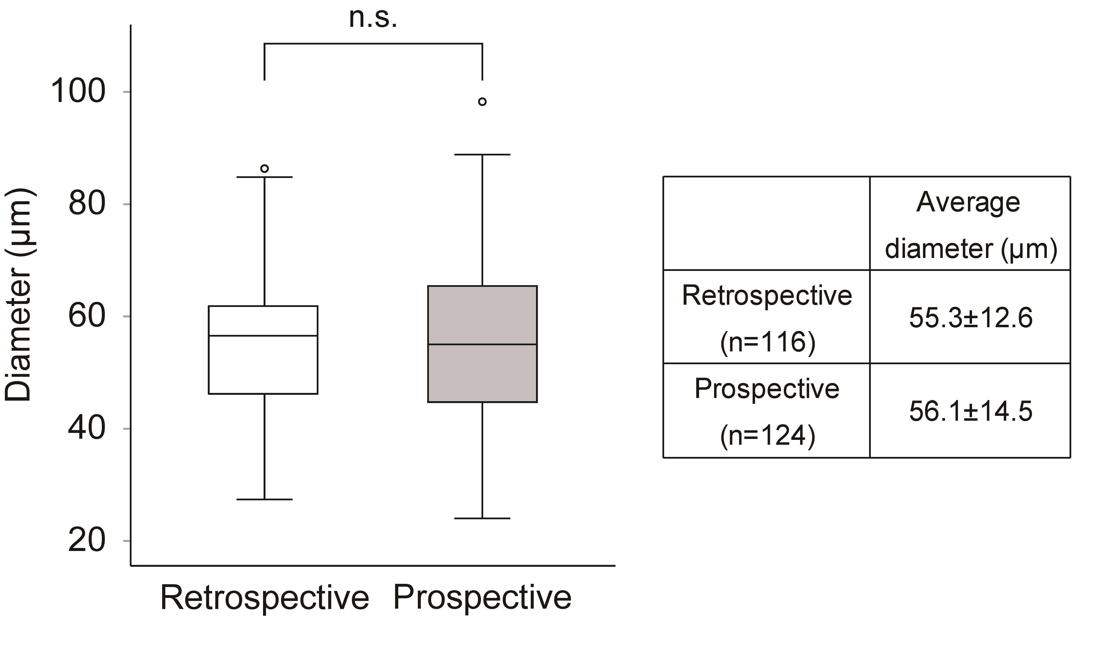

The comparison between the retrospective (n=116, 55.3±12.6 µm) and prospective (n=124, 56.1±14.5 µm) groups shows no significant difference (n.s.) in overall hair diameter measurements.

**Supplementary figure 2. Standardized measurement of hair diameter at specified height from scalp**

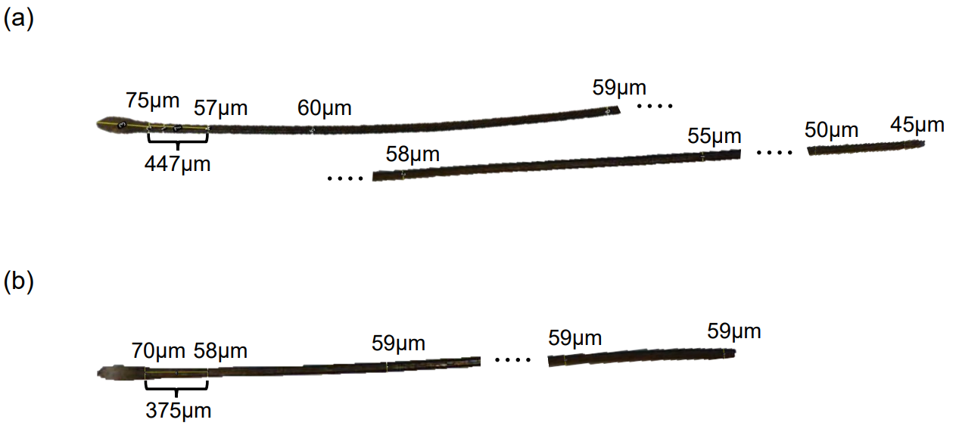

Measurement of hair thickness using telogen hair shafts from healthy donors, (a) a young female with long hair and (b) a young male with short hair, highlights that from 350-450 µm above the scalp up to the mid-shaft, the hair maintains its thickness before tapering towards the end due to wear.

**Supplementary figure 3. ROC curves for different hair diameter thresholds at 30 µm, 40 µm, 45 µm, and 50 µm.**

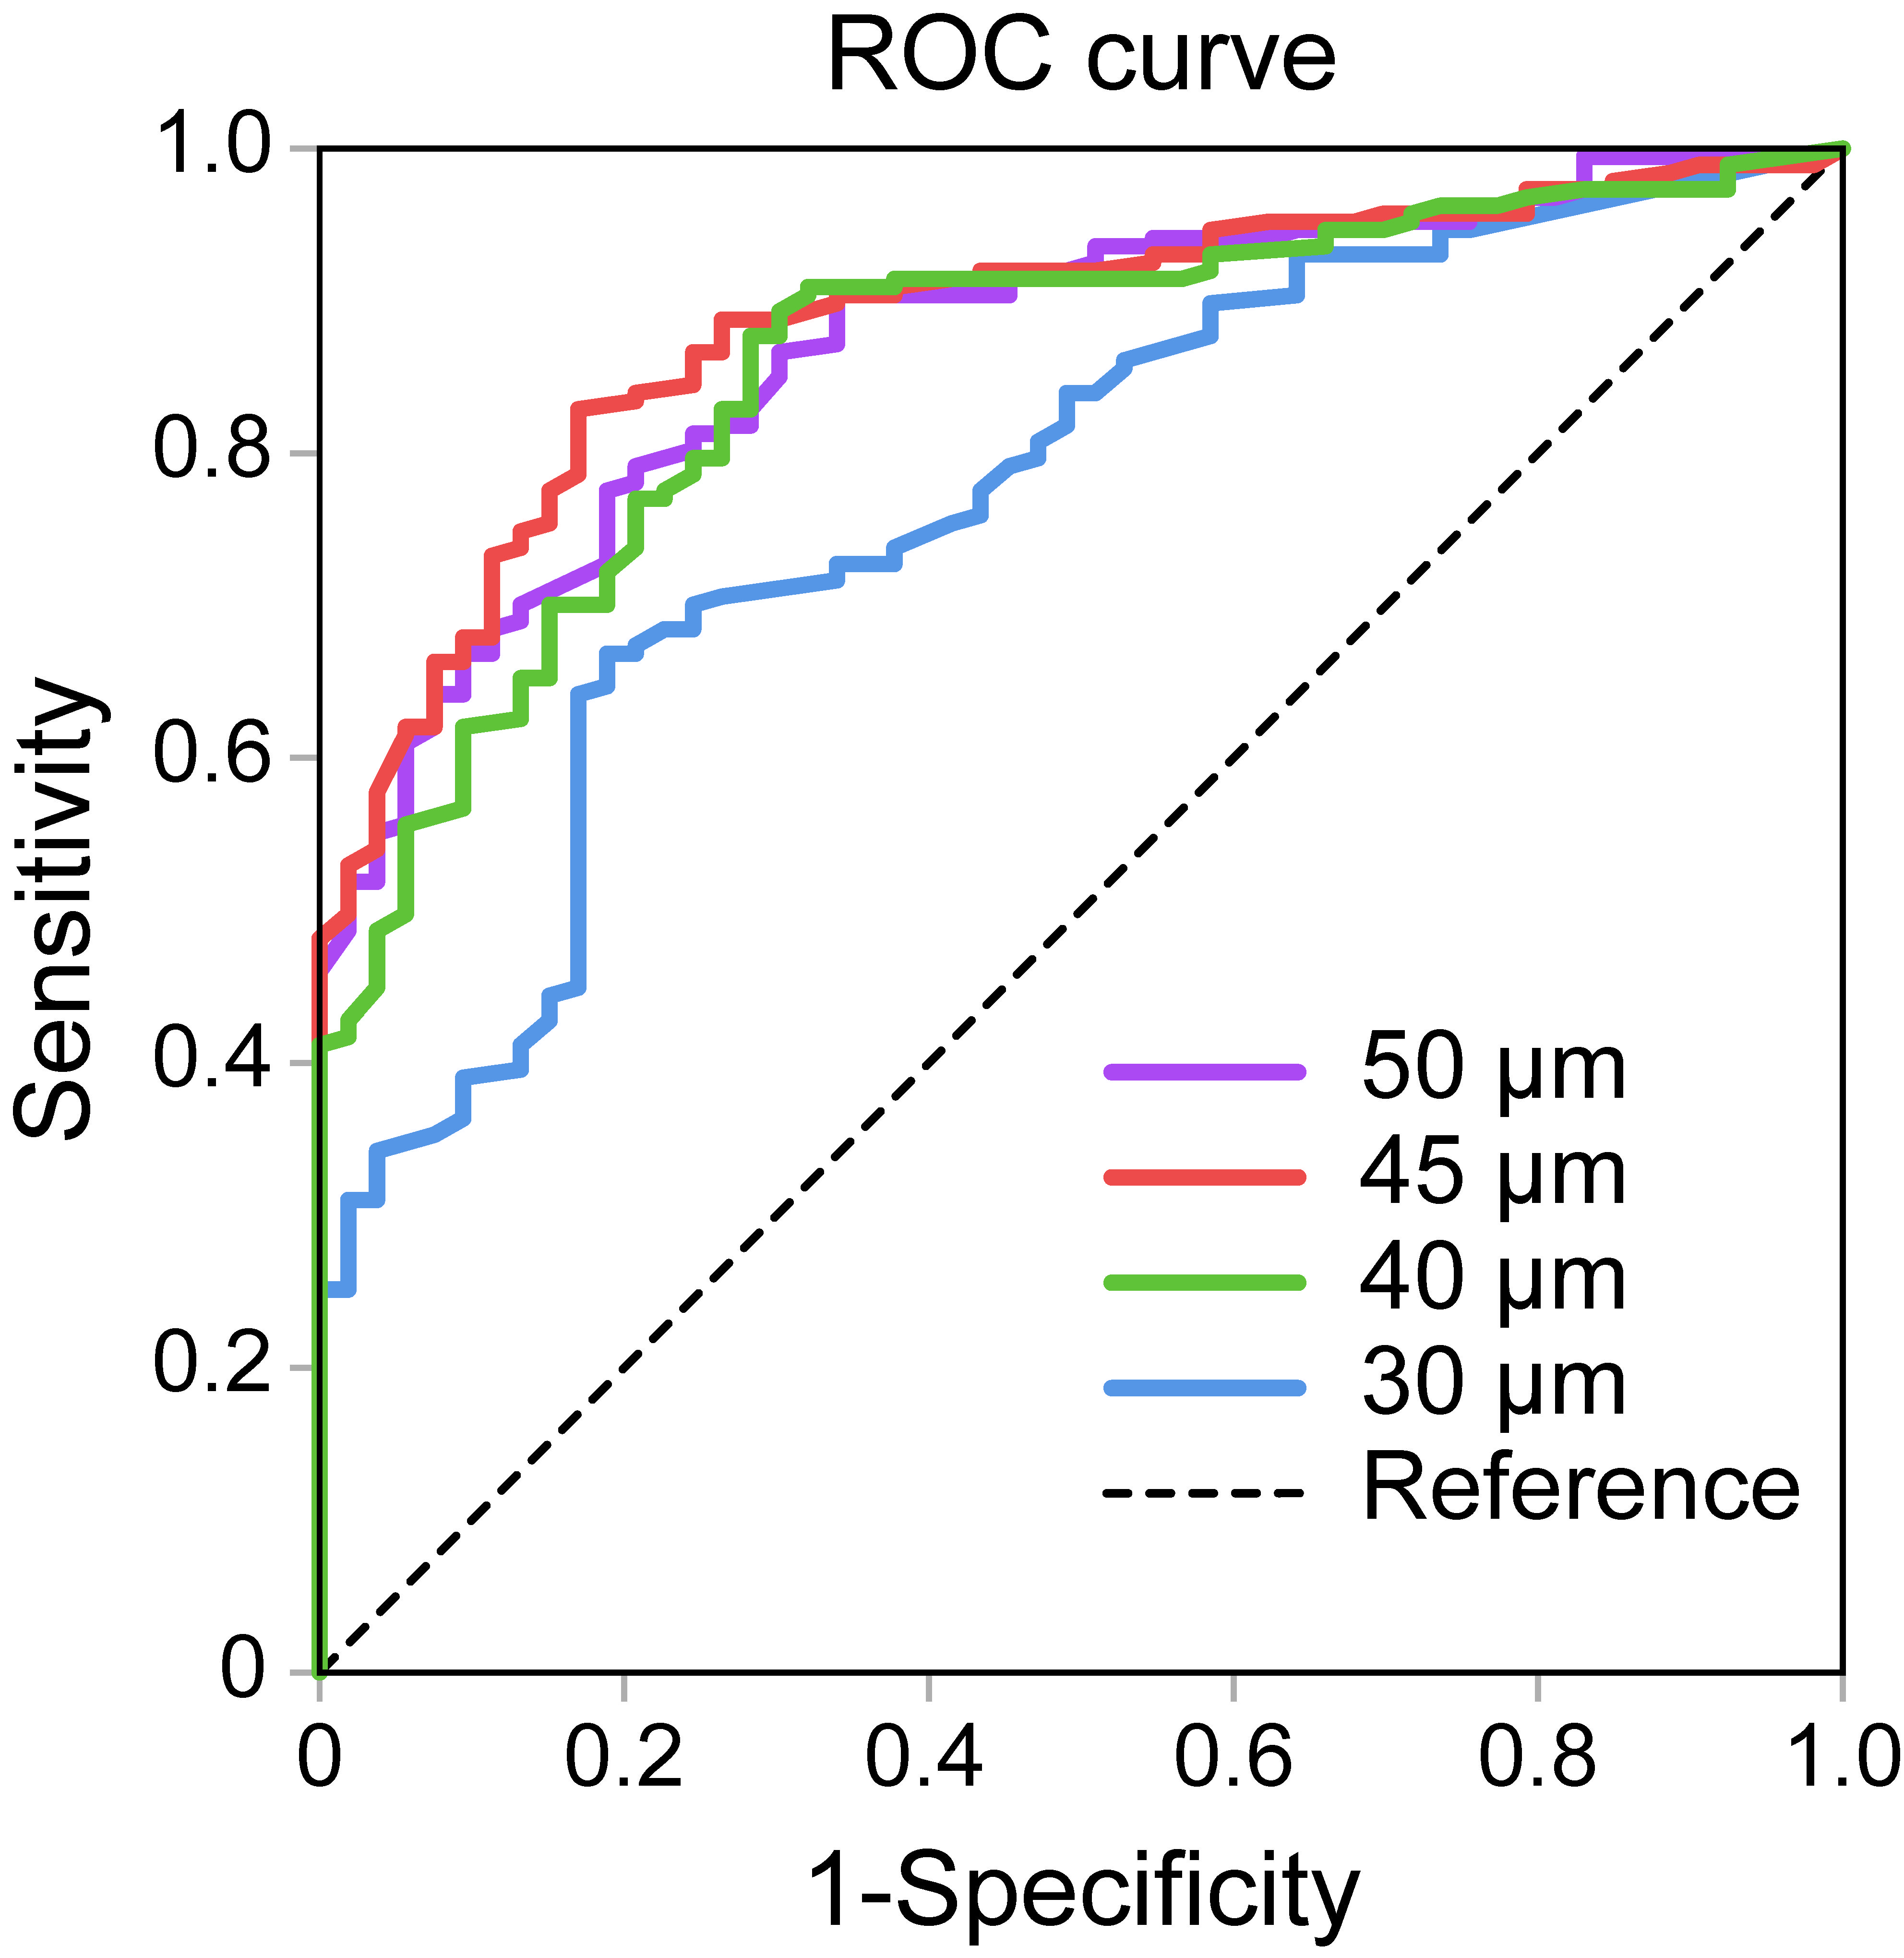

The ROC curves illustrate the diagnostic performance of different hair diameter thresholds for AGA, with the 45 µm line showing the highest AUC.