SUPPORTING MATERIAL

A DNA Hydrogel Gated Organic Field Effect Transistor

Justine Pallu¹, Meltem Avci-Adali², Peter Mackeben², Leila Mohammadnejad², Giorgio Mattana¹, Vincent Noël¹, Benoît Piro^{1,*}

¹ Univ. Paris Diderot, Sorbonne Paris Cité, ITODYS, UMR 7086 CNRS, 15 rue Jean-Antoine de Baïf,
75205 Paris Cedex 13, France
² Department of Thoracic and Cardiovascular Surgery, University Hospital Tübingen, Tübingen, Germany

Fabrication procedures for the lithographied transistors
Transistor electrodes were photolithographied on (100) 2’’ n-doped Si wafers with a 200 nm-thick thermally grown oxide layer (BT Electronics, France). Wafers were ultrasonicated in acetone and isopropanol during 3 min each, cleaned 3 min in an ozone cleaner (UVOCS 10×10 OES, USA) then dried 10 minutes at 120°C on a hot plate, then the AZ 5214 photoresist was spin-coated (30 s at 4000 rpm) then baked at 110ºC for 1 minute. Interdigitated source and drain gold electrodes were UV-photolithographied by exposure to UV light (1.8 s) in low vacuum contact mode followed by hard baking for 2 min at 120ºC and again exposure the full wafer to UV light for 1 min. Development was performed in AZ 326 metal ion free (MIF) developer for 15 s and electrodeionized (EDI) for 60 s. An adhesion layer of 10 nm of titanium (0.15 nm s⁻¹) followed by a gold layer of 100 nm (0.30 nm s⁻¹) were evaporated through the photomask. The obtained transistors present interdigitated source and drain contacts defining a channel width (W) of 30,000 μm and a channel length (L) of 10 μm.

Fabrication procedures for the DNA hydrogel-modified gate
1.1. DNA sequences
For the generation of DNA hydrogels by rolling circle amplification (RCA) and multi-primed chain ampliﬁcation (MCA) [1]), the linear ssDNA (5’-phosphate-TCGTTTGATGTTCCTAACGTACCAACGCACACGCAGTATTATGGACTGGTAAAAGCTTTCCGAGGTAGCCTGGAGCATAGAGGCATTGGCTG-3’), primer 1 (5’-TAGGAACATCAAACGACAGCCA-3’), primer 2 (5’-ACGCAGTATTATGGACTG-3’), and primer 3 (5’-thiol-TGGTACGTTAGGAACATC-3’) [2], VEGF aptamer conjugated to primer 2 (5'-TCTGTCAATCGATCGTATCAGTCCACAAGCCCGTCTTCCAGACAAGAGTGCAGGGC-spacer C18-ACGCAGTATTATGGACTG-3') [3], and FAM antidote (5'-FAM-spacer C18-GCCCTGCACTCTTGTCTGGAAGA-3') were used. All oligonucleotides were ordered high-performance liquid chromatography (HPLC)-purified from Ella Biotech GmbH (Martinsried, Germany).

1.2. Generation of the circular DNA template for rolling circle amplification (RCA)
To obtain the circular DNA template, 0.5 µM of phosphorylated linear ssDNA was incubated in 200 µL nuclease-free water (Qiagen, Hilden, Germany) containing 1000 U CircLigaseTM ssDNA Ligase (100 U µL⁻¹, Biozym Scientific GmbH, Hessisch Oldendorf, Germany), CircLigase™ 1x reaction buffer, 50 µM ATP, 2.5 mM MnCl₂ overnight at 60°C. Afterwards, the reaction mixture was incubated for 10 min at 80°C to inactivate the CircLigase and then gradually cooled to 4°C. In order to eliminate non-circular ssDNA residues, the reaction mixture was further supplemented with 300 U of Exonuclease I and 3000 U of Exonuclease III (Epicentre, Wisconsin, USA), 1x Exonuclease III reaction buffer in 250 µL and incubated for 3 h at 37°C. The solution was then incubated for 40 min at 80°C to inactivate the exonucleases and the reaction mixture was then stepwise cooled down to 4°C. The solution was purified using Amicon Ultra-0.5 mL centrifugal filters (10K, Merck Millipore, Darmstadt, Germany) according to manufacturer´s instructions. The circular DNA concentration was measured with a spectrophotometer (ScanDrop, Analytik Jena, Jena, Germany). Afterwards, 100 pmol circular DNA was mixed in 100 µL nuclease-free water containing NaCl (50 mM) with 100 pmol primer 1 to hybridize the primer 1 to the circular DNA and incubated for 2 h at RT.

1.3. RCA
To perform RCA, 580 ng circular DNA hybridized with the primer 1 was incubated for 4 h at 37°C with 50 U Φ29 DNA polymerase and 1x reaction buffer (New England Biolabs, Ipswitch, USA), 2.5 mM dNTPs (Qiagen, Hilden, Germany), and 200 µg mL⁻¹ bovine serum albumin (BSA) in a final volume of 50 µL for each gold wire.

1.4. Detection of incorporated VEGF aptamer
The successful incorporation of anti-VEGF aptamer into the DNA hydrogel was analyzed by using a FAM-labeled antidote, which is complementary to VEGF aptamer conjugated to primer 2. The detection of fluorescence intensity (excitation 490 nm, emission 535 nm) was performed using the microplate reader (Mithras LB 940, Berthold Technologies, Bad Wildbad, Germany).

1.5. VEGF ELISA
DNA hydrogels with or without VEGF aptamer were incubated with 375 pg recombinant human VEGF (biomol, Hamburg, Germany) in 250 µl DPBS containing 1% BSA. The amount of bound VEGF to 50 µl DNA hydrogel was determined using human VEGF DuoSet ELISA, R&D Systems (Minneapolis, MN, USA).

1.4. Functionalization of the gate electrode
Details are given in Section 2.2 of the main manuscript. Fig. SI.1 shows a picture of result, where the DNA hydrogel can be seen at the extremity of the gold wire.
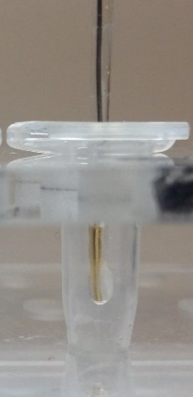
Figure SI.1. DNA hydrogel made on a gate electrode. Diameter = 1 mm; Hydrogel thickness = 1 mm; Hydrogel length = 2 mm.

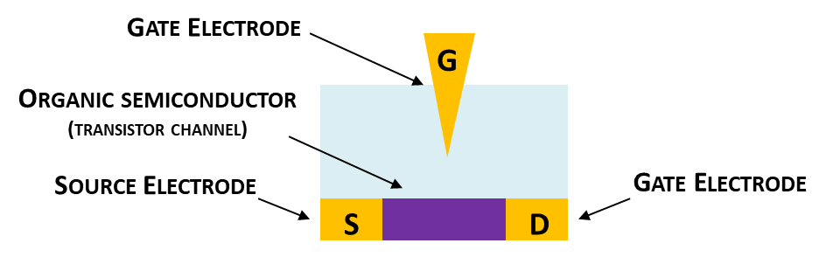
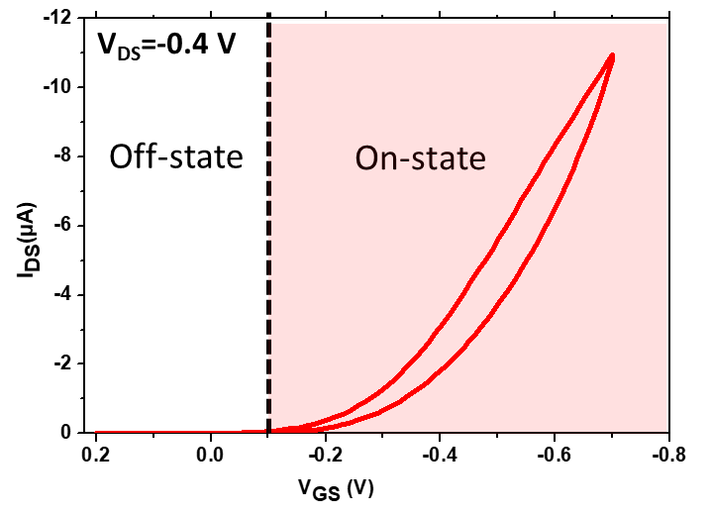
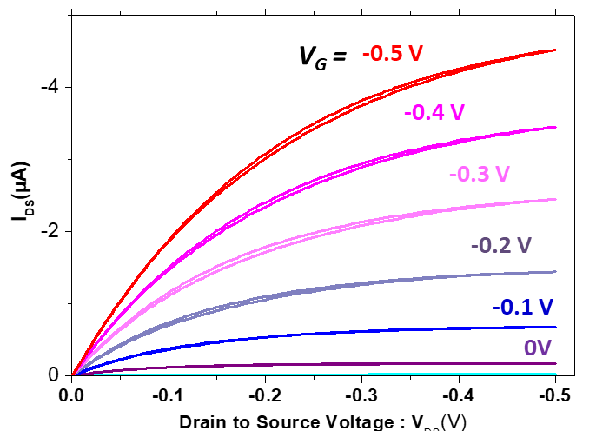

Figure SI.2. Top: Schematic view of the water-gated organic field effect transistor (WGOFET) arrangement, without DNA hydrogel. Middle: Transfer curves I_{D} = f(V_{GS}) obtained at V_{DS} = -0.4 V. Bottom: Output curves I_{D} = f(V_{DS}) acquired at V_{GS} from +0.2 V to -0.5 V for an Au gate without DNA hydrogel. Medium: PBS. Gate electrode diameter = 1 mm.

Figure SI.3. A. Detection of fluorescence intensity after addition of FAM-labeled antidote complementary to the aptamer introduced within the DNA hydrogel (positive). Two negatives: one with a hydrogel without VEGF aptamer, and another without antidote (n=3). B. ELISA detection of bound VEGF to the DNA hydrogel, after incubation of the DNA hydrogel with (w) or without (w/o) VEGF aptamer with 375 pg VEGF (n=5).

References
[1] H. Stoll, H. Steinle, K. Stang, S. Kunnakattu, L. Scheideler, B. Neumann, J. Kurz, I. Degenkolbe, N. Perle, C. Schlensak, H.-P. Wendel, M. Avci‐Adali. Generation of Large‐Scale DNA Hydrogels with Excellent Blood and Cell Compatibility, Macromol Biosci. 17(4) (2017). DOI: 10.1002/mabi.201600252.
[2] J.B. Lee, S. Peng, D. Yang, Y.H. Roh, H. Funabashi, N. Park, E.J. Rice, L. Chen, R. Long, M. Wu, D. Luo, A mechanical metamaterial made from a DNA hydrogel, Nature nanotechnology 7(12) (2012) 816-20. DOI: 10.1038/nnano.2012.211.
[3] M. Kimoto, R. Yamashige, K. Matsunaga, S. Yokoyama, I. Hirao, Generation of high-affinity DNA aptamers using an expanded genetic alphabet, Nat Biotechnol 31(5) (2013) 453-457. DOI: 10.1038/nbt.2556.

