Genetic and Biochemical Characterization of Lacticaseibacillus rhamnosus MDC 2012 and Its Potential in Processing of Raw Pork Meat
Hasmik Grigoryan¹,²*, Gayane Marmaryan¹, Tigran Soghomonyan², Lev Khoyetsyan², Ani Paloyan², Flora Tkhruni², Kristina Karapetyan², Artur Hambardzumyan²
¹Armenian National Agrarian University, Department of Biosciences and General Chemistry, 0009, Teryan str. 74, Yerevan, Republic of Armenia
²Scientific and Production Center "Armbiotechnology,” National Academy of Sciences of the Republic of Armenia, 14 Gyurjyan Str., 0056 Yerevan, Republic of Armenia
*Corresponding Author: Hasmik Grigoryan, PhD Student, Department of Biosciences and General Chemistry, 0009, Teryan str. 74, Yerevan, Republic of Armenia

Table S1. Lacticaseibacillus rhamnosus MDC 2012 whole-genome sequences overview
Contig | Length (bp) | Coverage | Circular | Repeat |  | Multiplicity
contig_3 | 475804 | 13 | N | N | 1
contig_2 | 352330 | 11 | N | N | 1
contig_23 | 324785 | 10 | N | N | 1
contig_11 | 245092 | 15 | N | N | 1
contig_24 | 209309 | 11 | N | N | 1
contig_41 | 146653 | 13 | N | N | 1
contig_53 | 143496 | 13 | N | N | 1
contig_46 | 136510 | 10 | N | N | 1
contig_51 | 135189 | 10 | N | N | 1
contig_28 | 118115 | 13 | N | N | 1
contig_35 | 97372 | 10 | N | N | 1
contig_7 | 88740 | 14 | N | N | 1
contig_12 | 64543 | 11 | N | N | 1
contig_54 | 64499 | 26 | N | N | 2
contig_45 | 57020 | 7 | N | N | 1
contig_27 | 50393 | 12 | N | N | 1
contig_44 | 44874 | 9 | N | N | 1
contig_15 | 43676 | 11 | N | Y | 1
contig_14 | 37510 | 9 | N | N | 2
contig_38 | 24580 | 14 | N | N | 1
contig_40 | 17129 | 10 | N | N | 2
contig_8 | 16302 | 10 | N | N | 1
contig_36 | 14008 | 8 | N | N | 1
contig_30 | 12029 | 12 | N | Y | 1
contig_32 | 11450 | 8 | N | N | 1
contig_47 | 10852 | 9 | N | N | 1
contig_39 | 9313 | 8 | N | N | 2
contig_1 | 8306 | 10 | N | N | 2
contig_16 | 7564 | 7 | N | N | 1
contig_37 | 7021 | 9 | N | N | 1
contig_50 | 5466 | 3 | N | N | 1
contig_33 | 4496 | 9 | N | Y | 1
contig_42 | 4327 | 5 | N | N | 1
contig_17 | 3701 | 4 | N | Y | 1
contig_6 | 3565 | 15 | N | N | 2
contig_48 | 3560 | 2298 | Y | Y | 255
contig_49 | 2828 | 9 | N | N | 2
contig_19 | 2352 | 3 | N | Y | 1
contig_26 | 2008 | 3 | N | Y | 1
contig_13 | 801 | 6 | N | Y | 3
SUM | 3007568

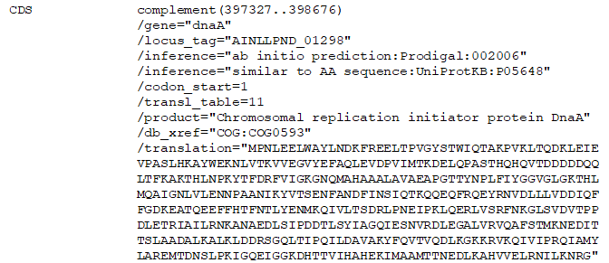
Fig. S1. Chromosomal replication initiator protein DnaA gene CDS

