**Setting the environmental performance threshold for diverting residual streams towards bioeconomy strategies**

SI – II

Dataset on characterization, quantity and current use of French residual biomasses

U. Javourez1, S.K. Karan1,2, L. Hamelin1,*

1TBI, Université de Toulouse, CNRS, INRAE, INSA, Toulouse, France

2 Department of Geomatics, Norwegian Institute of Bioeconomy Research, Ås, Norway

* Corresponding author: [hamelin@insa-toulouse.fr](mailto:hamelin@insa-toulouse.fr)

**List of figures:**

Figure 1 – Current use of residual biomass streams in France, in PJ.yr-1 2

**List of tables:**

Table 1 – Current use: Primary Forestry Residues 3

Table 2 – Current use: Crop Residues 3

Table 3 – Current use: Pruning Residues 3

Table 4a – Current use: Bovine Manure 4

Table 4b – Current use: Slurry 4

Table 4c – Current use: Poultry Manure 4

Table 5 – Current use: Green/Garden Waste 5

Table 6 – Current use: Sewage Sludge 5

Table 7 – Current use: Household organic waste 6

Table 8 – Current use: Agro-Industrial Waste 6

Figure 1 – Current use of residual biomass streams in France, in PJ.yr-1

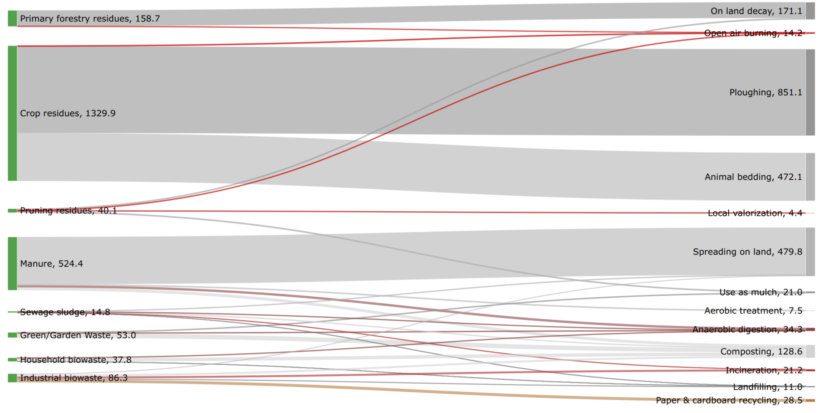

The values shown for Primary Forestry Residues, Crop Residues and Manure are purely theoretical (maximum amount available). Values on the left-hand side might not add up exactly to the ones on the right-hand side due to (i) rounding and (ii) because come current uses representing less than 1% of the overall use per stream has been removed

Table 1 – Current use: Primary Forestry Residues

|  |  |  |  |
| --- | --- | --- | --- |
| Stream | Share | Current use | Source and methodological consideration |
| Primary Forestry Residues (PFR) | 98% | On land decay | Personal communication with French forest expert. The National forestry accounting plan of France (2020)1, reports that about 90% of the PFRs are burned because of “scanty knowledge”, therefore they used the IPCC default assumption (4-15% of above-ground biomass is burned). However, after exchanges with French forestry experts the values were updated as 0-1% of above-ground biomass burned (corresponds to 0-4% of the PFR as PFR represents 23% of above-ground biomass in their model). Lodato et al., 20222 considered 100% of PFR decayed in Occitanie region. |
| 2% [0-4%] | Open air burning |

Table 2 – Current use: Crop Residues

|  |  |  |  |
| --- | --- | --- | --- |
| Stream | Share | Current use | Source and methodological consideration |
| Crop residues | 35.5%  [40-30%] | Animal Bedding (Harvested straw) | The data on current use of agricultural straw comes from CITEPA, 20223 (weighted average over all crops residues at year 2020). A small portion of the straw is also used for mushroom farming, but its contribution is less than 1% of the overall use, hence use of straw for mushroom cultivation has been ignored in the present study. Aguerre et al.4 reported in their study that there was no loss of organic matter, organic N, organic C when straw was used as a bedding material (during In-house and Outdoor storage). Therefore, the eventual use on land of animal bedding has been modeled as conventional storage and use on land process for manure (see SI.4.Inventory document). The share of animal bedding based on multi-actor consultations is reported around 20%5–7, but here CITEPA values were kept. |
|
| 64% | Ploughed (Portion of unharvested straw) |
| 0.5%  [0-1%] | Open air burning (Portion of unharvested straw) |

Table 3 – Current use: Pruning Residues

|  |  |  |  |  |
| --- | --- | --- | --- | --- |
| Stream | Share | | Current use | Source and methodological consideration |
| Pruning residues | 39.5% | | Organic Amendment (On land decay) | Concrete data on the current use of pruning residues for France is not documented well in the literature. Two European projects EuroPruning8 and uP_running9,10 tried to bridge this gap by providing a first ever harmonized effort for valorization of these residues. Both of these studies however reported that a major portion of pruning residues generated are used at the farm itself. As per the latest assessment of agricultural resources in France (ONRB, 2021)5 suggested that 79% of the vineyards pruning residues were used as organic amendment and the remaining were either burned on site without energy recovery or used for domestic heating. *We partition the later share equally between domestic heating and burning on site as precise data on their shares was not available, and assume it applied to the whole pruning residues category (as current use of orchard pruning unknown). |
| 39.5% | | Organic Amendment (Mulch) |
| 21%  (Self-Consumption) | 10.5%* | Domestic Heating |
| 10.5%* [0-11%] | Burned on site without energy recovery |

Table 4a – Current use: Bovine Manure

|  |  |  |  |
| --- | --- | --- | --- |
| Stream | Share | Current use | Source and methodological consideration |
| Bovine Manure | 90% | Conventional storage and use on land | The data on current treatments and use of manure in France comes from Loyon, 201711 (based on a 2013 survey data). It estimated that only 8% was treated (mostly through composting), and the rest was conventionally spread. Yet, CITEPA, 20223 reporting indicated that 3-4% of bovine manure has been derived towards AD platforms in 2019-2020. |
| 6% [1-8%] | Composting |
| 4% [3-5%] | Anaerobic digestion (AD) |

Table 4b – Current use: Slurry

|  |  |  |  |
| --- | --- | --- | --- |
| Stream | Share | Current use | Source and methodological consideration |
| Slurry | 85% | Conventional storage and use on land | Loyon, 201711 did not differentiate bovine manure and slurry, but considered 85% of swine slurry is treated (among which ca. 7% through aerobic treatments). On the other hand, CITEPA, 20223 reports an increasing share of AD treatments: in 2020, 91% of slurry underwent conventional spreading, and 9% were diverted towards AD facilities (no mention of aerobic treatments). Ranges adapted to capture both references. |
| 8% [6-10%] | Anaerobic digestion (AD) |
| 7% [5-10%] | Aerobic treatment |
| <1% | Physical-chemical treatment |
| <1% | Other |

Table 4c – Current use: Poultry Manure

|  |  |  |  |
| --- | --- | --- | --- |
| Stream | Share | Current use | Source and methodological consideration |
| Poultry Manure | 89% | Conventional storage and use on land | Loyon, 201711 considers 11% is treated, half being through composting. On the other hand, CITEPA, 20223 indicates that all poultry manure / slurry / litter is conventionally stored and spread. Range adapted accordingly. Drying not accounted as either (i) performed outside or (ii) part of management system of poultry production (to keep litter within a defined moisture content range). |
| 11% [0-11%] | Composting |

Table 5 – Current use: Green Waste

|  |  |  |  |  |
| --- | --- | --- | --- | --- |
| Stream | Share | Current use | Specific Treatment | Source and methodological consideration |
| Green Waste | 90% | Organic Recovery12 | 82% Composting | Here green waste only accounted for share already collected. Distribution based on SINOE data13, relatively consistant between 2013 and 2019.Yet, umbrella category gathering composting and anaerobic digestion: uncertainty range adapted. (0.1% incinerated was neglected). "Material recovery" modeled as mulch. |
| 8% [0-10%] AD |
| 9.9% | Material Recovery | Shredding and use as mulch |
| 0.1% | Incineration with energy recovery | Not considered |

Table 6 – Current use: Sewage Sludge

|  |  |  |  |
| --- | --- | --- | --- |
| Stream | Share | Current use | Source and methodological consideration |
| Sewage Sludge | 26% [17-35%] | Agricultural Spreading | National survey by Pradel, 201914 (data of 2014): digested sludge represented 22% of total sludge in DM (and considering average 14%DM loss during digestion, amount of initial sludge digested is around 25%). Composted sludge (after dewatering) represented ca. 31% of total sludge and incinerated sludge around 15%. 3% were landfilled and rest directly applied on land (26%). Stabilization was mostly performed through liming. French reporting database15 does not include anaerobic digestion as end-of-life treatment, hence reports that over 2018-2021 period, on a DM basis, sludge has been incinerated (8-16%), directly spread (27-35%) and composted (45-63%). This also applied for Occitanie specific study by Lodato et al., 20222 who report ca. 22% directly spread and 78% after composting. Baseline as reviewed by Pradel but considering variation ranges as official French data15, b. |
| 32% | Composting |
| 15% [8-16%] | Incinerationa |
| 3% | Landfilling |
| 24% | Anaerobic Digestion |

a Due to lack of data this assumption was made to a conservative hypothesis in the perspective of establishing the threshold for bioeconomy.

b Note that constrained on sludge managment has been enforced during COVID outbreak, meaning that such statistics might not be representative of past 2 years management.

Table 7 – Current use: Household organic waste

|  |  |  |  |  |
| --- | --- | --- | --- | --- |
| Stream | Treatment | Current use | Near-future | Source and methodological consideration |
| Household Organic Waste | Composting | 20% | 89% | Seggregated biowaste collection is mandatory in France from 2024. Indeed, currently only ca. 10-15% of household biowaste is collected separetly, rest is within mixed municipal waste. Therefore current situation and near-future might be significantly different. Here, the near-future situation is considered, and the treatment proxy was selected as the current use of the already separated household biowaste (based on SINOE, 2019-2021 data)13, see SI.3.Household_biowaste. |
| Anaerobic digestion | 2% | 9% |
| Landfilling | 21% | 2% |
| Incineration | 57% | 0% |

Table 8 – Current use: Agro-Industrial Waste

|  |  |  |  |
| --- | --- | --- | --- |
| Stream | Share | Current Use | Source and methodological consideration |
| Agro-Industrial Waste | 22% [10-22%] | Incineration with energy recovery | The data on current use of agro-industrial residues was obtained from the French National Pollution Register16. The data was processed and synthesized at the French departmental level. The information on current treatments were obtained from the list of waste treatment operations17. Duplication was avoided by ignoring D13, D14, D15, R12 and R13 treatments. Ranges only for landfilling and incineration as being phased out by French regulations. |
| 22% | Composting |
| 33% | Paper and Cardboard recycling |
| 11.5% [5-12%] | Landfilling |
| 11.5% | Use on land |

Uncertainties on current uses are not reported for each potential use are these are linked (sum is 100%). Such uncertainties are mostly due to the different methodologies used by the references (bottom-up e.g. through voluntary declarations, surveys, interviews or extrapolations, or using material flow analysis and empirical functions of diverse granularities). These do not represent seasonal variations.

References

1. CITEPA. The National Forestry Accounting Plan of France including the Forest Reference Level (FRL) for the 2021- 2025 and 2026-2030 periods. (2020).

2. Lodato, C., Hamelin, L., Tonini, D. & Astrup, T. F. Towards sustainable methane supply from local bioresources: Anaerobic digestion, gasification, and gas upgrading. Applied Energy 323, 119568 (2022).

3. CITEPA. Rapport CCNUCC. (2022).

4. Aguerre, M. J., Wattiaux, M. A., Hunt, T. & Lobos, N. E. Effect of nitrogen content and additional straw on changes in chemical composition, volatile losses, and ammonia emissions from dairy manure during long-term storage. Journal of Dairy Science 95, 3454–3466 (2012).

5. FranceAgriMer. L’Observatoire National des Ressources en Biomasse, Évaluation des ressources agricoles et agroalimentaires disponibles en France – édition 2020. 93 https://www.franceagrimer.fr/content/download/66147/document/DON-ONRB-2020_VF3.pdf (2021).

6. Couturier, C., Jack, A. & Miviere, J.-M. Schéma Régionale Biomasse de la Région Occitanie. 195 (2019).

7. Le Ravalec, V. Panorama des coproduits et résidus biomasse à usage des filières chimie et matériaux biosourcés en France. 70 (2015).

8. FCCIRCE. EuroPruning: Development and implementation of a new and non-existent logistics chain for biomass from pruning. (2016).

9. UP_running. Project materials | uP_running. https://www.up-running.eu/project-materials/ (2020).

10. UP_running. Report on collected Observatory data : Year 3. (2020).

11. Loyon, L. Overview of manure treatment in France. Waste Management 61, 516–520 (2017).

12. ADEME. Déchets Chiffres-clés, l'essentiel 2021. (2021).

13. SINOE. Module Statistiques / Collecte. https://www.sinoe.org/thematiques/consult/ss-theme/6 (2000).

14. Pradel, M. Survey data of sewage sludge treatment and disposal routes originated from activated sludge water treatment in France. Data in Brief 26, 104541 (2019).

15. Ministère de la Transition écologique et solidaire. Portail assainissement collectif. (2023).

16. BRGM. Installations industrielles rejetant des polluants (2020).

17. European Parliament. DIRECTIVE (UE) 2018/851 DU PARLEMENT EUROPÉEN ET DU CONSEIL du 30 mai 2018 modifiant la directive 2008/98/CE relative aux déchets. Journal officiel de l’Union européenne 109–140 (2018).