SUPPLEMENTARY MATERIAL

Supplementary figure 1: Calibration graph of Cd, Co, Cr, Cu, Fe, Hg, Mn, Se, Zn, Ca, K, Mg, Mo, Na, P and S standard solution as illustrated shown below (a-p).

**a) C**alibration graph of Cd standard **b)** Calibration graph of Costandard

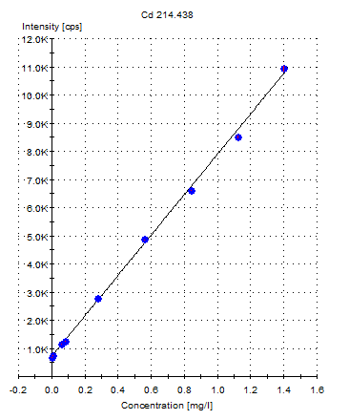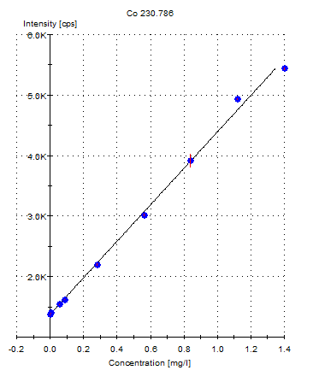

**c)** Calibration curve graph of Cr standard  **d)** Calibration graph of Cu standard

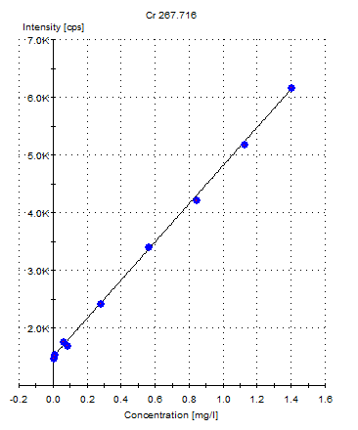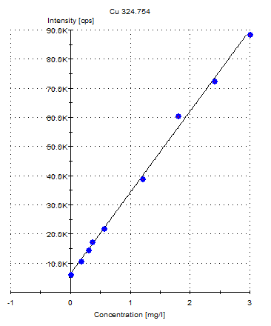

**e)** Calibration curve graph of Fe standard  **f)** Calibration graph of Hg standard

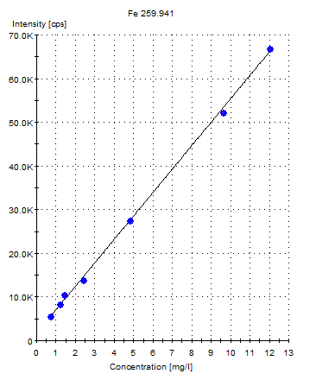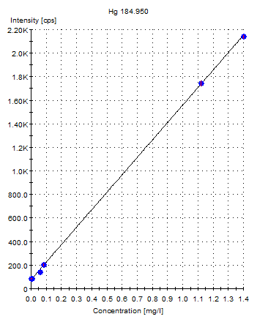

**g)** Calibration curve graph of Mn standard  **h)** Calibration graph of Se standard

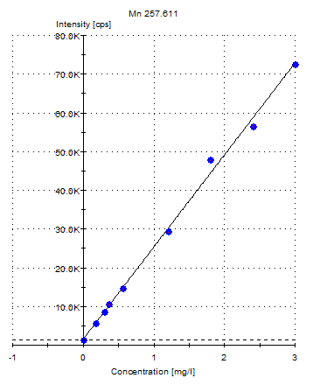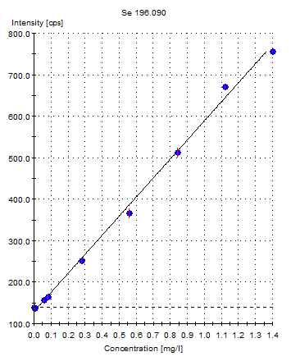

**i)** Calibration curve graph of Zn standard  **j)** Calibration graph of Ca standard

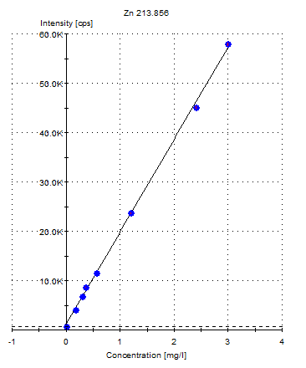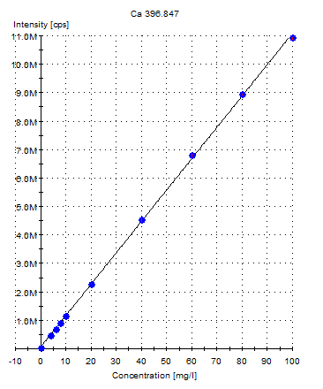

**k)** Calibration curve graph of K standard  **l)** Calibration graph of Mg standard

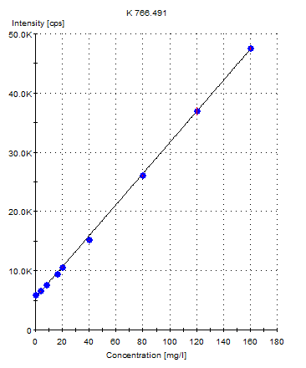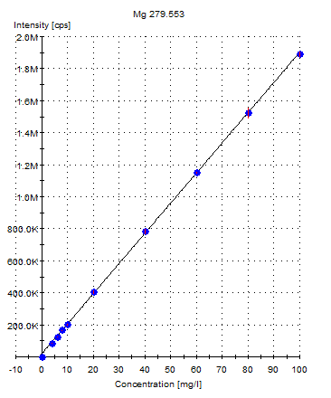

**m)** Calibration curve graph of Mo standard  **n)** Calibration graph of Na standard

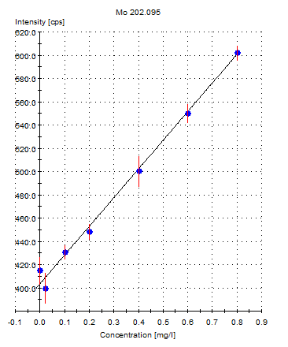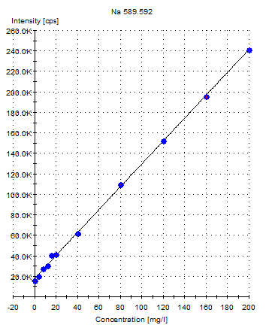

**o)** Calibration curve graph of P standard  **p)** Calibration graph of S standard

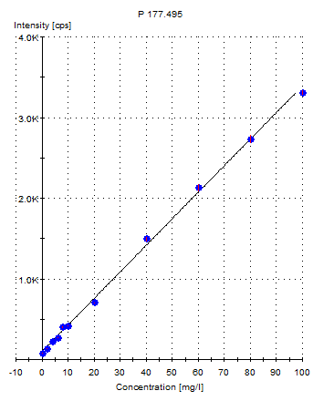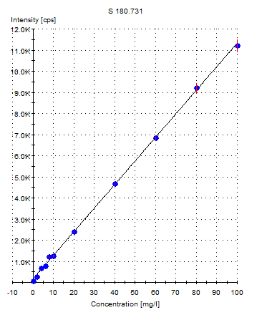

**Supplementary figure 2: Map of study area**

