Nursing Practices During Clinical Placements: An In-Depth Exploration

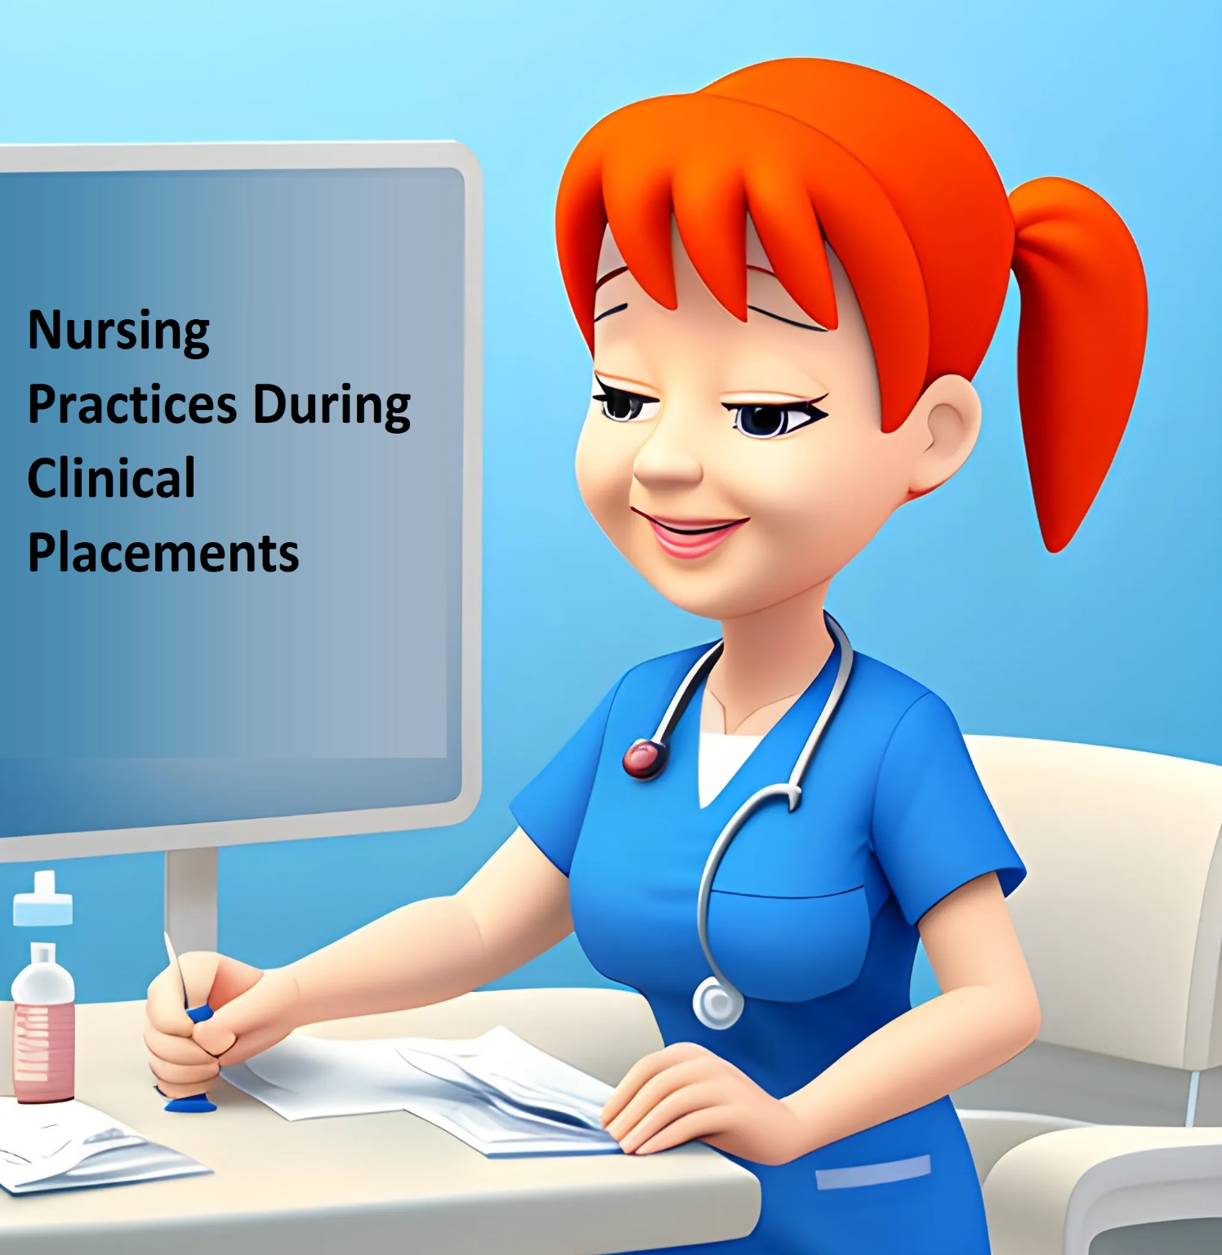
Mirela Tushe
Aldent University
1.08.2024
ORCID: https://orcid.org/0000-0003-4648-5915

Nursing Practices During Clinical Placements: An In-Depth Exploration
Abstract
Clinical placements are essential in nursing education, providing students with hands-on experience in real-world healthcare settings. This article examines the practical aspects of clinical placements, focusing on the diverse roles and responsibilities of nursing students, the support provided by healthcare professionals, and the impact on students’ professional development. Key topics include patient assessment, medication administration, communication skills, documentation, emergency response, and more. By detailing these areas, the article highlights how clinical placements prepare students for successful nursing careers.
Keywords
Nursing education, clinical placements, patient assessment, medication administration, communication skills, documentation, emergency response, mentorship, simulation-based learning.
Introduction
Clinical placements are a crucial component of nursing education, bridging the gap between theoretical knowledge and practical application. These placements allow students to develop essential clinical skills and gain experience in real-world healthcare settings. This article explores the practical roles and responsibilities of nursing students during their clinical placements, the support provided by healthcare professionals, and the overall impact of these experiences on their professional development.
Roles and Responsibilities of Nursing Students
Patient Assessment and Care Planning
During clinical placements, nursing students perform a range of tasks related to patient assessment and care planning:
- Assessment Techniques: Students use various techniques to assess patients, including taking vital signs, conducting physical examinations, and obtaining patient histories. These skills are fundamental for evaluating patient health and planning appropriate care (Watson, 2008; Orem, 1991).
- Care Planning: Based on assessments, students create care plans that outline patient goals and the interventions required to achieve them. This process involves setting realistic objectives and determining the best strategies for patient care (Naylor et al., 2011).
- Evaluation and Adjustment: Students regularly evaluate the effectiveness of care plans and make necessary adjustments based on patient progress and changing conditions (Gibbs & Simpson, 2004).
Administration of Medications and Treatments
Nursing students are involved in the administration of medications and treatments under supervision:
- Medication Administration: Students learn to accurately administer medications, including calculating dosages, selecting appropriate routes, and observing for side effects. This experience is crucial for developing skills in medication management and patient safety (Cant & Cooper, 2010).
- Treatment Procedures: Students perform various treatment procedures, such as wound care or intravenous therapy, following established protocols and guidelines to ensure effective and safe care (Cook et al., 2010).
- Documentation: Accurate documentation of medication administration and treatments is essential for maintaining patient records and ensuring continuity of care (Hattie & Timperley, 2007).
Communication and Interpersonal Skills
Effective communication is a key component of nursing practice:
- Patient Interaction: Students practice communicating with patients to provide education, address concerns, and offer emotional support. Building rapport and establishing trust are essential for delivering holistic care (Brashers, 2001).
- Family Communication: Students also interact with patients' families, providing updates on care and addressing any questions or concerns. This interaction is important for involving families in the care process (Campinha-Bacote, 2002).
- Interprofessional Collaboration: Students collaborate with other healthcare professionals, including physicians and therapists, to ensure comprehensive patient care. Effective communication within the healthcare team enhances patient outcomes (Rosen et al., 2019).
Documentation and Record-Keeping
Accurate documentation and record-keeping are vital in nursing practice:
- Patient Records: Students learn to maintain detailed and accurate patient records, including assessments, care plans, interventions, and outcomes. Proper documentation is essential for legal and ethical reasons and for ensuring continuity of care (Melnyk & Fineout-Overholt, 2019).
- Electronic Health Records (EHRs): Students use EHR systems to enter and manage patient information. Proficiency in EHRs is important for modern nursing practice and improves care efficiency (Cook et al., 2010).
- Compliance and Confidentiality: Students are trained to adhere to legal and ethical standards regarding patient privacy and confidentiality. Ensuring compliance with regulations is crucial for protecting patient information (Black & Wiliam, 1998).
Participation in Multidisciplinary Teams
Working within multidisciplinary teams is a key aspect of clinical placements:
- Team Collaboration: Students collaborate with various healthcare professionals, including doctors, nurses, and therapists. This experience helps students understand the roles of different team members and the importance of collaborative care (Campinha-Bacote, 2002).
- Role Understanding: Students gain insight into how different disciplines contribute to patient care and how to effectively communicate and coordinate with other team members (Purnell, 2002).
- Team Dynamics: Exposure to team dynamics and conflict resolution strategies enhances students' ability to work effectively within a team (Gibbs & Simpson, 2004).
Handling Emergencies and Critical Situations
Students are trained to handle emergencies and critical situations:
- Emergency Response: Students learn to respond to emergencies, such as cardiac arrests or severe injuries, using established protocols and life-saving techniques (Fanning & Gaba, 2007).
- Critical Thinking: Handling critical situations requires quick decision-making and critical thinking skills. Students develop these skills through simulation exercises and real-life experiences (Kneebone et al., 2006).
- Stress Management: Students are guided on managing stress and maintaining composure during high-pressure situations, which is essential for effective emergency response (Cant & Cooper, 2010).
Patient Education and Health Promotion
Educating patients and promoting health are key responsibilities:
- Patient Education: Students provide information to patients about their health conditions, treatment options, and preventive measures. Effective education empowers patients to participate in their own care and make informed decisions (Gibbs & Simpson, 2004).
- Health Promotion: Students engage in health promotion activities, such as advocating for healthy lifestyles and preventive care. These activities contribute to improved patient outcomes and overall community health (Naylor et al., 2011).
- Behavioral Change: Students learn techniques for encouraging behavior change, including motivational interviewing and setting achievable health goals (Purnell, 2002).
Assistive Technology Usage
Familiarity with assistive technology is essential for modern nursing practice:
- Technology Integration: Students learn to use various healthcare technologies, such as patient monitoring systems and EHRs. Effective use of technology improves patient care and enhances clinical efficiency (Cook et al., 2010).
- Training and Support: Students receive training on how to operate and troubleshoot healthcare technologies, ensuring they can effectively integrate these tools into their practice (Hattie & Timperley, 2007).
- Data Management: Proficiency in managing and interpreting data from technological tools is crucial for making informed clinical decisions (Melnyk & Fineout-Overholt, 2019).
Ethical and Legal Aspects of Care
Understanding ethical and legal considerations is fundamental:
- Patient Consent: Students learn about obtaining informed consent from patients before procedures and treatments. Understanding consent processes is essential for respecting patient autonomy and rights (Brashers, 2001).
- Confidentiality: Maintaining patient confidentiality and privacy is a critical aspect of nursing practice. Students are trained on legal requirements and ethical considerations related to patient information (Black & Wiliam, 1998).
- Professional Conduct: Students are guided on ethical dilemmas and professional conduct, including issues related to integrity, honesty, and accountability (Melnyk & Fineout-Overholt, 2019).
Quality Improvement and Research Participation
Involvement in quality improvement and research enhances practice:
- Quality Improvement Projects: Students may participate in projects aimed at improving healthcare processes and outcomes. This involvement helps them understand the importance of continuous improvement in nursing practice (Kneebone et al., 2006).
- Research Activities: Students are exposed to research methodologies and evidence-based practice. Participating in research activities fosters a deeper understanding of how research informs clinical practice (Fanning & Gaba, 2007).
- Evidence-Based Practice: Students learn to apply research findings to clinical practice, ensuring that patient care is based on the best available evidence (Cant & Cooper, 2010).
Conclusion
Clinical placements are a vital component of nursing education, providing essential hands-on experience that complements theoretical learning. Through a range of responsibilities, support from healthcare professionals, and exposure to various clinical scenarios, students develop the skills and insights necessary for successful nursing careers. The integration of practical experience, mentorship, and reflective learning significantly contributes to students' professional growth and readiness for the challenges of nursing practice.
References
- Black, P., & Wiliam, D. (1998). Assessment and classroom learning. Assessment in Education: Principles, Policy & Practice, 5(1), 7-74. DOI: 10.1080/0969595980050102.
- Brashers, D. E. (2001). Communication and uncertainty management. Journal of Communication, 51(3), 477-497. DOI: 10.1111/j.1460-2466.2001.tb02892.x.
- Campinha-Bacote, J. (2002). The process of cultural competence in the delivery of healthcare services: A model of care. Journal of Transcultural Nursing, 13(3), 181-184. DOI: 10.1177/10459602013003003.
- Cant, R. P., & Cooper, S. J. (2010). Simulation-based learning in nursing education: A systematic review. Journal of Advanced Nursing, 66(1), 3-15. DOI: 10.1111/j.1365-2648.2009.05240.x.
- Cook, D. A., Levinson, A. J., & Garside, S. (2010). Internet-based learning in the health professions: A meta-analysis. JAMA, 300(10), 1181-1196. DOI: 10.1001/jama.300.10.1181.
- Fanning, R. M., & Gaba, D. M. (2007). The role of debriefing in simulation-based learning. Simulation in Healthcare, 2(2), 115-125. DOI: 10.1097/SIH.0b013e3180315539.
- Gibbs, G. (1988). Learning by Doing. Oxford Polytechnic, Further Education Unit. ISBN: 978-0947888227.
- Gibbs, G., & Simpson, C. (2004). Conditions under which assessment supports students' learning. Learning and Teaching in Higher Education, 1(1), 3-31. DOI: 10.1080/1359866032000157361.
- Hattie, J., & Timperley, H. (2007). The power of feedback. Review of Educational Research, 77(1), 81-112. DOI: 10.3102/003465430298487.
- Kneebone, R., Kneebone, R., & Little, C. (2006). Simulation-based learning in health care. Journal of Health Services Research & Policy, 11(1), 36-40. DOI: 10.1258/1355819052884541.
- Melnyk, B. M., & Fineout-Overholt, E. (2019). Evidence-Based Practice in Nursing & Healthcare: A Guide to Best Practices (4th ed.). Wolters Kluwer. ISBN: 978-1496398184.
- Orem, D. E. (1991). Nursing: Concepts of Practice (4th ed.). McGraw-Hill. ISBN: 978-0070999427.
- Purnell, L. D. (2002). The Purnell model for cultural competence. Journal of Transcultural Nursing, 13(3), 193-196. DOI: 10.1177/10459602013003006.
- Rosen, K. R., & Hunt, D. (2019). Simulation-based medical education. In Principles and Practice of Simulation (pp. 45-69). Springer. ISBN: 978-3030207480.
- Watson, J. (2008). Nursing: The Philosophy and Science of Caring (revised ed.). University Press of Colorado. ISBN: 978-0870819544.
- Naylor, M. D., Aiken, L. H., & McCormick, K. A. (2011). The effectiveness of transitional care: A systematic review. Journal of Nursing Scholarship, 43(2), 114-122. DOI: 10.1111/j.1547-5069.2011.01301.x.

