DRIVERS OF CAPACITY BUILDING DATA

APPROACH AND METHODOLOGY

INTRODUCTION
The selection of a suitable research method is a major determinant in the success or otherwise of any research activity (Fellows and Liu, 2008). According to Cresswell (2016) the research methodology entails the entire approach beginning from the research’s design to the basics involving the collection of data and the process for analysing the same for any study. The research methodology allows for ascertaining how to go about the task of finding out what is believed to be true as opined by Bajpai (2015)
Newby (2014) further posits that in undertaking any study, it is imperative to properly set out strategies that ensure the research is carried out in a logical and orderly manner. It should therefore begin from the plan or design which acts as a framework or the blueprint upon which the whole research is carried out from the beginning to the end. The selection of a suitable process provides the ethical approach for researching and evaluating the findings of the study. This would strengthen the legitimacy of the arguments and findings of the study as revealed by Khalid et al. (2012)
This chapter, therefore, presents the design of the research as well as the methods chosen. An overview of research paradigms and strongly related research approaches are provided. Explanation is provided of the chosen research instruments for data collection and analysis

RESEARCH DESIGN
A research design is the entire procedure for collecting, analyzing, interpreting and reporting data in the conduct of a study (Cresswell et al., 2011). It encompasses the fundamental structure of any research study. According to Bajpai (2015), the research design is defined as the overall strategy chosen to integrate the various components of a study in a way that is logical and coherent to allow the research problem to be solved effectively. The research design is the complete blueprint that allows for the collection, analysis and interpretation of the data. As posited by Fowler (2013), the research design gives the overall direction and approach to the study itself. Like any other research phenomenon, no one research design is perfect in itself (Newby, 2014). That is to say, different research designs have different advantages and disadvantages in order to maximize their impact and allow for the accurate collection and analysis of data. Notwithstanding, researchers can manage the advantages and disadvantages of the various research designs to improve the study’s impact (Khalid et al., 2012). In order to do this, the researcher must have a full grasp of the various research designs and make an informed decision on the one that best suits the study under review (Fowler, 2013). Research designs are broadly categorised into Descriptive, Explanatory and Exploratory research designs.

Explanatory Design
The explanatory research design seeks to answer the question of ‘why’ in research. It explores the causal relationship between one concept and another (Newby, 2014). The explanatory design hinges on the fact that one phenomenon is influenced by various factors. It accepts that the cause of a concept can at times be complex and thus, seeks to explore the causality factors of the study’s variables (Khalid et al., 2012). Explanatory designs have however been criticized for their lack of statistical strength, however, they have the advantage of explaining why things happen. As an advantage, this research design can help shape or direct future paths for subsequent studies.

Exploratory Design
The exploratory design unlike the explanatory provides the researcher with a higher level of understanding of a subject matter (Newby, 2014). It can be used when a research study is in its introductory stages of enquiry (Fowler, 2013). This research design allows for data to be obtained using the observation of actions, people or events. Exploratory research designs have been criticized for being ambiguous, preliminary and unstructured in their approach (Khalid et al., 2012).
The exploratory design is conducted to have a better understanding of an existing research problem although it would fail to provide conclusive results. As such the researcher starts with a general idea and uses this design to identify the issues that can be of focus for future research. As ambiguous and unstructured as it is, it allows the researcher to change the direction of the study depending on the revelation of new and significant preliminary data. Normally, it is referred to as the grounded theory approach or the interpretive research used in answering the question of ‘how’ (Newby, 2014).

Descriptive Design
The descriptive research design aims to systematically and accurately describe a situation, phenomenon or population (Stokes, 2017). This research design can adopt a wide range of research methods and tools to investigate the variables in question. Unlike the other research designs, the descriptive design does not allow the researcher to influence, control or manipulate any of the variables but to only observe and measure them. Based on the approach used to measure them, the descriptive design is classified into several different types (Khalid et al., 2012). They include but are not limited to descriptive-normative survey, descriptive-comparative research, descriptive-survey, descriptive-analysis, descriptive-status, descriptive-comparative, and descriptive classification. The descriptive research design seeks to answer the question of ‘what’ in research studies (Stokes, 2017).

Research Design Adopted for the Study
This study adopted the explanatory research design. This study adopted the explanatory design bearing in mind the complex nature of the concept of building capacities. As a contextual study, the study focuses on the issues of building capacities of BE professionals bearing the state of the Ghanaian construction industry in mind. Explanatory studies allow for the use of in-depth interviews, focus group discussions, case study analysis and literature reviews to increase the understanding of a study. It has been seen as more qualitative in nature owing to its related methods, yet it is limited by its statistical strength. Notwithstanding, in order to understand the ‘why’ of any issues, an explanatory research design would be the most suited (Stokes, 2017).
From the review on research design above, it, therefore, goes without saying that the choice of an appropriate research design is highly vital to the final outcome of any study. As such, this study identified for use the popular model proposed by Saunders et al. (2003). The model equates the entire research process to an “onion” as seen in Figure 4.1 below.

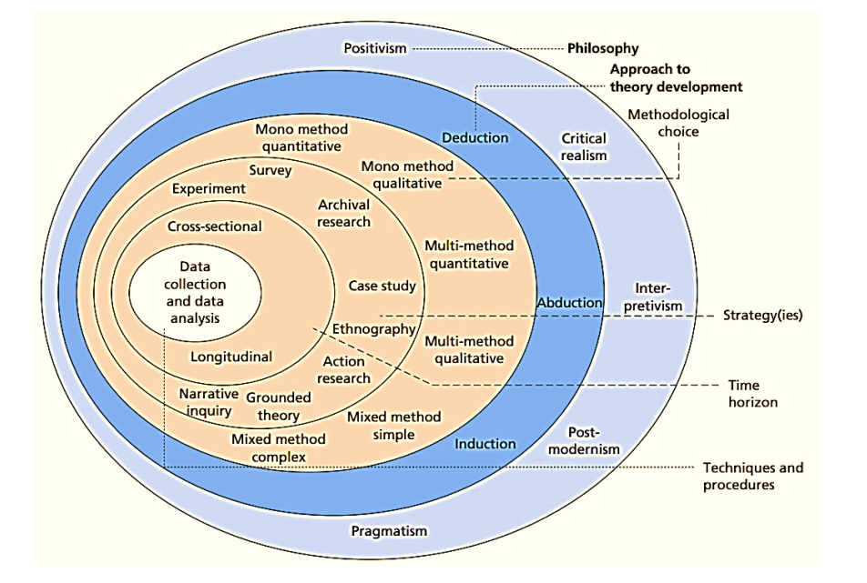
Figure 4.1 The “Onion” Research Design Model
Source: Saunders et al., 2016

RESEARCH PARADIGM
Yin (2009) encapsulates research design as the logical arrangement that links the collated empirical data to the initial objectives of the research and consequently to its conclusions. The multifaceted and multi-disciplinary nature of sustainability studies reflects its un-integrated theory. Thus, sustainability often draws on a wide range of theoretical bases from the social and natural sciences (Rahi et al., 2019). Researchers are met with a difficult problem in clearly articulating an appropriate research design due to this multiplicity of diverse theoretical bases (Kumatongo and Muzata, 2021).
Many considerations come to play in the decision to select a suitable research methodology for a particular study. Most influential among those considerations are the defining aims of the research study and the kind of data type that have to be collected. The researcher is confronted with two broad research methodologies which must be deliberated upon in the subsequent selection of the appropriate one for the particular study (Bonache and Festing, 2020). The research methodologies can be categorized as quantitative and qualitative. However, the use of either one or a combination of both is not uncommon in literature as far as the adopted approach is adequate in answering the research questions.
Research methodology is not developed in a vacuum. Various paradigms guide and inform a given research in the selection of the appropriate research methodology (Liu, 2008). Paradigms provide insights into the way researchers seek to comprehend and make sense of reality (Rahi et al., 2019). Paradigm shapes the way researchers perceive the research methodology adopted and the techniques to be used. Two main research paradigms dominate the literature: positivism and interpretivism (Bogna et al., 2020). In positivism, the social phenomenon is assumed to follow natural laws and thus quantitative logic can be used. The scientific method employed avoids the inclusion of human influence in establishing the meaning of reality and as such, prevents researchers’ bias (Kekeya, 2019). On the other hand, interpretivism assumes that social phenomenon does not follow natural laws but is constructed based on peoples’ interaction with their environment (Kankam, 2019). This thus assumes the use of qualitative logic.
The onus then lies on the researcher to select a suitable philosophy for the study. In doing this, the researcher should be able to fully identify, explain and properly understand each of the considerations and concepts (Cresswell, 2013; Kankam, 2019). It aids in ultimately determining the suitable method for conducting a study (Kulatunga et al., 2007). Against this backdrop, the selection of the research philosophy was done following thorough and critical consideration of the axiological, ontological and epistemological assumptions subsequently defined for this study.

Ontology
Commonly described as “the study of being”, Ontology as opined by Easterby-Smith, Thorpe, and Jackson (2008) concerns the “nature of reality of the assumptions we make about reality” (Easterby-Smith et al.,2012; Kankam, 2019). This is to say, ontological considerations are focused on whether or not social entities need to be viewed subjectively or objectively; how they truly are and; how they really work (Kankam, 2019). In view of this definition, realism and idealism can be derived as the two ontological assumptions. While realists focus on the reality of the research with a predetermined and thorough structure, idealists hold that the reality of the research is based on the varying perspectives of different observers (Bonache and Festing, 2020).
Realists are of the view and belief that reality is independent of the cognition and consciousness of humans and that it is predetermined by nature. Idealists, on the other hand, are of a contrary view. They believe that observers may possess opposing views because they attribute reality to result from the state of the human mind (Kumatongo and Muzata, 2021). To sum up, the realists lean towards the positivists philosophical standpoint while idealists are more inclined to the interpretivist philosophy (Kankam, 2019; Sohail et al., 2021).
Capacity building of BE professionals to deliver ESBs is the phenomenon being explored in the context of developing countries. The contextual nature of the phenomenon brings to bear its idealist nature contrary to the realists’ position. Taking a logical perspective of the nature of the phenomenon of this research, the ontological position that the research should appropriately take becomes evident. Whilst the realism school of thought does not consider the contextual or constructivist evolution of knowledge (reality) in the world in which we live, the idealist school of thought does (Nola, 2012). Thus, based on the nature of the research questions, the ontological stance of this research has been indicated as idealist.

Epistemology
The epistemological considerations that underpin the philosophical position of any research study focus on matters of the level of acceptance of knowledge in a particular discipline (Cresswell, 2009; Kankam, 2019). Additionally, the causal relationship between the subject in focus and the researcher is properly defined. Epistemological viewpoints may either be subjective or objective. In social science and studies related to the construction industry, Cresswell (2009) posits that the two main epistemological considerations are positivism and interpretivism (Bryman, 2009; Cresswell, 2009; Osei-Asibey, 2021). These two dominant paradigms in construction management studies represent different philosophical bases (Kankam, 2019).

Positivism Epistemology
Positivists are of the belief that in the study of a social phenomenon such as that which this study
seeks, natural science methods are more suitable in application. The positivist approach also holds
that the world is more confined to the fixed laws of cause and effect and hence issues are easily
dealt with using fundamental approaches and simplified mathematical methods (Bryman, 2009;
Cresswell, 2009; Kankam, 2019). Positivism is strictly based on rules of logic and measurement, truth, absolute principles and principles and prediction (Bonache and Festing, 2020). It, however, advocates the application of the methods of natural sciences to the study of social reality. Positivism rest upon a realist ontology which however presupposes that there is an objective reality and that people can know this reality (Bonache and Festing, 2020). Moreover, the rigid methodological protocol adopted in positivism allows for more objectivity to be achieved and eliminates any subjective bias (Cohen and Crabtree, 2006). With positivist philosophy, there is a distance between the subjective bias of the researcher and the objective reality being studied.
Additionally, this epistemological position believes that the problems and questions in a research study are easily solved through an objective process of measurement and repeatability where the researcher is in a neutral and detached position during the entire study (Saunders et al., 2009; Bryman 2009). Again, Tamminen and Poucher (2020) assert that knowledge is derived from observable facts and phenomena and is measured accurately through objective methods.

Interpretivism Epistemology
Interpretivists on the other hand assert that the context and phenomenon does not necessarily
follow a single universal truth of the issue in question but is rather subject to the understanding
and the interpretation of the researcher’s viewpoint, study and the interpretations of the results (Mauthner, 2020). With such strong bias and commitment towards the research, the values and beliefs of the researcher form the driving force behind the interpretations of the findings of the study (Muhaise et al., 2020).
Interpretivism focuses on the adoption of methodological approaches which seek to provide the opportunity for the concerns and practices of research participants to be heard (Hürlimann and Hürlimann, 2019). In fact, this philosophy rests upon an idealist ontology which therefore presupposes that reality is relative and multiple. Moreover, idealists believe that there exists more than one reality and a more single structured way of accessing such realities. The interpretivist approach to understanding social reality is more of human interaction and therefore rejects objectivism and adopts more qualitative methods for understanding a phenomenon (Mauthner, 2020). In construction management research, interpretivism has not been highly adopted as compared to positivism. It only accounts for 8.4% of construction management studies (Dainty, 2008).

Pragmatism Epistemology
Pragmatism is also an epistemological stance which was developed following the adoption of mixed methodologies in research studies. Pragmatists lean towards the development of knowledge without the commitment or the bias to a specific philosophy and reality. Cresswell (2013) is of the view that the Pragmatists do not view the world as a true absolute unity. They however believe that research occurs in different contexts and that the view of the entire world can be either dependent or independent of the mind (Mauthner, 2020). They hence use the pluralistic approach in the collection of data and the analysis of the same for the development of knowledge (Hürlimann and Hürlimann, 2019).
According to Dainty (2008), 71% of research in construction management is purely based on quantitative (positivism) ideology, 8.4% is based on qualitative (interpretive) ideology and 11.2% adopted mixed methodology (pragmatic paradigm). It must be emphasized that the high use of positivism has received lots of criticism over the past decade (Zou et al., 2014). However, the arguments on the dominance of quantitative paradigms in construction management research and which paradigm appropriately best fits construction management research has come up in the previous years. This heated up in the mid-1990s when Seymour et al. (1997) pointed out the dominance of scientific theorizing which relates to a realist ontological and positivist epistemological stance where the object often considered in construction management research is people. Other researchers defended the use of more quantitative methods in construction management research (Khatri, 2020). The conclusion drawn was that the choice of a particular ideology whether positivism or interpretivism depends on the objectives and research questions of the research.

Table 4.1 Nature of Positivism and Interpretivism Paradigms
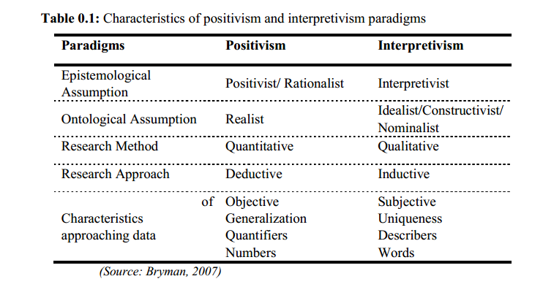
Source: Bryman, 2007
With heavy consideration of the social constructs of the study, it is imperative to opt for the standpoint that allows for a dynamic approach while obtaining objective data for the study. The contextual nature of CB bears on the approach to be adopted dependent on the diverse nature of reality. Thus, the study adopts the interpretivist epistemological stance.

Axiology
The axiological standpoint of any study regards the value-free or value-laden nature of the
research phenomenon in use (Muhaise et al., 2020). If the research is said to be “value-free”, it means its factual basis may be subjected to an evaluative and objective criterion whereas the “value-laden” studies are geared towards the subjective criteria. Bryman (2009) and Cresswell (2013) are of the strong opinion that the Positivists are inclined towards the value-free position whereas the interpretivists lean towards the value-laden position in carrying out their studies (Cresswell, 2009; Hürlimann and Hürlimann, 2019; Mauthner, 2020). According to Hürlimann and Hürlimann (2019), a study that usually investigates social constructs are more
often subjective in its approach and hence would utilise the value-laden axiological perspective.
Similarly, this axiological position is in congruence with the Interpretivist epistemological and
the Idealist ontological position and hence supports the choice of the value-laden position
(Hürlimann and Hürlimann, 2019). It can thus be said that this study is positioned in the value-laden axiological perspective. Figure 4.2 typifies the epistemological, ontological and axiological considerations of research philosophy
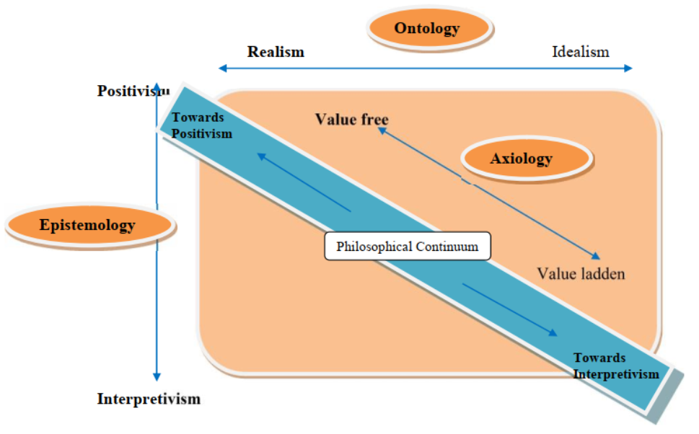
Figure 4.2 Philosophical Continuum of Research Assumptions
Source: Cresswell, 2009

RESEARCH APPROACH
The essence of illustrating a research approach is to increase the validity of social research. As asserted by Cresswell (2013), the selection of a suitable research approach is highly influenced by the philosophical underpinnings of the study and hence the philosophical standpoint of the study must be first resolved. This would aid in typifying the general approach used in answering research questions and finding answers to the problem at hand (Hürlimann and Hürlimann, 2019; Mauthner, 2020). Clark et al. (2021) reveal three approaches to a research study. They are the deductive, inductive and abductive approaches.

Deductive Approaches
The top-down method is employed in the use and application of the deductive approach. Harris et al. (2019) posit that in the formulation of theories and the testing of hypotheses, the deductive
the approach moves from the general to the specific in the course of the study. Strijker et al. (2020) refer to this approach as the quantitative method or design. In the quantitative design, statistical
and mathematical methods are used in the collection, analysis, interpretation of data to test
hypothesis and to draw solid conclusions (Atkinson et al., 2021).

Inductive Approach
On the other hand, the inductive approach employs the bottom-up method moving from the
specific to the general as defined by Atkinson et al. (2021). Again, this method makes observations of phenomena to establish generalised theories and is often referred to as the qualitative approach (Clark et al., 2021). It is exploratory and subjective and maintains the full commitment of the researcher. Yet again, its interpretive nature allows for a non-linear approach that leads to generalisation in a broad base (Mauthner, 2020).

Abductive Approach
Finally, the abductive approach arises where empirical observation evolves simultaneously and interactively with theoretical frameworks. Kovacs and Spens (2005) highlighted that the abductive approach begins with deriving theories from a literature review, presenting the theory in the form of the hypothesis, testing the hypothesis in an empirical setting and then drawing conclusions in line with specific instances.

Research Approach Chosen for the Study
This research which is contextual and characterised by a dearth of studies in this area requires that a bottom-up approach be used. The study which seeks to develop a framework for CB would move from the unknown to the known by making use of data and findings to develop the framework. As such, adopting the inductive research approach for this study is deemed appropriate to facilitate the achievement of the research aim.

RESEARCH STRATEGY
Following the selection of the philosophical standpoint and the approach for the study, the next
important step was to identify the strategy to be used in carrying out the study. The choice of the
the strategy should be founded on the type of research questions, the experience of the researcher and the targeted audience for the study (Creswell, 2013; Atkinson et al., 2021). This strategy is also closely connected to the philosophical paradigm chosen for the conduct of the study. The strategy determines the method that would be used in the collection of the data and the analysis of the same (Clarke et al., 2021).
There exist six (6) main strategies considering the philosophical stance and the context of the
study. They are survey, experiment, action research, case study, archival analysis and ethnography
(Creswell, 2013; Atkinson et al., 2021). Blismas (2011) however orates that out of the six (6) identified, four (4) (experiment, survey, action research and case study) are best suited for project management and social science research within the construction industry. They thus demand that a thorough critique be performed to opt for the most appropriate.

Experiment
Experiments require finding correlations among variables by manipulating one variable while keeping the other constant (Dawson, 2019). Among the natural sciences and medical research, experimental research is very common (Kumar, 2011). Experimental research attempts to determine if a specific treatment affects an outcome. To be able to measure the impact of the treatment given, will require offering a particular treatment to one group and withholding the same treatment from another group. After the treatments have been administered, there will then be the need to assess how both groups fared on an outcome (Atkinson et al., 2021).

Surveys
The survey strategy is popular and common in business and management research and is most frequently used to answer ‘what’, ‘who’, ‘where’, ‘how much’ and ‘how many’ questions (Saunders et al., 2016). Surveys are used to collect both quantitative and qualitative data. There are two broad forms of collecting data via surveys (Dawson, 2019). They are questionnaires and interviews.
Questionnaire surveys are more efficient when there is a need to gather information within a limited time frame from a larger population. It does not lend itself to deeper enquiries to be carried out in order to foster a deeper understanding of the research issues at hand (Clarke et al., 2021). Alternatively, interviews are personalised usually involving the researcher (interviewer) and the participants (interviewee) in either a group or individual interview. Data collected in interviews are textual in nature thus requiring qualitative analysis whereas questionnaires can be quantitatively analysed (Saunders et al., 2016; Atkinson et al., 2021).

Archival and Documentary Research
This strategy enables the researcher to answer the research questions from historical documents and monitor changes over time (Dawson, 2019; Atkinson et al., 2021). The ability to answer research questions does, however, depend on the quality and accessibility of documentation (Saunders et al., 2016). Saunders et al. (2016) caution researchers to be careful in the use of these documents as they were not originally created for research purposes.

Case Study
Chalmers and Cowdell (2021) postulate that the use of case studies helps in developing an in-depth understanding of a phenomenon. A case study is a strategy involving an empirical examination of a specific contemporary phenomenon within its real-life context (Clarke et al., 2021). Advocates of this strategy recommend its use where the emphasis is on understanding a phenomenon rather than quantifying variables (Kumar, 2011; Saunders et al., 2016).
There are different methods of data collection methods to be used in case studies, such as interviews, observations and analysis of documents (Atkinson et al., 2021). In some cases, a questionnaire can also be used for the purposes of collecting data (Dawson, 2019). Chalmers and Cowdell (2021) stressed that case studies are best suited to answering questions about' how' and' why'. Case studies can be exploratory, explanatory or descriptive (Saunders et al., 2016). The descriptive case study is specifically designed to gain a description of persons, events or situations whiles the exploratory case study tends to explore an issue or a problem. The explanatory type of case study is also used to gain an explanatory response to a phenomenon (Dawson, 2019).

Ethnography
Ethnography studies the culture or social world of a group. Literally, it can be explained as a written account of a people or ethnic group (Saunders et al., 2016). Primarily, ethnographic studies will involve the researcher embedding him/herself in the natural environment of the study participants for a significant amount of time (Clarke et al., 2021). It is a qualitative inductive approach that comes from anthropology (Atkinson et al., 2021). The biggest criticism regarding this technique rests on the fact that it is time-consuming as the researcher has to immerse him/herself in the social environment under study (Chalmers and Cowdell, 2021).

Action Research
Action Research is an innovative and iterative research method designed to create solutions to real problems in an organisation. This is achieved through a participatory and collaborative approach that utilizes various forms of knowledge (Clarke et al., 2021). It also has implications beyond the research project for the participants and the organisation (Coghlan and Brannick 2014). Participation is an integral part of Action Research. Consequently, an action researcher works with different people within an organisation to improve the situation for these participants and their organisation as a whole, acting as facilitator and teacher (Dawson, 2019). Thus, without such participation from members of the organisation, this approach simply would not be viable (Atkinson et al., 2021). It is difficult in practice to foster such a participative and collaborative approach as it will normally be met with resistance at various levels (Atkinson et al., 2021; Chalmers and Cowdell, 2021).

Research Strategy Adopted for this Study
The use of the survey emerged as the best-suited strategy upon careful consideration of the four (4) pre-selected methods. With the pragmatist perspective of the study which demands that inductive conclusions be made, the survey strategy was deemed to be the most appropriate. Against this background, the survey strategy presents as the most suitable choice for the study.
As already stated, surveys are used as tools for the collection of data in research through the use of standardized questionnaires (Atkinson et al., 2021), and/or structured interviews with the aim of generalizing from the sample to the population (Adams et al., 2018). Surveys are broadly categorised into questionnaires and interviews. Whereas questionnaires would allow for the collection of large quantities of data on a research topic, the interviews are more personalised and collect textual data from participants (interviewees) in a study (Clarke et al., 2021). The study is skewed towards the qualitative design and thus would utilise interviews to collect qualitative (textual) data from selected respondents in the study. In order to delve into the contextual issues underlying the research problem, interviews are deemed to be the most suitable research strategy to collect the needed data.

RESEARCH CHOICE/ METHOD
Kothari (2011) argues that the techniques used to perform all activities related to research are known as the Research Method. In this, Clarke et al. (2021) posit that the three main methods of any research are; the quantitative, qualitative or mixed method. Notwithstanding, the type of information, the nature of the study and the available information for the subject matter dictates the choice of method (Adams et al., 2018; Chalmers and Cowdell, 2021). In this section, a review of the three methods and the actual method adopted for this study was considered.

Quantitative Method
Quantitative research relies on the assumption of positivism and therefore, it is based on the principles of natural science. It is aligned towards the objectivity approach thus, employing the deductive approach in reasoning about a concept or theory (Chalmers and Cowdell, 2021). Hence, it is good for the generalisation of a theory. In addition, the quantitative method to research is normally hinged on presenting data collected in a numerical form that is supported by statistical analysis either in a table form or graph. Furthermore, Sarantakos (2012) argued that the common objective of quantitative research is normally to employ mathematical models, theories, and hypotheses in studying natural phenomena. For every quantitative research, the key process is measurement due to the extent to which it provides the basis for linking empirical observation and mathematical expression of qualitative relationships (Walliman, 2021). Notwithstanding, critics opined that this method sometimes leaves vital social phenomena that cannot be quantified out of data analysis (Adedoyin, 2020). The weakness is further attributed to its limitation in the correlation explanation of the development of theory, hence, it cannot be relied on when providing an understanding of variables in the building of theories (Adedoyin, 2020).
In quantitative research, Rajasekar et al. (2013) posit that it begins with the collection of data on the premise of a proposed theory or hypothesis to be tested and this is followed by applying descriptive and/or inferential statistics.

Qualitative Method
This technique is aligned with the subjective evaluation of attitudes, views, and behaviour (Skarbek, 2020) and it, therefore, assumes subjective opinions about the real world. The qualitative technique in terms of research also relies on the interpretivism and subjectivity approaches which are the epistemological and ontological paradigms respectively (Adedoyin, 2020). It further considers the natural world as a conscious one and can create awareness of the environment within which it is situated and rationalised. In this instance, data are collected and analysed based on surveys, interviews, focus groups, discussions, observations, and ethnographies. Hence, this technique intends to answer the question of how, why, and what about the occurrence or effect of the subject under study (Köhler et al., 2022). Notwithstanding, the enormous advantages this technique possesses, it has several disadvantages.
According to Sarantakos (2012), it lacks reliability due to its inability to give a degree of accuracy in terms of the relationship between variables. Furthermore, it is difficult to generalise or replicate, because with this technique the researcher cannot decouple himself or herself from the findings (Adedoyin, 2020; Skarbek, 2020). Thus, the researcher decides the trend of the results which highlights the main findings, however, using the same data elsewhere would give different results. It is also worth noting that qualitative research relies on relatively small numbers, which makes it more subjective and narrower in terms of the research output (Clarke et al., 2021). According to Cresswell (2013), the qualitative method of research relies on the judgement and the views of participants. Data is gathered in words by asking questions and analysing these statements subjectively.

Mixed Method
Drawing from the inherent weakness and strengths of the qualitative and quantitative methods, the next technique to be emphasised is the combination of the two methods (Atkinson et al., 2021). Mixed method research is an approach to inquiry that combines or associates both qualitative and quantitative forms. It involves philosophical assumptions, the use of qualitative and quantitative approaches, and the mixing of both approaches in a study (Dawson, 2019). Thus, it is more than simply collecting and analyzing both kinds of data; it also involves the use of both approaches in tandem so that the overall strength of a study is greater than either qualitative or quantitative research (Clarke et al., 2021).
The popularity of the mixed method is due to these four main factors;
- Participant enhancement i.e. this method improves the sample using techniques that ensure that each respondent nominated is appropriate for inclusion;
- Instrument reliability i.e. evaluating the appropriateness and/or efficacy of obtainable instruments, generating new mechanisms and observing the performance of human mechanisms;
- Management veracity i.e., evaluating the reliability of involvement; and
- Impact improvement i.e., assisting depth and richness of data, enhancing understanding and practicality of findings.

Method Chosen for This Study
The choice of the research method adopted for research is the basis for the choice of the research philosophies. It is therefore not surprising that most researchers are pinioned on the epistemological and ontological paradigms. Based on the philosophy, approach and strategy chosen for this study, it follows to say that the qualitative method was deemed as most suitable for satisfying the objectives of the study. This research was built on an inductive approach which helped the researcher to use bottom-up reasoning and also involved the use of interviews and a critical review of the literature.
The qualitative method was chosen for this study on the basis that it provides an appropriate, deeper and fuller understanding of the phenomenon under study (Adedoyin, 2020; Skarbek, 2020). It further creates a greater level of confidence in terms of the results by subjecting them to critical interpretation of the results.
In this research, it was posited to get a deeper understanding of the concept surrounding CB of BE professionals. The qualitative method would aid in understanding, explaining, exploring, discovering and clarifying situations, feelings, perceptions, beliefs and experiences of the BE professionals concerning how their capacities can be built to deliver ESBs in Ghana.

TIME HORIZON
The Time horizon of a research work signifies how long it takes in conducting the study (Saunders and Tosey, 2012). There are two classifications: longitudinal, where studies are done over a considerable period to see the evolution of a phenomenon; or cross-sectional, where the study investigates a situation at a specific time (Saunders and Tosey, 2012). Choosing between the two types depends greatly on the extent to which the research questions can be answered within a set period (Atkinson, 2021).
An important question to ask is,' Would the research be a snapshot taken at a given time, or will it be more akin to a series of snapshots and reflect events over a given period?'. The time horizon “snapshot” is what is known as cross-sectional, while the “series” view is known as longitudinal (Saunders et al., 2016; Dawson,2019). This study is cross-sectional as it is generally a snapshot of the phenomenon at a specific period. Data collected was required at a given point in time to address the research questions.

PARTICIPANT SELECTION
Identifying and selecting participants is very important in research studies, especially in areas where the research is relatively new. This section details the population, sample size and sampling techniques adopted for the study.

Target Population
The population of a study involves a group of individuals to which the results, discussion of the results and the implication of the study are to be generalized (Sampson, 2012; Berndt, 2020). However, the target population are the entire group of people about which information is wanted. The target population is sometimes also referred to as the theoretical population. According to Berndt (2020), unless the population is defined, it is impossible to authenticate the representatives of the sample. The study focused on BE professionals within the Ghanaian construction industry. To this end, the population comprises all BE professionals in Ghana. In Ghana, BE professionals comprise the following professions;
- Architects
- Cost Engineers (Quantity Surveyors)
- Project Managers
- Mechanical and Services Engineers
- Structural Engineers
- Contractors
This study is scoped contextually to cover the pre-construction phases of the construction process as it is well-documented that ESB delivery begins at the design stage of the project. This would allow for the study to delve into the issues that impact the delivery of ESBs in Ghana. Geographically, the study was not limited by scope to allow for a wider scope of BE professionals to be targeted.

4.8.2 Accessible Population
The target population is who the researcher wants to study, and the accessible population is who the researcher can actually study (Berndt, 2020). Resource restrictions such as budget constraints, geographical location and time contribute to the need for a limited research population. When it is not practical to recruit every human being in the target population, it is necessary to employ an accessible population as a subset of the target group.
The accessible population, therefore, is the population to which the researchers can apply their conclusions. In essence, while the target population is a subset of the population, the accessible population is a subset of the target population.
The accessible population is possible in this study due to the research limitations of time, budget and the qualitative method employed. The conduct of interviews is largely critiqued for its weakness in generalisation, owing to the limited number of participants that can be used in a study as compared to a quantitative study. In this study, the use of interviews means that not as many participants can be used in the study. Furthermore, as posited by Cooper and Schindler (2006), participants shy away from interviews and would rather fill in survey questionnaires, thus reducing the number of participants that can be accessed by this study. The accessible population is thus limited to BE professionals who are willing to undertake the interviews required for this study.

4.8.3 Sampling Technique
The selection of data sources for a research study is an essential aspect of research. This process is referred to as sampling. Gravetter and Forzano (2018) opine that sampling is needed to initiate the process of choosing actual data sources from the larger set of possibilities. The process of sampling involves;
- defining the full set of possible data sources – which is generally termed the population;
- selecting a specific sample of data sources from that population (Gravetter and Forzano, 2018)
Broadly, sampling techniques are classified into two; probability and non-probability sampling techniques (Berndt, 2020). Probability sampling employs the random or probabilistic process to select participants for the study (Patten and Newhart, 2017; Berndt, 2020). Probabilistic sampling techniques provide every member of the population with an equal chance of being selected. The various forms include simple random, systematic, cluster and stratified random sampling (Fowler, 2013; Berndt, 2020). In this process of sampling, the participants selected for the study are determined through some kind of ‘random’ process of selection. For instance, here, every member of the population can be assigned a particular number and these numbers can be picked out of the lot using randomly generated numbers (Patten and Newhart, 2017).
Non-probabilistic sampling, on the other hand, does not involve the use of a ‘randomised process for the selection of participants for the study. In this method, members of the population selected as participants do not stand an equal chance of being selected and in many cases, it has been criticised that some members will have no chance of being selected. Examples of this technique include convenience sampling, quota, purposive and the snowball technique (Fowler, 2013).
In Qualitative research studies, however, there are three main sampling techniques as given by Fowler (2013). They are purposive sampling, quota sampling and snowball sampling. While snowball sampling stands distinct, purposive and quota sampling methods bear the similarity of selecting a sample based on predetermined criteria/characteristics that are necessary for achieving the objectives of a given research (Turkson, 2011). The only difference is that quota sampling has a rigid number to be used for a described group different from other groups in the study with different characteristics.
Purposive sampling is considered non-probability sampling (Bhardwaj, 2019). Non-probability sampling techniques involve the drawing of samples from a larger population without the requirement of random selection (Tansey, 2007). Unlike probability sampling, purposive sampling does not require drawing a relationship between the sample unit and the populations from which it is being drawn (Tansey, 2007). The number of sample units that may be covered when using purposive sampling would depend on the theoretical saturation of data, and other research challenges such as available resources and time (Berndt, 2020). Purposive sampling is also appropriate in situations where not all the sample units in a given population bear characteristics of the phenomenon being studied. Consequently, a sample unit would be selected based on meeting a set of criteria developed based on the characteristics of the research phenomenon. This study adopted the purposive and snowball sampling technique for the selection of participants.

4.8.3.1 Application of Snow Ball and Purposive Sampling in This Study
Bhardwaj (2019), Dawson (2019) and Berndt (2020) have argued for the use of different kinds of techniques for data acquisition in the same study in order to ensure the minimisation of prejudices and also overcome weakness(es) inherent in one method or the other. The purposive sampling method was adopted for selecting BE professionals in this research. In applying this method, a selection criteria was developed for choosing the appropriate BE professionals, as respondents, from the appropriate construction organisations. This is seen in Table 3.1 below. The purposive sampling method also facilitated obtaining data from interested participants who were qualified and willing to offer the needed information.
The snowball technique becomes necessary for use in this study because of the limited information on BE professionals who have ever worked on sustainable construction projects within the chosen cities. Amidst the resource constraints of limited time and budget, it is necessary to employ the snowball method to augment the few participants purposively selected for the study. Here, interviewees can be asked to direct the researcher to another professional who was likely on a sustainable construction project either at the pre-construction stage or the construction stage. The snowball sampling method normally takes the form of personal recommendations and the introduction of the researcher to other BE professionals. With such recommendations, the fear of giving information to a complete stranger was eliminated and other participants could readily provide the needed information upon first or second appearance at the place of interview. According to Bhardwaj (2019), snowball sampling is a widely employed sampling method in qualitative research and it enhances easy access to data.

Table 4.2 Participant Selection Criteria
S/N | Criterion | Indicator
1 | Member of a construction professional body | The individual should be in good standing
2 | Worked on a sustainable building project | The individual should have been engaged in one or more sustainable building projects
3 | Must be willing and interested to share knowledge and experience on the research subject via face-to-face interview | The individual must be a responsive BE professional with a minimum of tertiary qualification and 5 or more years of working experience; these professionals must be willing to avail themselves for the validation of the framework as well
Source: Author’s Construct, 2023

4.9 DATA COLLECTION
Data collection is a critical stage in any research. It is at that point that a study goes beyond the literature review (Dawson, 2019). Data collection is a method of gathering information and facts in the research study (Siedlecki et al., 2020). Data collection can be carried out either through ‘fieldwork or desk study’ or both (Clarke et al., 2021). ‘Fieldwork’ is data generated from primary sources and ‘desk study’ is a literature review which is a secondary source of data (Siedlecki et al., 2020). Data collection strategies are classified into two: quantitative and qualitative methods (Adedoyin, 2020)
In qualitative research, Namey et al. (2020) outline three main methods for collecting data: in-depth interviews, focus group discussions and participant observation. This is partly supported by Siedlecki et al. (2020) who rather indicate field observation instead of participant observation, in addition to the former two methods. The in-depth interview allows face-to-face interaction with participants to be able to obtain their ideas and responses to the research issue under investigation. On the other hand, field observation allows direct contact with activities or personal behaviour in its natural setting (Lobe et al., 2020).
This study focuses on qualitative data collection strategy as an approach to fieldwork data collection. In determining the data for the study, the qualitative research strategy was used. The strategy concentrated on in-depth interviews, with BE professionals who were selected based on the selection criteria identified in Table 3.1 of this study. These interviews were conducted in an ethical and semi-structured manner. This is elaborated in the sub-sections below.

4.9.1 Structured In-depth Interviews
Interviews are important when collecting data based on a person's or group's experiences with a phenomenon (Lobe et al., 2020). It facilitates more in-depth analysis of the answers and gives opportunities to the participant to ask for explanations of questions asked, and to build on the answers given. Essentially, it is about asking purposeful questions and listening carefully to the answers for further analysis (Saunders et al., 2016).
There are three major interview categories: structured interviews, semi-structured interviews, and unstructured interviews (Namey et al., 2020). Structured interviews use a guide based on a predetermined and ‘standardized’ or identical set of questions (Saunders et al., 2016). Therefore, the answers largely remain within the predefined scope. On the other hand, unstructured interviews do not use a predetermined list of questions, although the researcher needs to have a clear idea of the aspect or aspects that he/she wants to explore (Siedlecki et al., 2020). Nevertheless, to avoid complete variation the general concept and essence of the study will need to be defined. The semi-structured interviews combine the structured and unstructured features of an interview (Denscombe, 2010). The semi-structured approach to interview gives more freedom to respondents to explore, as predefined questions are relied on, but to a lesser extent (Alam, 2021). The structured approach was adopted for this study as predetermined questions were used to a larger extent in the data collection process. The adoption of the structured approach allowed for shorter time used in interviews and prevents deviations in the collection of data. Also, it allows for the corroboration of findings from the literature with findings in the field (Goldkuhl, 2019).
The in-depth interview was carried out specifically by adopting a structured interview that allowed iterative questioning predetermined in the interview guide. The questions introduced during the interview were necessary for probing further, statements made by the interviewees and also crosschecking earlier answers given to ensure that the understanding obtained conforms to the actual intentions of interviewees. In this study, audio recordings of the structured face-to-face interviews were taken and recordings of phone conversations were also done.

4.9.2 Interview Process
In order to ensure a well-focused interview, structured questions which were close-ended were used as a guideline throughout the interview process. This allowed for control during the interview and also reduced the time for the interview.
Before the fixing of the interview date, the close-ended questions were sent to all interviewees. To allow for the convenience of the interviewees, the interview session took place in the offices of the interviewees except for those that were carried out on phone calls. On average, the interview session took between 30 and 45 minutes.
All interviews (phone and face–to–face) were recorded to ensure the accuracy of notes taken from the field and also to allow for better coding of the data. The audio recordings were then transcribed manually by creating a verbatim text of each interview. The interview transcripts were then analyzed by re–reading the transcripts to identify the themes that emerged from the interviewees’ responses. The themes were then summarized and analysed. The interviewees were given an assurance of confidentiality and anonymity of responses given.

4.10 DATA ANALYSIS
Data analysis consists of examining, categorizing, tabulating, testing or otherwise recombining evidence, to draw empirically based conclusions. There are a multiplicity of viewpoints to the analysis of qualitative data. Goldkuhl (2019) managed to reduce these to three basic approaches. The first was ‘language-oriented’ approach. This is related to the use of language and the meaning of words in how people communicate and make sense of their interactions. Second was the ‘descriptive/interpretive’ approach. These are oriented to provide thorough descriptions and interpretations of social phenomena, including their meaning to those who experience them. Lastly, was the ‘theory-building’ approach, which is orientated to identifying connections between social phenomena for instance, how events are structured or influenced by how actors define situations.
Several techniques exist for analyzing qualitative data. These include grounded theory, Inter Phenomenological Analysis (IPA), content analysis, thematic analysis using templates and data matrix analysis (Goldkuhl, 2019; Dawson, 2019; Clarke, 2021). In all these coding and categorization of the qualitative data along emerging themes or themes set a priori are common features.

4.10.1 Grounded theory
Qualitative researchers use grounded theory to advance social enquiries. Grounded theory adopts a process that begins with inductive logic. It also uses emergent strategies and relies on comparative inquiry (Charmaz, 2011). These methods are analytic.
This orientation of grounded theory would not be useful in situations where contextual descriptions of practices within a particular economic developmental setting or a certain culture are the focus as it is in this study. Furthermore, grounded theory targets discovering the kinds of concepts and hypotheses that are relevant to the area one wishes to understand (Lansisalmi et al., 2014). With the use of grounded theory, the researcher aims to inductively build a theory that accounts for much of the observed behaviour from qualitative data (Clarke et al., 2021). The aim of grounded theory is not to produce a perfect description of the subject matter under research. Grounded theory rather starts by uncovering the conceptual scheme without a predetermined theoretical or conceptual framework. It is therefore not a suited analytical tool for this study.
This study seeks to understand and describe barriers, enablers and drivers of capacity building of BE professionals towards the delivery of ESBs. This research further delves into other qualitative techniques that could offer better solutions. There is a need to predetermine theoretical underpinnings to enhance the development of the CB framework, which is the ultimate goal of this research

4.10.2 Interpretative Phenomenological Analysis (IPA)
IPA, similar to template analysis, comes with the development of conceptual themes and classifying them into broader groupings and identifying ‘master themes’ and associated ‘subsidiary themes’ (King, 2014). IPA is relatively more time-consuming since it tends to carry out individual case analyses in greater depth before attempting the integration of a full set of all cases. This study does not utilise a case study method and thus would IPA would not be suited for this study. IPA is also critiqued to have a lower level of ability to handle larger data sets comfortably. According to King (2014) while IPA studies are capable of handling samples of 10 or fewer, template analysis studies are commonly capable of handling participants of 20 – 30.

4.10.3 Content Analysis
Content analysis seeks to “analyse data within a specific context such as a group or a culture” (Krippendorff, 2012). It is a research method that focuses on “the subjective interpretation of the content of textual data through the systematic classification process of coding and identifying themes or patterns” (Hsieh and Shannon, 2015). As a research tool, content analysis is used to “determine the presence of certain words or concepts within texts or sets of texts” (Busch et al., 2012). Taking on a more quantitative appearance, content analysis involves the “systematic assignment of communication contents to categories according to rules, and the analysis of relationships involving those categories using statistical methods” (Riff et al., 2014). Thus, content analysis can be used to quantitatively and/or qualitatively analyse any occurrence of communicative language. It is also observed to exhibit most of the elements of analysis that all the other qualitative methods of analysis portray.
Researchers have argued that the ability of content analysis to quantify and analyse the presence, meanings and relationships of some words and concepts is a systematic and objective procedure as well as the only logical way for describing and assessing communication content. (Riff et al., 2014). Hsieh and Shannon (2005) have also contended that emerging trends show more qualitative content analysis, which eliminates the quantitative aspect of the process of analysis. However, the specific type of content analysis approach chosen by a researcher varies with the theoretical and substantive interests of the researcher and the problem being studied (Hsieh and Shannon, 2015).
The problem under investigation in this research requires an in-depth discussion of the issues surrounding the CB of BE professionals to deliver ESBs in Ghana. Furthermore, the study would attempt to develop a framework that would facilitate the effective building of capacity within the Ghanaian construction industry. This does not require a quantitative analysis of data since such an approach does not engender an in-depth discussion of primary data (Bazeley and Jackson, 2013).

4.10.4 Thematic analysis using templates – ‘template analysis’
Analyzing textual data normally requires the development of codes. A code is “…a label attached to a section of text to index it as relating to a theme or issue in the data which the researcher has identified as important to his or her interpretation” (King 2014). Considering coding as an activity Naoum (2004) indicates that it is “the process of identifying and classifying each answer with a numerical score or other character symbol”. Thus, the codes become the numerical score or character symbols that facilitate the identification of the various categories or themes inherent in the data. This is where organizing and analyzing the textual data thematically, referred to as template analysis, become evident. The list of codes referred to as ‘template’ (King, 2014), represents the themes identified in the textual data or fixed a priori, a typical feature of template analysis (Brooks and King, 2012).
In the coding of the data, there was a dialogue between the collected data and the literature used in this research due to the inductive approach of this research (Atkinson, 2019). Furthermore, the inductive nature allowed for the use of established CB theories to explain the analysed data in this study.

4.10.6 Pareto Analysis
A Pareto plot is a graphical overview of the process factors and/or interactions of influence, in ranking order of the most influencing down to the least influencing (Al-Salahi et al., 2020). A threshold separates the influencing and non-influencing ones. The Pareto analysis utilises the Pareto rule, otherwise known as the 80/20 rule owing to the idea that 80% of failures are the result of only 20% of causes. Pareto analyses are a common quality assurance tool that has likewise been widely applied by the industry to summarise categorical information graphically (Shankar et al., 2020). Whilst a useful business tool, Pareto analyses can be applied generally and have previously been used in some qualitative studies. A Pareto chart is similar in appearance to an ordered histogram but likewise includes a cumulative line plot (Al-Salahi et al., 2020).

4.11 FRAMEWORK DEVELOPMENT PROCESS
The process of developing the framework involved three steps. First, a review of relevant theories to determine the framework parameters was conducted. Secondly, the discussion of the empirical findings from the analysis of the interview data, in light of the theories, facilitated the determination of detailed components of the framework under the various parameters/themes. The third and final stage of development of the framework involved validating the detailed components of the framework, which had been determined based on a back-and-forth iteration between the theories and empirical findings, through a focus group discussion and individual expert interviews. The purpose of the focus group discussion was to ensure trustworthiness, reliability, validity, rigour and ease of implementation of the framework. Comments from the focus group discussion and interviews were applied to fine-tune the framework.

4.11.1 Validation of the Framework
Using qualitative data as the basis for the development of the framework requires validation, which will ensure the workability of the framework for the target group. A framework that does not possess the qualities of credibility, transferability, dependability, and conformability cannot be reliable and valid (Cresswell, 2013). To achieve this reliability and validity, the framework developed out of the data analysis and discussions was validated. The validation process required the collection of qualitative data from BE professionals. At this stage, two methods were employed; the expert interviews and a Focus Group Discussion (FGD). The FGD was particularly utilized in view of its ability to:
- Allow for expression of views, opinions and counter opinions on sustainability within the construction industry practices;
- Provide pointers on the direction of the framework as a policy guideline for the use of construction organisations;
- Be useful for explaining/understanding behavioural issues, opinions and attitudes and for identifying the trends towards favouring or opposing the proposed framework. This also gives a clue as to the extent to which the final research product (framework/guidelines) would be patronized; and
- Providing bases for assessing the contents and acceptability of the framework in curriculum development and industry market research.

4.12 ETHICAL ISSUES
In this study, steps taken to avoid compromising ethical issues include:
- obtaining an introductory letter from the Department of Construction Technology and Management, Kwame Nkrumah University of Science and Technology, Kumasi, Ghana (see appendices);
- with the introductory letter, securing the consent of identified participants to allow for audio recordings to be taken;
- assuring interviewees of confidentiality of information and observations;
- where special permission to carry out the interview and take recordings was needed from a higher authority in an organisation, due contacts were made before setting off with the data collection;
- explanations of the objectives of the research were given to respondents both in the letter and upon first contact before the commencement of the interview.
The researcher was very careful at all times not to abuse any research rules such as plagiarism or tampering with data. In that sense, the raw data was used in the analysis to draw conclusions and make recommendations. Also, promises made to participants were kept, protecting their interest and giving them summaries of the recommendations for the benefit of their outfits. Furthermore, an effort was made to ensure the safety of the participants and researcher in the fieldwork. Trustworthiness in the data collection was not compromised and would be upheld in the analysis and presentation of the remaining work (Dawson, 2019). These accounted for the reliable and ethical collection of data.

5.1 INTRODUCTION
This chapter presents a detailed explanation of the interviews conducted and discussions of the results. The results include the major findings based on the literature and empirical data obtained from field surveys of various experts. The data collected were analysed using various statistical tools including thematic analysis. Furthermore, the chapter is presented in main sections which present the analysis, findings and a discussion of the objectives for the study.

5.2 POINT OF SATURATION- SALIENT THEMATIC SATURATION
Samples for qualitative studies are generally much smaller than those used in quantitative studies. Ritchie et al. (2003) provide reasons for this. There is a point of diminishing return to a qualitative sample such that as the study goes on more data does not necessarily lead to more information. This is because one occurrence of a piece of data, or a code, is all that is necessary to ensure that it becomes part of the analysis framework. Frequencies are rarely important in qualitative research, as one occurrence of the data is potentially as useful as many in understanding the process behind a topic. This is because qualitative research is concerned with meaning and not making generalised hypothesis statements. By this assertion, sample size determination for qualitative studies such as this relies primarily on finding the point where little to no new information is obtained. This point is referred to in the literature as the point of saturation. For many qualitative studies involving interviews, the key question posed is this; How many interviews are needed to be sure that the range of salient themes is covered? Guidelines for collecting data often recommend continuing interviews until saturation is reached.
In the literature, there are two forms of saturation, theoretical and thematic. The concept of theoretical saturation first articulated by Glaser (1965) and Glaser and Strauss (1967), refers to the point where the main ideas and variations relevant to the formulation of a theory have been identified. Theoretical saturation was coined in the context of how to develop grounded theory. Most of the literature on analysing qualitative data, however, deals with observable thematic saturation. Thematic saturation refers then to the point during a series of interviews where few or no new ideas, themes, or codes appear (Mason, 2010). Since the goal of research based on qualitative data is not necessarily to collect all or most ideas and themes but to collect the most important ideas and themes, salience may provide a better guide to sample size adequacy than saturation as proposed by some authors.
In determining the adequacy of sample sizes Guest et al. (2006) found that about 12–16 interviews were adequate to achieve thematic saturation. Similarly, Hagaman and Wutich (2017) found that they could reliably retrieve the three most salient themes from each of the four sites in the first 16 interviews. A small sample (n = 10) can collect some of the most salient ideas, but a small sample with extensive probing can collect most of the salient ideas. A larger sample (n = 20) is more sensitive and can collect more prevalent and more salient ideas, as well as less prevalent ideas, especially with probing. If the goal is to get a few widely held ideas, a small sample size will suffice. If the goal is to explore a larger range of ideas, a larger sample size or extensive probing is needed.
By including the principle of salience in the point of thematic saturation, this study concludes that salient thematic saturation was reached more meaningfully and productively at the point where the most salient ideas were obtained. This guiding principle aided in determining the sample size of the interviews conducted. To this end, thirty-eight (38) interviews were conducted with various BE professionals.

5.3 RESPONDENT’S DEMOGRAPHIC DATA
A total of 38 interviews were conducted with various BE professionals and subsequently analysed. The summary of the respondents’ background and demographic information is presented in Table 5.1. From the table, each of the BE professionals was grouped into their various professions to allow for their views to be analysed relevant to their field of practice. By so doing, the findings of the study can appreciate the various perspectives of the professionals towards addressing their capacity needs towards CB efforts. Furthermore, the various themes from the individual categories of respondents would be analysed using the cross-analysis. A crucial element of consensual qualitative research is the cross-analysis which seeks to identify common themes across cases.
Table 5.1 Respondents’ Data
Interviewee Code | Profession | Professional Body | Firm | Level of Education | Years of Experience
 | Architect | GIA
A1 | Architect | GIA | Private | MArc | 6
A2 | Architect | GIA | Public | MArc | 8
A3 | Architect | GIA | Public | MArc | 8
A4 | Architect | GIA | Private | PHD | 20
A5 | Architect | GIA | Public | MArc | 4
A6 | Architect | GIA | Private | MArc | 5
A7 | Architect | GIA | Public | PHD | 15
A8 | Architect | GIA | Private | MArc | 8
A9 | Architect | GIA | Private | BSc | 4
A10 | Architect | GIA | Public | MArc | 10
A11 | Architect | GIA | Private | MArc | 8
A12 | Architect | GIA | Private | MArc | 6
A13 | Architect | GIA | Private | MArc | 6
A14 | Architect | GIA | Private | MArc | 4
 | Quantity Surveyor
QS1 | Quantity Surveyor | GHIS, IET-Gh | Public | MSc | 6
QS2 | Quantity Surveyor | GHIS, IET-Gh | Private | BSc | 6
QS3 | Quantity Surveyor | GHIS | Public | MSc | 8
QS4 | Quantity Surveyor | GHIS, PMP, IET-Gh | Public | PhD | 16
QS5 | Quantity Surveyor | GHIS | Public | BSc | 4
QS6 | Quantity Surveyor | GHIS, PMP | Public | BSc | 6
QS7 | Quantity Surveyor | GHIS | Private | MSc | 12
 | Project/Construction Manager
PCM1 | Project/Construction Manager | GHIE | Public | MSc | 8
PCM2 | Project/Construction Manager | PMP | Public | MSc | 8
PCM3 | Project/Construction Manager | PMP | Private | MSc | 6
PCM4 | Project/Construction Manager | IET, GHIS | Public | BSc | 4
PCM5 | Project/Construction Manager | GHIS, IET-Gh | Private | PhD | 18
PCM6 | Project/Construction Manager | PMP | Public | MSc | 12
PCM7 | Project/Construction Manager | GHIE | Private | BSc | 9
PCM8 | Project/Construction Manager | GHIE | Private | PhD | 15
PCM9 | Project/Construction Manager | GHIS, IET-Gh | Private | MSc | 6
PCM10 | Project/Construction Manager | PMP, IET-Gh | Private | BSc | 8
PCM11 | Project/Construction Manager | PMP, IET-Gh | Public | MSc | 4
PCM12 | Project/Construction Manager | PMP, IET-Gh | Public | PhD | 9
 | Civil/Structural Engineer
CSE1 | Civil/Structural Engineer | GHIE | Private | MSc | 8
CSE2 | Civil/Structural Engineer | GHIE | Private | MSc | 6
 | Services Engineer
SE1 | Services Engineer | GHIE | Private | MSc | 12
SE2 | Services Engineer | GHIE | Private | MSc | 11
SE3 | Services Engineer | GHIE | Private | MSc | 8
Total No. Professionals | 38 Professionals
Source: Field Survey, 2023

5.3.1 Architects
For this study, Architects formed the majority of respondents whose views were taken. This was for good reason as would be seen in subsequent discussions. On any ESB project, an architect is responsible for areas such as building design, creating construction documents, and identifying and specifying sustainable building materials. Architects were fourteen (14) in number and all the interviewees had at the very least an undergraduate degree (BSc). Two (2) Architects held the highest level of education (PhD) and were affiliated with the Department of Architecture in KNUST, Kumasi. However, the vast majority of Architect interviewees held a Master’s degree in Architecture (MArc). All selected Architects in the study were affiliated with the Ghana Institution of Architects (GIA) giving reliability to the findings of the study and credibility to their responses. Furthermore, it goes to show that respondents truly fit the selection criteria given. In terms of the firm, the majority of Architects were practising in Private firms while the remaining practised in public firms. Finally, their level of experience in the Architectural practice ranged from 4 years being the lowest to 20 years being the highest. Averagely, the respondents had 8 years in Architectural practice with 3 possessing more than 10 years of experience in the field and the remaining 11 having less than 10 years in this field.

5.3.2 Quantity Surveyors
A total of seven (7) quantity surveyors were interviewed for the study before the point of saturation was reached. In this study, the QS interviewees all belonged to the Ghana Institution of Surveyors (GhIS) with some belonging to other construction-related professional bodies. Three QS interviewees belonged to the Institute of Engineering Technology, Ghana (IET-Gh) and two were members of the Project Management Professional (PMP) body. One member of prominent status belonged to all three professional bodies. Furthermore, five of the interviewees worked in public institutions, accounting for the majority of the QS interviewees, while the remaining two worked in private institutions. On their educational levels, only one interviewee possessed a PhD whereas three had a Bachelor’s degree and three had a Master’s degree. This goes to provide reliability to the views expressed by such learned interviewees.
In terms of the years of experience working in the field, it was seen that almost all interviewees had above 5 years of experience in their field of practice. One interviewee had 16 years of experience in the field being the highest recorded among the participants whereas the second and third highest were 12 and 10 years respectively. One interviewee had eight years of experience and three possessed 6 years of experience each. Only one interviewee had 4 years of experience in the field but nonetheless contributes significant knowledge to the findings of this study.

5.3.3 Project/Construction Managers
The project/construction managers represented the second-highest category of respondents selected for this study. accounting for twelve (12) of the total interviewees. This was partly because of their seminal role in the delivery of ESBs. As a role, project managers aid in the delivery of ESBs by integrating sustainability concepts into their practices. Some of the primary objectives of green buildings, according to Kubba (2010), are reducing energy consumption, protecting the ecosystem, improving the health of occupants and increasing productivity all under the control of the Project/construction manager. Recently, a few studies have acknowledged the role of the project manager in the success of ESB delivery (Brones et al., 2014; Marcelino-Sádaba et al., 2015).
All participants in this category fit the selection criteria by belonging to at least one professional body. Here, as can be seen from the summary in Table 5.1, the participants had various professional backgrounds although they classified themselves as Project/construction managers. Here, six of the participants belonged to PMP the globally recognised professional body for Project managers. In addition to this, six participants with an engineering background belonged to IET as well while three belonged to the GhIE. Finally, two participants belonged to GhIS, showing their background in Quantity Surveying prior to becoming project/construction managers.
Regarding the sectors of the interviewees, six belonged to the private sector while the remaining six belonged to the public sector. The level of education of the selected participants showed that three held PhDs while six had Master’s degrees in various fields. Finally, the remaining three held a Bachelor’s degree, showing the high level of education possessed by the interviewed participants.
In their years of experience, two interviewees had 4 years of experience, being the least among the participants. Of the remaining participants, two had 6 years of experience, three with 8 years of experience, and two with 9 years of experience. The remaining interviewees had 12, 15 and 18 years of experience each.

5.3.4 Civil/Structural Engineer
As part of the professionals who are directly involved in the delivery of ESBs, Civil/Structural engineers were included in the study. The two interviewed engineers belonged to the GhIE and were employed in private firms. Furthermore, it was seen that their highest level of education was the MSc and their years of experience were 6 and 8 respectively, thus providing some reliability to their views expressed.

5.3.5 Services Engineer
Similar to the Civil/ Structural Engineers, the number of participants for the services engineer was few owing to the point of thematic saturation arising from the interviews. This would be explored further in the subsequent discussions. All three participants in this category belonged to the GhIE and all possessed a Master’s degree as well. The years of experience in the field were 8, 11 and 12 respectively.

5.6 DRIVERS OF CAPACITY BUILDING OF BUILT ENVIRONMENT PROFESSIONALS TO DELIVER ESBs IN GHANA
Towards the development of a framework for building the capacities of BE professionals to deliver ESBs in Ghana, it was deemed important to identify from these professionals, what would drive them to build their capacities.
Similar to the method adopted for identifying the barriers to CB, the various drivers emerging from the interviews were presented based on the category of professionals interviewed. This study acknowledges that drivers affecting one category of professionals may not affect another category owing to key differences in training and education as well as their roles in the delivery of ESBs within the design team. As such, to better appreciate the drivers of CB towards the delivery of ESBs, the various drivers are discussed under the various professional categories interviewed.

5.6.1 Drivers from Architects
From the interviews of Architects, five (5) drivers emerged. These drivers are the demand for ESB projects, visible impact of ESB designs, laws, policies and mandatory regulations, availability of training avenues, and competitive advantage and branding. Figure 5.27 below presents the identified drivers of CB towards the delivery of ESBs in Ghana in the perspective of Architects.
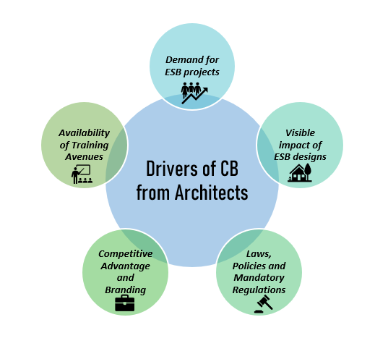
Figure 5.27 Drivers of CB from Architects
Source: Author’s Construct, 2023

5.6.1.1 Demand for ESB projects
The increased demand for ESB projects was cited as a driver for building the capacities of BE professionals, particularly Architects, to deliver ESBs. To this A2 stated:
“I think one of the things that will motivate me is if people or should I say clients begin to demand for these projects. Then I would want to build more knowledge in this area.” [A2]
A6 further notes;
“The basic motivating factor for me will be the demand for sustainable projects. And I think others will agree too.” [A6]

Furthermore, A12 echoes this driver by stating;
“Just like demand drives supply, if there is a higher demand for designs that are sustainable and will actually be built, then Architects or should I say professionals will build their knowledge in it to get it done.” [A12]

5.6.1.2 Visible impact of ESB designs
The visible impact of ESB designs on the environment, the occupants and the pockets of clients was cited as a driver for building capacities. In this, A1 posits,
“Well one of our joys is seeing that the client is happy so if I can see visibly, that putting up sustainable buildings will make clients happy then I think building my capacity to put up more won’t be a bad idea” [A1]
A10 also comments;
“Most of the time we don’t see the visible impact of sustainable designs on the environment. So, if by putting up more sustainable buildings I see that it is not just cheaper long term but also I have contributed to something bigger than myself, and I believe this goes for other people too, we will be more likely to want to design more sustainable buildings. As it stands now, people think they are just buildings that are expensive and also just designed differently. The green impact has not been seen properly.” [A10]
A11 explains;
“I think one thing that will drive me will be if I can let my clients see that sustainable building is not just in words. So, the client can also see that when the building is sustainable, it has better health outcomes for the users, it is cheaper in the long run and we are protecting the environment. That will drive them to demand it more and will also make me want to build my knowledge to design and build such projects.” [A11]

5.6.1.3 Laws, Policies and Mandatory Regulations
Similar to studies on drivers of concepts, the laws, policies and mandatory regulations were cited here as a driver for building the capacities of BE professionals. Here, A3 notes;
“I think as many people are driven by rules if there are some rules or building codes that demand some designs to be done or considerations for the environment, the professionals themselves will go looking for training to be able to meet the requirements.” [A3]
Similarly, A4 states;
“Our industry is very competitive, and you can lose a project by not meeting some requirements. So if there are those building codes that say you have to add some sustainable designs here and there, the professionals will build themselves to incorporate the requirements or go employ the experts and add them to the design team.” [A4]
Again, A7 supports this assertion by stating;
“I think because the building standards and codes are not too stringent on some of these things, people take them as suggestions, not compulsory regulations. But if there are some sanctions added or penalties for failing to design green, people will naturally try to grow their knowledge to be able to meet the requirements.” [A7]

5.6.1.4 Availability of Training Avenues
The availability of training avenues for Architects to build their capacities on ESB project delivery was cited as a driver.
As seen in the comment of A5,
“One thing I think will drive me is if there are some avenues or programs properly advertised for training in this area.” [A5]

A2 states here that,
“Because a lot of our training avenues are focusing on other aspects of the profession, very few of them are targeting this area so it's hard to build your knowledge or your capacity.” [A2]
A14 adds to this by stating;
“If I hear of training or seminars for green building, as long as it will deliver on their promise, I am sure to partake in it. But you hardly hear of them and the professional bodies are also training us in other areas not to design sustainable buildings per se. So, providing the place or platform for training will make me want to build my capacity more.” [A14]

5.6.1.5 Competitive Advantage and Branding
As the competition in the industry grows, Architects cite that the need to gain a competitive edge over their colleagues serves as a driver for building their capacities to deliver ESBs. Here, A8 comments;
“Because this sustainability thing is now catching up in the industry, some professionals are trying to make a name for themselves by being unique in their designs. So if I want to set myself apart from the competition I can make myself known as a sustainability expert and I think that is a good enough reason to become an expert in that field.” [A8]
Similarly, A3 explains;
“I think I will push to build my knowledge in this field if it means I can stand out from the crowd and become a brand of some sort. That is actually one of my motivations for learning stuff about sustainable buildings.” [A3]
A13 adds to this by stating;
“I think because the industry is choked, some people will want to make themselves unique or stand out by adding a certain touch to their brand or their designs. So one thing that will drive them to build their capacities is the prospect of being unique in the industry with their designs.” [A13]

5.6.2 Drivers from Quantity Surveyors
The Quantity Surveyors revealed five (5) drivers that enabled them to build their capacities to deliver ESBs in Ghana. In their opinions, the increased demand for ESB projects, Awareness of ESB issues, Available platforms for sharing ESB knowledge, Government advocacy and Training avenues were cited as the drivers for building their capacities. These drivers identified are presented in Figure 5.28 below.
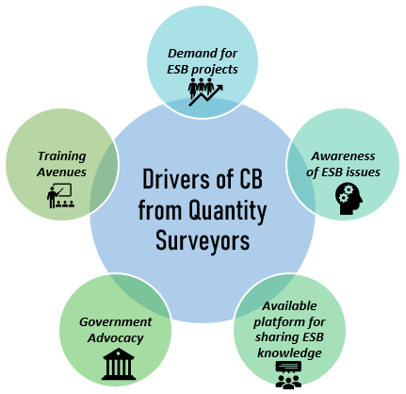
Figure 5.28 Drivers of CB from Quantity Surveyors
Source: Authors’ Construct, 2023

5.6.2.1 Demand for ESB projects
Similar to Architects, the demand for ESB projects was also cited by Quantity Surveyors as a driver for building their capacity to deliver ESB. As seen in the statement of QS1,
“Well, the demand is low, so naturally no one is thinking of developing their capacities. But if this can be changed, I believe a lot more people will want to know more about sustainability.” [QS1]
QS 3 also states;
“A lot of the professionals are driven by trends in the industry. So if the industry is growing or towing one line, they will want to go in that direction by building their capacities but as it stands now, that demand is not there.” [QS3]
QS5 echoes this driver by stating;
“I think if the demand for sustainable buildings were there, professionals will learn more about it and then try to add it to the designs and the materials we purchase.” [QS5]

5.6.2.2 Awareness of ESB issues
The increased awareness of ESB issues was in the opinion of Quantity surveyors, a driver for building their capacities to deliver ESBs. As QS 2 states;
“With the increasing demand for more sustainable projects, I think the awareness needs to increase from both sides. Awareness of incorporating sustainable methods or materials or designs from the professional’s side and also the awareness of the benefits from the client's side. But if only one side is aware, the demand will still be low.”[QS2]
Again, QS7 explains;
“Maybe, because professionals are not fully aware of the full range of ways they can add sustainable designs to their projects, they are not doing it or building sustainably. Sometimes, something as simple as making honeycomb walls to allow for ventilation and light into corridors while maintaining the aesthetic value is sustainable so they don’t know. And complacency will also not allow them to learn more.” [QS7]

QS 1 also had this to say;
“The general awareness of the sustainability issues itself is not there so it won’t even drive them to go and look for knowledge on it. If I know I don’t know something, I will be inclined to learn about it or find out more. But if I don’t know that I don’t know, then I won’t even bother. So, becoming aware of the lack of knowledge on sustainability issues will drive them.” [QS1]

5.6.2.3 Available platform for sharing ESB knowledge
In this study, the Quantity surveyors cited the availability of platforms for knowledge sharing as a driver to CB towards ESB delivery in Ghana.
QS2 states;
“We have very little support for building knowledge on ESB issues or green buildings. There are no platforms where you can share knowledge or ask questions when you are stuck in your learning process. So if some platforms were provided or available, it will drive people to build their capacities.” [QS2]
QS 3 also comments;
“I think because a lot of people are not even aware of sustainability issues, there is no support system. But if there can be a platform for sharing ideas or asking questions, making suggestions, and stuff like this, it will drive more people to build their knowledge. As it stands now, if I need to ask a question about something related to sustainability, I would have to google it.” [QS3]
Finally, QS4 echoes this driver in his comment stating;
“I would have thought the professional bodies will provide a platform for building knowledge on green building issues, but it is really not there. I believe a platform like that will motivate people to discuss issues on sustainability and make more people curious about it and want to learn more. If not for anything, the support will drive or ginger more professionals to learn.” [QS4]

5.6.2.4 Training Avenues
To Quantity Surveyors, the availability of avenues for training would drive them to build their capacities to deliver ESBs. Here QS1 states;
“Maybe, providing more training programs specifically targeting sustainable buildings will drive capacity building because frankly, this seems missing in our Ghanaian context.” [QS1]
Again, QS5 opines;
“I think more training conferences, and workshops will create a curiosity and a yearning to know more about sustainable buildings. The ones available don’t necessarily focus on this, so it does not motivate people to even attend them. But I think I will be motivated to build my capacities if I know there are some avenues there ready to provide the knowledge I need.” [QS5]
Finally, QS6 voices;
“Probably, because our attention is not on sustainability per se but on ways to minimise spending on projects, there are not so many avenues for training. But professionals will patronise the green building concept if the training was readily available.” [QS6]

5.6.2.5 Government Advocacy
The advocacy or support from the government was also cited as a driver in building the capacities of Quantity Surveyors to deliver ESBs in Ghana. To this end, QS1 revealed;
“You see because we follow a lot of what our leaders do, we are quick to copy them. Since they are not advocating for sustainability issues, people are also not focusing there, or trying to learn about it. If this were to change, I think more people will follow suit and learn to at least try and incorporate some element of sustainability.” [QS1]

Furthermore, QS4 points out;
“The government is not really supporting this movement and so we don’t see it reflecting in the industry. Look at the many projects the government embarks on, if they insisted on sustainable designs and methods or materials, don’t you think the professionals on them would go and look for ways to deliver? They will. So that is where I think all our problems begin.” [QS4]

5.6.3 Drivers from Project/ Construction Managers
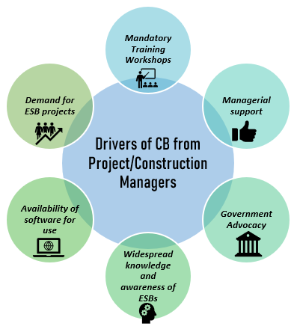
The interviews of Project/Construction Managers also revealed six (6) drivers, the highest number of identified drivers from the interviews conducted. Here, they cited mandatory training workshops, managerial support, the availability of software for use, the demand for ESB projects, widespread knowledge, and awareness of ESBs and government advocacy as the drivers for building their capacity to deliver ESBs in Ghana. Figure 5.29 summarises the various identified drivers and these are subsequently discussed.

Figure 5.29 Drivers of CB from Project/ Construction Managers
Source: Author’s Construct, 2023

5.6.3.1 Mandatory Training Workshops
The presence of mandatory or compulsory training workshops either provided by their firms or by professional bodies was cited as a driver of CB for Project/ Construction Managers. Here, PCM 1 states;
“I think some compulsory training will force a lot of us to learn about sustainable construction or green buildings.” [PCM1]
PCM3 also comments;
“If our companies for instance demanded that we attend some number of workshops in a year like some of them do and also organise them, definitely, we will learn about these sustainable buildings.” [PCM3]
Again, PCM 5 states;
“Maybe if as part of our requirements, we are supposed to have some certification on green buildings, a lot of us will go to school for it or go and look for such training.”[PCM5]
Furthermore, PCM 10 comments;
“A lot of people, even myself, are driven by force. So if there was some compulsory training maybe by the professional bodies or our workplaces then we will have no choice but to attend and there we will build our knowledge even if it is by force.” [PCM10]

5.6.3.2 Managerial support
The presence of managerial support for building capacities towards the delivery of ESBs was also cited as a driver. Here, PCM 11 reveals;
“For some reason, there is no management support for adding some sustainable materials or doing things sustainably. So a lot of professionals are not driven to learn more about it. But if such a support was available through pay raises or software or training then we will want to build our capacities to deliver.”[PCM11]
Again, PCM 4 explains;
“I think because upper management doesn’t really discuss issues on sustainability, there isn’t that kind of support for it. They are more concerned about getting the job done or delivering on time within the budget so if you were to bring something on sustainability it will just sound like you are trying to work outside of scope. So having some management backing will make some of us learn more about sustainability issues and then implement it.” [PCM4]
As stated by PCM 6;
“If management does not give you a go-ahead on something, you cannot really implement it. So with the sustainability issues, they are not supporting training or learning in it, so we will even implement or suggest it at least. But if the firm was more open to training us in it, then that will be great.” [PCM6]

5.6.3.3 Availability of software for use
The availability of ESB management software was cited as a driver for building the capacities of professionals according to project/construction managers.
As PCM 9 explains;
“The software for implementing sustainable building designs is even lacking so it is hard to develop an interest for it much more go and get training on it.”[PCM9]
Similarly, PCM 9 is of the view;
“If I were to even build my capacity or knowledge on some software for GB designs, other professionals are not knowledgeable on it and so you cannot use it to communicate with anyone. But if other professionals had the software or if the software was available then more and more people seeing its benefits will gravitate towards it.” [PCM9]
Likewise, PCM 12 comments;
“If software like BIM was readily available, lots of professionals will build their capacities in that area.”[PCM 12]

5.6.3.4 Demand for ESB projects
The increased demand for ESB projects was also cited here as a driver to building the capacities of BE professionals to deliver ESBs in Ghana. As PCM 2 simply states;
“The demand has to be there for people to want to learn about it or construct it.” [PCM7]
Again, PCM 4 states;
“If there was a higher demand for ESBs, then more professionals will lean towards that area and learn how to put up such buildings.” [PCM4]
This was also echoed in the statement of PCM 7 who comments;
“I believe if more clients decided they wanted projects that were environmentally sustainable, the professionals will build their knowledge on how they can make this happen.” [PCM7]

5.6.3.5 Widespread knowledge and awareness of ESBs
The driver of widespread knowledge and awareness of ESBs was in reference to increased knowledge and awareness of ESBs by both clients and professionals alike, which would then lead to CB towards the delivery of ESBs in Ghana. To this, PCM5 states;
“The awareness of ESBs is actually low, so people are not talking about it or learning about it. Unlike in developed countries where there are lots of publicity and movements challenging the construction industry and even other industries to be mindful of environmental problems. So, increasing the awareness will make more people train in it.” [PCM5]

PCM 8 also supports this driver by stating;
“Although some people are aware of sustainability issues, a lot more are not, and those not aware far outweigh those that know. Because of this, training or learning is not skewed in this direction. But if people are aware of the impact of construction on the environment and why we need green buildings, it will be easier to attract professionals to build their capacities.” [PCM8]

5.6.3.6 Government Advocacy
The support and advocacy of the government were also identified as a driver of CB efforts as seen in the statement of PCM 11;
“I would say, the government does not care about sustainability so the professionals on those projects don’t also care and are not even learning about it. If the situation were to change, more projects will be sustainable and more professionals will want to learn more about sustainability to implement it.” [PCM11]
PCM12 laments;
“In other countries, the government is pushing the agenda on sustainability so professionals are following suit. They will have websites praising projects that are sustainable, and some awards for sustainable projects and the professionals or the companies on such projects. But in Ghana, there is nothing like that so there is no drive. If there was some form of advocacy by the government, even in the form of awards, policies, or stuff like that lots more professionals will be interested in building their capacities.” [PCM12]

5.6.4 Drivers from Civil/Structural Engineers
The interviews with Civil/Structural Engineers also identified four (4) drivers of CB to deliver ESBs in Ghana. Here, increased training and development programs, managerial support, laws, policies and mandatory regulations and demand for ESBs were revealed as the drivers of CB to deliver ESBs. Figure 5.30 presents the identified drivers which were subsequently discussed.
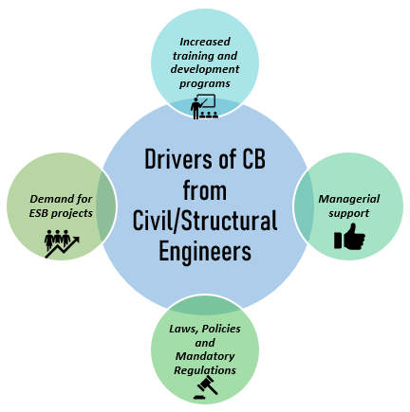
Figure 5.30 Drivers of CB from Civil/Structural Engineers
Source: Author’s Construct, 2023

5.6.4.1 Increased training and development programs
As identified by the civil/ structural engineers, the presence of increased training and development programs geared towards acquiring the needed knowledge on ESBs will drive them to build their capacities further. CSE1 states;
“In my opinion, there aren’t much of avenues or programs, conferences or workshops for building capacities on sustainable construction. In our case, a lot of the programs focus on the structural elements of the building so we hardly hear anything about sustainability. But some try their best. More programs would help.” [CSE1]
CSE 2 also supports this assertion by stating;
“I think coming out from school, the only other programs that exposed me to sustainable materials was the house fair or so, organised in Accra to showcase new materials on the market. If there were more programs like that naturally, people will get curious and want to learn about this sustainability concept.” [CSE2]

5.6.4.2 Managerial support
The presence of upper management support for ESB designs and CB efforts was also identified as a driver of capacity building. CSE1 states;
“Management needs to show some form of support for certain things before you can go ahead with it. So if management decides that going forward all our designs should focus on sustainability, then we will all toe the line by looking for some training on how to do this better. The required software and stuff like that.” [CSE1]
CSE 2 also orates;
“I would say that for most places, the focus of the organisation will determine what the professionals are experts in. At our firms, we don’t have any conversation on sustainability in our projects per se so we are focused on building our capacities in other areas. So, if this can be applied to sustainability, we will definitely be able to build our capacities.” [CSE2]

5.6.4.3 Laws, Policies and Mandatory Regulations
CSE 2 reveals that the presence of construction and building laws, policies and mandatory regulations would drive not just civil/structural engineers but also other BE professionals to build their capacities to meet those requirements.
“There are no specific mandatory laws or building codes in our practice that say anything about sustainability. But if there were something like that, I believe it will force me to learn about sustainability so I won’t be found wanting” [CSE2]

5.6.4.4 Demand for ESB projects
As identified by the other professionals, the increased demand for ESBs was also identified among Civil/Structural engineers as a driver for building their capacities to deliver ESBs in Ghana.
As CSE1 states;
“Generally, the demand is not there. I don’t think I have got up to four projects this year that look like they are considering sustainability. So, people out there are not demanding it and so professionals are also not training themselves in it.” [CSE1]
Again, CSE2 posits;
“Maybe if the demand for sustainable buildings increases, the professionals will look for avenues to build their capacities to construct such buildings. But I don’t have that demand so there is no push for me to really learn about it.” [CSE2]

5.6.5 Drivers from Services Engineers
From the interviews of Services Engineers in the construction industry, five (5) drivers were identified as the drivers of CB to deliver ESBs in Ghana. Here the drivers were Self-growth and development, competitive advantage, demand for ESBs, Visible Impact of ESBs and the availability of training avenues. The identified drivers are presented in Figure 5.31 below and subsequently discussed.

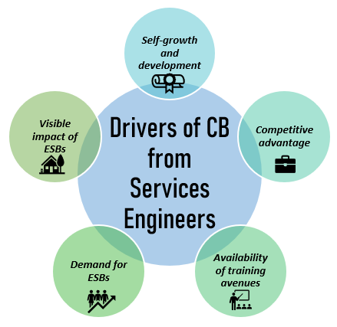

Figure 5.31 Drivers of CB from Services Engineers
Source: Authors Construct, 2023

5.6.5.1 Self-growth and development
One driver identified from the interviews was the possibility of self-growth and development of the professionals in this niche area of knowledge.
As SE1 states;
“I don’t know if I am the only one but I think what drives me is that I know more than I knew yesterday. So, in this profession, if you don’t learn new things, you will become archaic and obsolete. For me what will drive me to learn about sustainable buildings is that I will know something new.” [SE1]
Again, SE3 describes;
“The way the world is going, if you don’t upgrade your knowledge, you will be left out. So, for me, the fact that I will be in a meeting and they will mention something about sustainability and I will have a say in it is enough motivation for me to learn about it. I don’t want to ever look like I am from the ‘old generation’ of engineers.” [SE3]

5.6.5.2 Competitive advantage
The competitive advantage to be gained from building their capacities to deliver ESBs was also cited as a driver from the interviews. Here, SE 2 states;
“I also think it is a branding thing for me to add sustainability to my portfolio. If I can say with confidence that I am a sustainability expert, that makes me unique in the industry. So, it is a big driver for me.” [SE2]
SE3 supports this by stating;
“Maybe if learning about it will give me a competitive advantage, then that will be great. It will drive me to build my capacity more because I know I will be chosen above other tenderers at a bid because I know something new.” [SE3]

5.6.5.3 Demand for ESBs
Similar to the interviews of the other categories of professionals, the services engineers also identified the increased demand for ESBs as a driver to build their capacities to deliver ESBs. Here SE1 reveals;
“I think because people are not demanding for their projects to be sustainable, a lot of professionals are also not learning about it. You will only find one or two clients who want something sustainable and that will be it for about six months. But gradually, people are getting curious about it although the prices still scare them away.” [SE1]
SE 2 also states;
“I think the trends drive what people do or where they focus on. So, if more clients are requesting sustainable buildings, more professionals will develop the capacity to deliver them. This will be some form of push factor.” [SE2]

5.6.5.4 Visible impact of ESBs
The visible or apparent impact of ESBs on the environment, occupants and clients was also revealed to be a driver for building the capacities of BE professionals to deliver ESBs. Here SE3 states;
“For me, if I can see that adding sustainable elements will decrease the cost of operation and make the environment healthier, I will learn more about it and advocate it. But sometimes the benefits are not so visible so it’s hard to advocate for it.” [SE3]

5.6.5.5 Availability of training avenues
The availability of training avenues was seen to be a driver that will push professionals to build their capacities to deliver ESBs. To this end, SE1 comments;
“We hardly hear of training for sustainability, if there were more of these programs, more people will get the knowledge.” [SE1]
SE2 further comments;
“The professional bodies can provide more workshops to train us in this regard, this is what is missing in our industry. It will drive me to attend them and then I would have built my knowledge on sustainability.” [SE2]

5.6.6 Summary of Drivers of CB of BE Professionals
The interviews of the professionals brought to light several drivers of CB efforts. A summary of the various drivers of CB of BE professionals is thus presented. The drivers of CB identified under each professional category are presented in descending order of mentions per professional.

Table 5.9 Summary of Drivers of CB of BE Professionals
BE Professionals | Drivers | Total No of Mentions
Architects | Demand for ESB projects | 6
Architects | Visible impact of ESB designs | 3
Architects | Laws, Policies and Mandatory Regulations | 4
Architects | Availability of Training Avenues | 3
Architects | Competitive Advantage and Branding | 6
Quantity Surveyors | Demand for ESB projects | 6
Quantity Surveyors | Awareness of ESB issues | 6
Quantity Surveyors | Available platform for sharing ESB knowledge | 4
Quantity Surveyors | Training Avenues | 2
Quantity Surveyors | Government Advocacy | 3
Project/Construction Managers | Mandatory Training Workshops | 5
Project/Construction Managers | Managerial support | 4
Project/Construction Managers | Availability of software for use | 4
Project/Construction Managers | Demand for ESB projects | 6
Project/Construction Managers | Widespread knowledge and awareness of ESBs | 5
Project/Construction Managers | Government Advocacy | 4
Civil/Structural Engineers | Increased training and development programs | 2
Civil/Structural Engineers | Managerial support | 2
Civil/Structural Engineers | Laws, Policies and Mandatory Regulations | 1
Civil/Structural Engineers | Demand for ESB projects | 2
Services Engineers | Self-growth and development | 2
Services Engineers | Competitive advantage | 2
Services Engineers | Demand for ESBs | 2
Services Engineers | Visible impact of ESBs | 1
Services Engineers | Availability of training avenues | 2
Source: Author’s Construct, 2023

5.6.7 Pareto Analysis of Drivers of CB
In order to appreciate the drivers to be explored, and identify salient strategies for motivating or enabling professionals to build their capacity, a Pareto analysis was employed.

5.6.7.1 Pareto Analysis of Drivers from Architects
From the interviews of Architects, a total of five (5) drivers emerged. These drivers were then analysed using the Pareto tool and the result is presented in Figure 5.32 below.
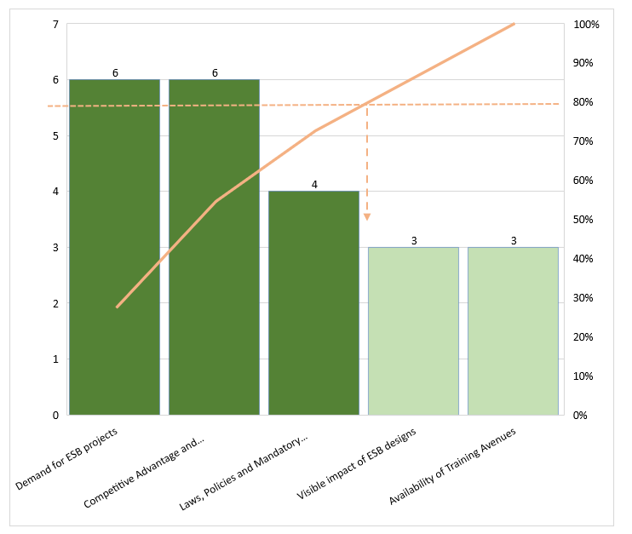
Figure 5.32 Pareto Analysis of Drivers of CB by Architects
Source: Author’s Construct, 2023
After applying the 80% rule, the drivers requiring the most attention were found to be demand for ESB projects, Competitive Advantage and Branding, and Laws, Policies and Mandatory Regulations. By focusing efforts on exploring these drivers, all other drivers can also be explored.

5.6.7.1 Pareto Analysis of Drivers from Quantity Surveyors
Five (5) drivers emerged from the interviews of Quantity Surveyors. These drivers were then analysed using the Pareto 80/20 rule and the results are presented in Figure 5.33 below.
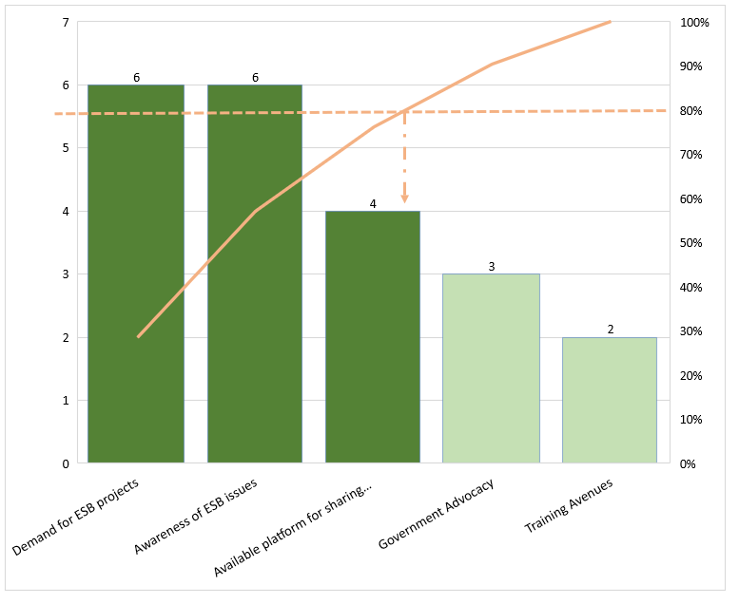
Figure 5.33 Pareto Analysis of Drivers of CB by Quantity Surveyors
Source: Author’s Construct, 2023
As can be seen from Figure 5.33 above, the demand for ESB projects, Awareness of ESB issues, and Available platform for sharing ESB knowledge were found to be the most influential drivers requiring attention. By exploring these drivers, the remaining drivers can also be explored.

5.6.7.1 Pareto Analysis of Drivers from Project/Construction Managers
The interviews with the Project/construction managers allowed for six (6) drivers to emerge. These drivers were then analysed with the 80/20 Pareto rule and the results are presented in Figure 5.34 below.
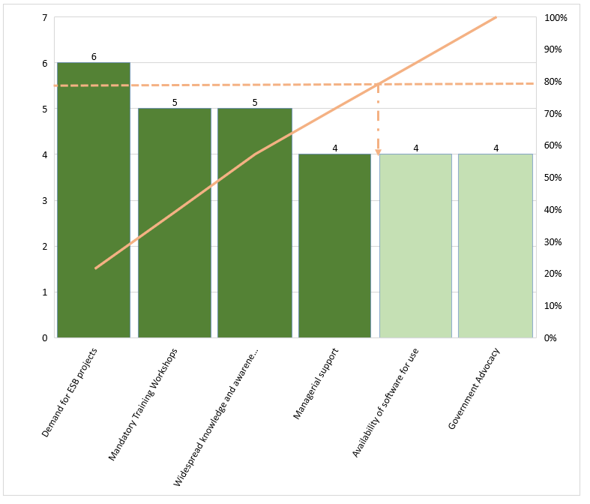
Figure 5.34 Pareto Analysis of Drivers of CB by Project/Construction Managers
Source: Author’s Construct, 2023
Once again, the 20% rule revealed that demand for ESB projects, Mandatory Training Workshops, Widespread knowledge and awareness of ESBs and Managerial support were the drivers that required immediate attention to be explored towards CB.

5.6.7.1 Pareto Analysis of Drivers from Civil/ Structural Engineers
Four (4) drivers emerged from the interviews of the civil/structural engineers. These drivers were thus analysed using the pareto principle and the result is presented in Figure 5.35 below.
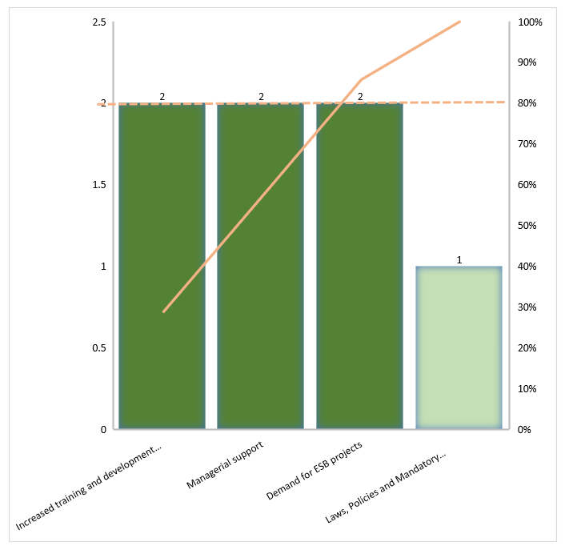
Figure 5.35 Pareto Analysis of Drivers of CB by Civil/structural engineers
Source: Author’s Construct, 2023
Under this category of respondents, Increased Training and development programs, Managerial support, and Demand for ESB projects emerged as the key drivers after applying the 80% rule.

5.6.7.1 Pareto Analysis of Drivers from Services Engineers
Five (5) drivers of CB emerged from the interviews of Services Engineers towards the delivery of ESBs. The drivers were then analysed using the Pareto 80/20 rule and the result is presented in Figure 5.36 below.
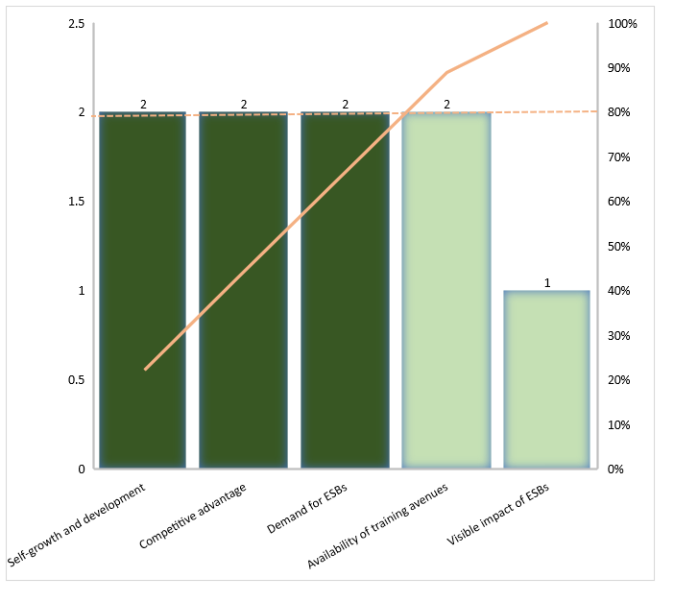
Figure 5.36 Pareto Analysis of Drivers of CB by Services Engineers
Source: Author’s Construct, 2023
As can be seen from the result of the analysis, self-growth and development, Competitive advantage, and Demand for ESBs, emerged as the key drivers of CB as revealed by services engineers.

5.6.7.6 Pareto Analysis of Drivers for CB from all Professionals
The study further analysed all the identified drivers by tabulating the identified drivers and counting their occurrences across all the interviewed professionals. This was done to satisfy the objective of the study which sought to identify the drivers for CB of professionals for ESB delivery. By congruently analysing these drivers, the most significant drivers which affect all professionals can be identified. Table 5.10 presents the twelve (12) identified drivers as well as their occurrence from the interviews of the professionals and this is subsequently analysed using the Pareto tool.
Table 5.10 Drivers for CB of BE Professionals and Total Number of Occurrences
Identified Drivers | Ach | QS | PCM | CSE | SE | Total No of Occurrences
Demand for ESB projects | 6 | 6 | 6 | 1 | 2 | 21
Awareness of ESB issues |  | 6 | 5 |  |  | 11
Availability of Training Avenues | 3 | 2 |  | 2 | 2 | 9
Competitive Advantage and Branding | 6 |  |  |  | 2 | 8
Government Advocacy |  | 3 | 4 |  |  | 7
Managerial support |  |  | 4 | 2 |  | 6
Laws, Policies and Mandatory Regulations | 4 |  |  | 1 |  | 5
Mandatory Training Workshops |  |  | 5 |  |  | 5
Visible impact of ESB designs | 3 |  |  |  | 1 | 4
Available platform for sharing ESB knowledge |  | 4 |  |  |  | 4
Availability of software for use |  |  | 4 |  |  | 4
Self-growth and development |  |  |  |  | 2 | 2
Source: Author’s Construct, 2023
Table 5.10 presented the various identified drivers ranking them from the highest number of occurrences to the lowest. This allows for an appreciation of the highest influencing drivers of CB of BE professionals and thus strategies for exploring these drivers can be focused on the higher-ranking drivers as they cut across all professionals regardless of services provided. To better appreciate this, the Pareto tool was used to separate the most influential drivers from the non-influential ones. Using the 80/20 rule then, the cumulative line plot was generated from the data in Table and subsequently discussed. Figure 5.37 presents the Pareto analysis of the drivers to CB of all BE professionals.
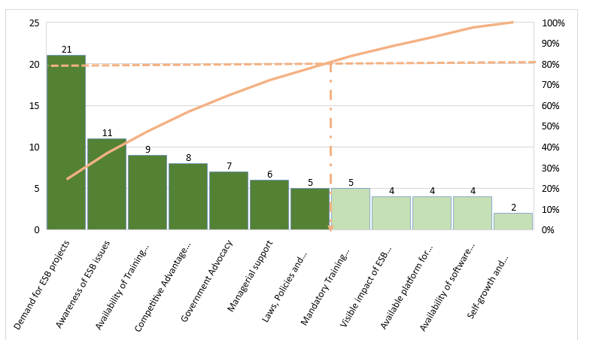
Figure 5.37 Pareto Analysis of Drivers of CB by all professionals
Source: Author’s Construct, 2023
Out of the twelve (12) identified drivers, seven (7) were found to be critical. From the Pareto chart the demand for ESB projects, Demand for ESB projects, Awareness of ESB issues, Availability of Training Avenues, Competitive Advantage and Branding, Government Advocacy, Managerial support and Laws, Policies and Mandatory Regulations emerged as the most influential drivers of CB for BE professionals.

5.6.8 Discussion of Findings- Drivers for CB of BE Professionals
In exploring the Demand for ESB projects, although the implementation of ESBs involves several stakeholders, clients or customers have the greatest influence, in that the real estate industry can only be motivated to meet ESB standards if clients or consumers are inclined to choose energy-efficient and sustainable architecture (Li et al., 2014). The importance of clients in this regard cannot be overlooked as clients constitute the market force that enhances or impedes green architecture. In light of this, Diyana and Abidin (2013) argue that the commercial viability of green architecture, which is affected by the demand of buyers, is crucial to push developers to produce green housing. Reiterating the findings of Hwang and Tan (2012) that clients are the most important members of a project team to influence ESB practices. Drawing the awareness of construction clients to the expectant benefits of GB is an important step to driving ESB demand (Braulio-Gonzalo and Bovea, 2020).
With increasing environmental concerns, and gradual Awareness of ESB issues, clients have started to demand the products that are manufactured or processed, based on environmental principles (Kanchanapibul et al., 2014). In fact, sustainability in construction has only become crucial because of the built environment's impact on climate change and natural resources, which affects the natural environment. It is not surprising to identify that increasing the awareness of ESB issues among clients and professionals alike would drive CB efforts. This finding concurs with the literature that client environmental concern and awareness is an important driver for the implementation of green technology (Wang et al., 2014; Braulio-Gonzalo and Bovea, 2020). Creating increased awareness of the high volume of carbon emissions from construction practices has been seen in the literature to drive clients and professionals towards seeking alternative greener solutions through CB. Häkkinen and Belloni (2011) argued that developing the awareness of clients about the benefits of ESBs is one of the most important actions to promote CB for ESB/GB delivery. As the attitudes and behaviours of consumers have a significant influence on professionals’ practices in ESB promotion, strengthening publicity and education may be an efficient and effective way to enhance public awareness of environmental sustainability as well as customers’ willingness to pay for ESBs (Zhang, 2015). In their study on ESB promotion in China, Li et al. (2014) proposed the following strategies to promote ESBs: to enhance the awareness of the stakeholders, to strengthen technology research and communication, and codes and regulations. These would invariably lead to increased CB efforts as professionals would then strive to meet the growing demand for ESBs.
The competitive advantage and branding offered by being ESB savvy is another highly recognized driver for CB towards ESB delivery. Market uncertainties, the gradual adoption of Construction 4.0, and the overall competitive pressure, along with their components, are constituents of a competitive environment under which construction professionals react by building their capacities to remain relevant in the industry (Won and Park, 2020). Turkes et al. (2019) found that Romanian professionals mainly adopt and use Construction 4.0 and GB/ESB technologies to keep up with competitors practising in the industry.
Scholars believe that Government Advocacy can play the most salient role in CB for ESB delivery, especially by easing the initial digital transition steps, including the adoption decision phase. Findings from previous studies show that the supporting role of government includes addressing the infrastructural gap, the financial gap by providing construction firms with tangible digital investments incentives and the digitalization policy gap through devising and enforcing supportive ESB construction laws, anti-digital oligarchy laws and other supportive laws that enhance digital inclusion while regulating construction practices. Academia and technology providers can also support the advocacy of governments mainly through streamlining the supply of ESB technologies, offering ESB technology assistance and support, providing training and upskilling services and helping construction firms with developing a culture of environmental awareness.
Studies have shown that organizational culture emanating from Management Support could be a driver or barrier toward the adoption of innovations in firms, especially construction firms. For example, Ingaldi and Ulewicz (2020) showed that employee resistance toward digitalisation negatively impacts a firm's decisions toward innovative transformation. In contrast, Michna and Kmieciak (2020) and Moeuf et al. (2020) demonstrated that a supportive business culture characterized by openness toward innovation and digitalization leads construction firms to build a positive attitude toward Construction 4.0 technology adoption. In this same vein, the support from management which creates an organisational culture for continuous learning and innovation for ESB delivery would lead to favourable environments for CB.
Many previous studies found strong evidence that Laws, Policies and Mandatory Regulations are important drivers that compel stakeholders to act sustainably and seek the needed knowledge on sustainable construction (Luna-Nemecio et al., 2020; Johnsson et al., 2020; Nikolaou et al., 2021).

